Consultation on our proposed

Installations Banding Tool

Introduction 2

Key messages 2

Bespoke Installation permit applications 3

The Installations Charge Tool 6

How the charge has been developed 6

New applications 10

Other Activities 11

How the tool works (Link to the tool) 13

Step 1 – the initial banding 13

Step 2 – Questions about complexity 13

Step 3 – Additional complexity factors 14

Variations 16

Transfer applications 18

Surrender applications 20

## Introduction

As a Welsh Government body, NRW must comply with requirements set out in ‘[Managing Welsh Public Money](https://www.gov.wales/managing-welsh-public-money)’. This requires that we fully recover the costs of the regulatory services we provide from those who use them, rather than having those services funded through general taxation.

Between October 2022 and January 2023 we consulted on [new application charges](https://ymgynghori.cyfoethnaturiol.cymru/sroc/strategic-review-of-charging/) for a number of regimes, including installations. We made these changes because our charges at that time did not reflect the cost of delivering our service to you. We implemented these changes to recover our costs.

As part of that consultation, we proposed introducing four new charging bands for installation permit applications. Feedback we received through the consultation told us that you felt that we hadn’t provided sufficient information on the four new bands and how they would apply. We committed to undertake further engagement with stakeholders with more detail before deciding whether to introduce the new banding tool.

To determine which charge band applies to an application, we have developed a banding tool. The banding tool is intended to match the charge payable more closely to the time it takes to determine each application and therefore the cost to us of providing this service. This is in contrast to the OPRA tool where applicants paid an amount based on an environmental ‘risk factor’ for the whole site.

The assessment needed to determine a variation is specific to an application. It can vary between applications made by the same site operator, and we want the charge to reflect the cost of the service provided. This won’t be a one-size-fits-all approach, but one that is flexible, to fit the individual application.

## Key messages

This section applies to permits issued to activities falling into Schedule 1, Part A(1) of the Environmental Permitting Regulations (Installations).

We have used the Operational Risk Assessment tool (OPRA) charging scheme for Installations since it was introduced in 2003 where application charges were calculated using a multiplier of each site’s risk score. The multipliers have only increased by about 4% in the last 10 years, and in addition to this deficit of cost recovery, our Strategic Review of Charges has determined that OPRA no longer fills the needs of a modern cost-recovery based charging scheme for permit applications.

We continuously look to make our assessment process more efficient through developing new tools, and where efficiencies are made in future there may be scope to reduce application charges.

For reference, the key differences are:

* four bands of base charge dependent on the complexity of the application
* additional charges for certain bespoke assessments
* time and materials charges where the time taken is more than 150% of that paid for
* time and materials charges for landfill-specific bespoke assessments
* we will retain 14% of the application charge where an application is returned for having insufficient information to be able to determine it
* applications for administrative only variations to permits will be charged for. We will not charge for NRW-initiated administrative variations.

## Bespoke Installation permit applications

These charges are currently based on OPRA multipliers. Evidence from analysis of the determination process shows that there is a wide range of time taken depending on the complexity of the application. For this reason, we are introducing four charge bands to replace the site specific OPRA score.

We will provide a tool using known factors which align with the information and assessments provided in the application to determine which band an application will fall into. The key factors in determining activities within these bands will be:

* the number of different Part A(1) listed activities on the site
* the multiples of the threshold that brings the main Part A(1) listed activity into regulation
* whether there are any Large Combustion Plant or Waste Incineration activities on site
* whether the site treats hazardous waste
* whether the installation is a landfill, and
* whether there is no applicable Best Available techniques guidance for the activity.

For substantial and normal variations, the charge will only apply to the parts of the installation that are affected by the variation. This aligns the charge with the work needed to determine the variation rather than the entire operation at the installation as is the current situation with the OPRA based charge.

Where an installation also carries out Part A(2) or Part B activities, or where there is a medium combustion plant or specified generator activity (MCP or SG), a fixed amount will be charged for each activity, as described above. We will also charge a fixed amount for a directly associated waste activity where that activity would require a bespoke Environmental Permit if it was not part of the installation.

In addition to the base charge from the appropriate band, as shown in Table 5, and where appropriate the ‘Part A(2), Part B or MCP or SG’ charge, supplementary charges for specific additional assessments will be added. These are for location or activity-specific assessments that are not relevant for every application, but which take a significant amount of time to assess, as shown in Table 6.

The core charges are:

|  |  |  |  |  |
| --- | --- | --- | --- | --- |
|  | Band 1 bespoke | Band 2 bespoke | Band 3 bespoke | Band 4 bespoke |
| New Application | £13,212 | £19,873 | £31,765 | £43,543 |
| Administrative Variation | £595 | £595 | £595 | £595 |
| Minor-technical Variation | £2,614 | £2,614 | £2,614 | £2,614 |
| Normal Variation | £8,705 | £11,080 | £19,009 | £34,108 |
| Substantial Variation | £12,655 | £19,063 | £30,480 | £41,443 |
| Part Transfer | £5,085 | £7,032 | £11,497 | £14,211 |
| Full Transfer | £2,601 | £2,601 | £2,601 | £2,601 |
| Part Surrender | £6,497 | £8,899 | £17,814 | £23,589 |
| Full Surrender | £5,642 | £8,125 | £14,301 | £19,960 |
| Low risk surrender | £2,614 | £2,614 | £2,614 | £2,614 |
| Surrender of a site that has never operated | £1,182 | £1,182 | £1,182 | £1,182 |

**Table 5 – Bespoke permit application charges**

|  |  |
| --- | --- |
| Additional assessments | Charge |
| Full air quality modelling assessment | £2,613 |
| Fugitive emissions assessment (where not part of air quality modelling) | £1,608 |
| Odour assessment (where not part of air quality modelling) | £1,571 |
| Bioaerosol modelling assessment | £3,281 |
| Full noise modelling impact assessment | £2,354 |
| Fire prevention and mitigation plan | £2,274 |
| Deposit for recovery assessment | £1,683 |
| Water Framework Directive assessment of process effluent | £3,128 |

**Table 6 – Charges for additional assessments**

**NRW-initiated variations**

Where NRW decides that a permit needs to be varied we will charge the appropriate amount from the tables above.

## The Installations Charge Tool

### How the charge has been developed

We examined how long all the various determination tasks took, and how frequently they occurred. From this we built a cost model.

It was clear that there is a wide variation in the amount of time that the different determination tasks take for different permit applications.

The options for charging ranged from having the same fee for every application to charging a bespoke fee for each application based on the actual time taken. We decided on four bands that we considered would fairly cover the range of time calculated in the cost model and built a charge model on this basis.

The bands will apply to the types of permit application where there can be a significant difference in the amount of assessment needed to complete the determination. This means that for applications where the determination is essentially the same regardless of the scale or complexity of the installation, such as Full Transfers, there is a single charge.

One of the key differences from OPRA is that the tool applies to the Application and not to the Installation. This means that variation charges can vary depending on how much of the installation is affected by the changes requiring that variation. This is to comply with our aim of cost recovery.

We have identified the most significant factors affecting the time taken and used these to build a tool that assigns the applications to the appropriate band.

The determination process involves assessing whether the Installation’s activities are compliant with Best Available Techniques (BAT) as described in the published BAT Conclusions documents. There may be several sets of BAT Conclusions to assess against and the banding tool uses this as one of the complexity factors, along with the number of different Part A(1) activities on site. The determination process is also more difficult if there is no published BAT for an activity, so this is also a complexity factor.

We use the scale of operations relative to the threshold that brings the activity into Part A(1) regulation as another indicator of the amount of assessment needed. Higher capacity sites are likely to have greater amounts of releases that need assessing.

Other factors for new applications are:

* Operating an Incinerator or co-incinerator (Chapter IV IED)
* Operating a Large Combustion Plant (Chapter III IED)
* Operating a Landfill Installation
* Solvent activity (Chapter V IED)
* Storage or treatment of hazardous waste
* Need for Technically Competent Management
* Need for a Multi-product protocol for certain Chemical activities
* If the Installation is a “Development of national significance”
* If the operator is requesting a derogation from a BATc limit.

The effect of each of these factors on the banding was decided by looking at evidence from the permitting team – from their time recording for individual applications and from their expert knowledge.

There are separate tools for the four different types of permit application – New application, Variation, Transfer and Surrender. Each has a guidance page so that no separate guidance documents are needed. There are also links to specific guidance which may be needed within the tool, for example to guidance about applying for commercial confidentiality.

There is then an Introduction page which also gives a summary of the charge for that application broken down into its component parts, along with the number of hours that the charge covers at current rates.

The tool is designed so that the applicant only needs to complete cells that are either white (free text) or bright blue (dropdown choices). Everything else is automated within the tool. The colour coding is consistent through the tool so the applicant can see what they need to complete. Prompts will appear if something has been missed.

This is what the Introduction page looks like for Variation applications:



### New applications

For new activities the operator is asked to complete the white and blue sections on this page:

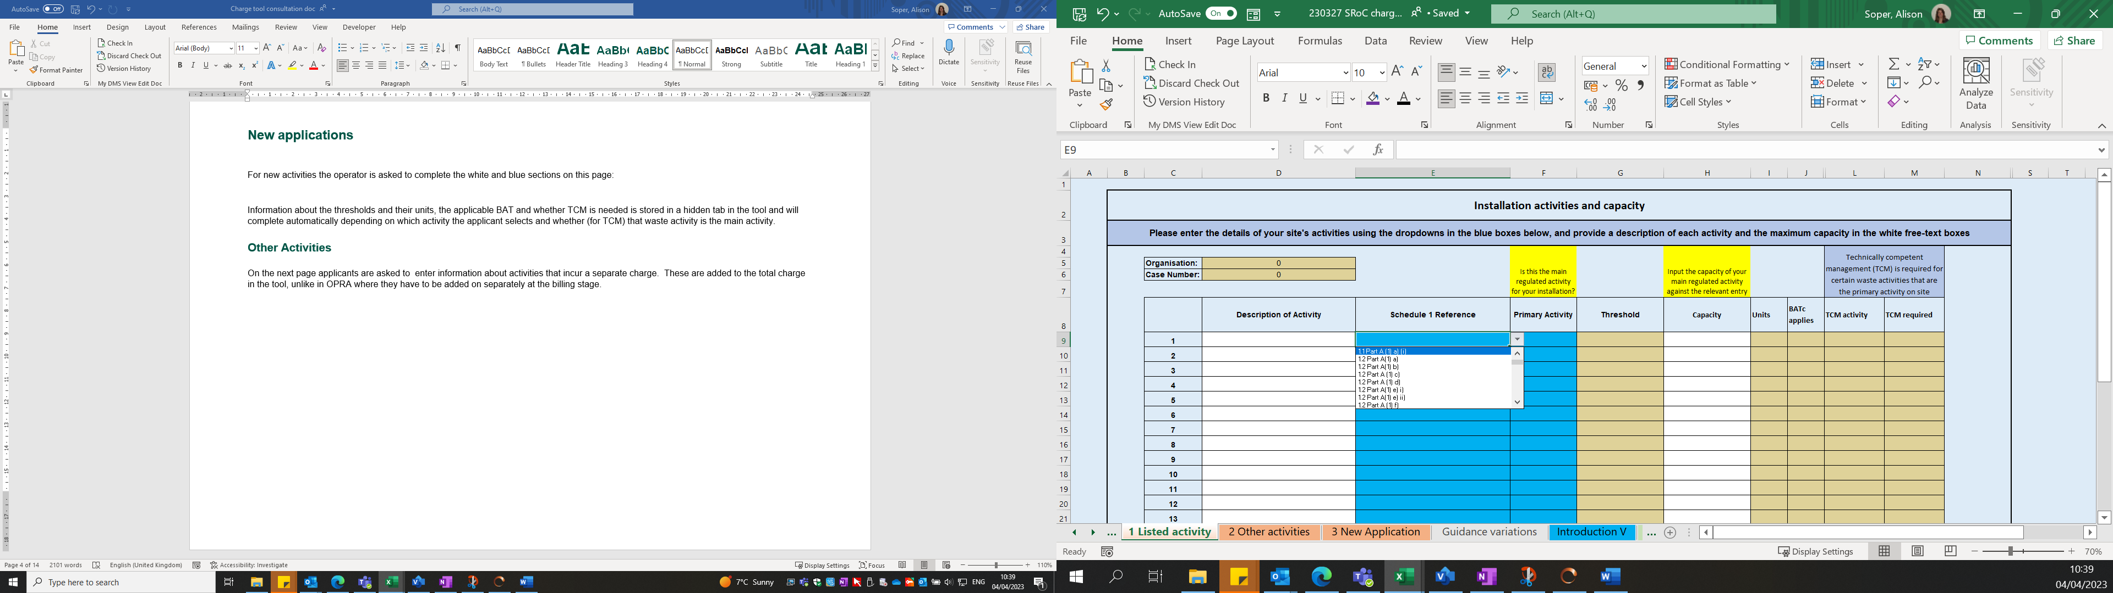

Information about the thresholds and their units, the applicable BAT and whether TCM is needed is stored in a hidden tab in the tool and will complete automatically depending on which activity the applicant selects and whether (for TCM) that waste activity is the main activity.

### Other Activities

On the next page applicants are asked to enter information about activities that incur a separate charge. These are added to the total charge in the tool, unlike in OPRA where they have to be added on separately at the billing stage.

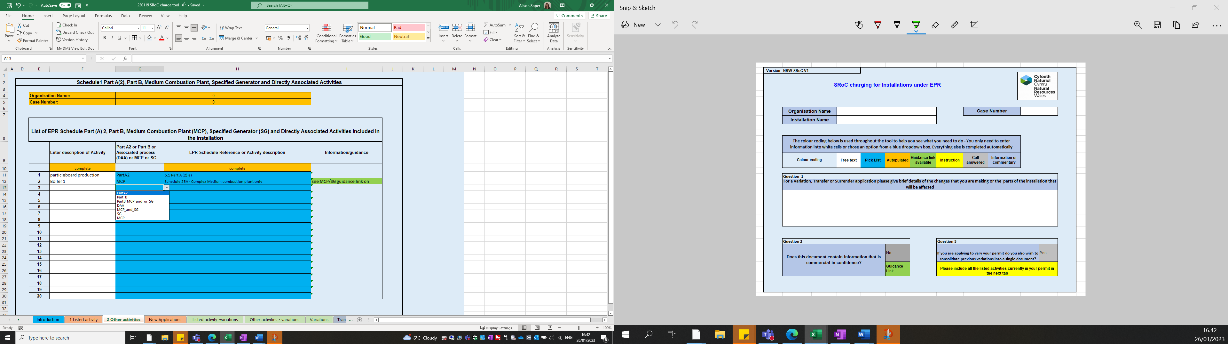

Links to guidance will appear

The applicant then moves on to the third tab to answer a series of questions that relate to the complexity of their activities.



The total charge is shown here

Additional assessment charges are added here

Information transferred in about MCP, LA activities etc

The charge band is shown here

This is a picture of what the applicant will see on the next tab to give an idea of what the page looks like. It’s where they answer some additional questions about their activities and the charge is calculated

Questions about initial complexity factors

Questions about additional complexity factors

Information about the number and scale of activities + BAT docs applicable

## How the tool works

#### Step 1 – the initial banding

The number in this column is a weighting score from 0 to 3

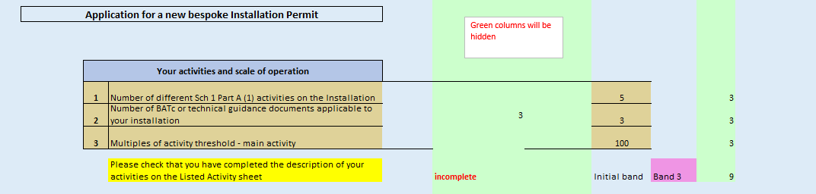

Each of the lines above contributes to the initial banding calculation. The information about the site is automatically transferred from the first page of the tool, and if anything has not been filled in on the first page a prompt will appear – The yellow box.

On the first line -

* 1 listed activity scores 1, 2 activities score 2 and more than 2 activities scores 3 (in this example there are 5 activities so the score is 3)

On the second line –

* 0 BAT docs scores 0, 1 doc scores 1, 2 docs scores 2 and more than 2 scores 3. (Here there are 3 BAT reference docs to assess so the score is 3)

On the third line –

* If the capacity is less than 3x the threshold it scores 1, if it’s less than 6x the threshold it scores 2 and if it’s more than this it scores 3.

When these scores are added up, a total of <5 will be Band 1, <8 Band 2, <12 Band 3, and 12 or more Band 4.

All these scores have been determined by looking at evidence of time taken for different permit applications involving different numbers of listed activities and different scales of operation. There are no thresholds for some activities, for example the chemical sector, but larger sites will tend to have other activities such as combustion plant or effluent treatment which increase the initial score. They may also need assessing against the Large Volume Chemical BRef which is a captured in a specific question about additional BATC documents in the next part of the tool.

#### Step 2 – Questions about complexity

We now ask 8 questions about factors that make the determination process more complex and time consuming.

The answers to two of these questions are entered automatically from information given on the first tab – they relate to the need to activities where there is no BReF or technical guidance and the need for technically competent management (TCM). TCM is required for certain waste installation activities where they are the main activity on site.

The 9th question in this group is about COMAH. If a site is also a COMAH site the score in this section is reduced by 1.

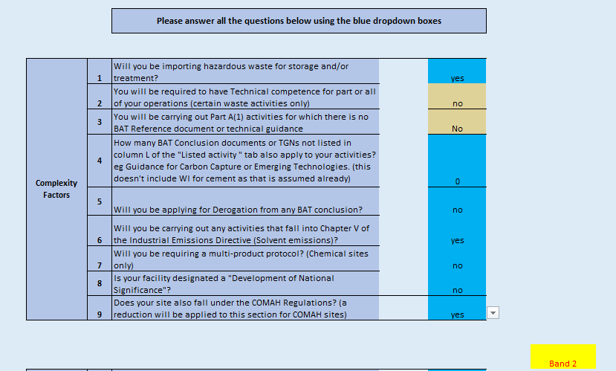

The number of additional BATc documents is capped at 3, this is added to the number of “yes” answers, the COMAH reduction is then applied if the answer to this question is Yes. The overall impact is limited to moving up a single band. To move from Band 1 to Band 2 needs a total score of 1 from this section, and to move from Band 2 to Band 3, or Band 3 to Band 4 needs a total of 2.

Evidence from the cost model shows that the additional time and cost is proportionate for the way these activities increase the banding.

#### Step 3 – Additional complexity factors

There are some activities which almost always take a significant amount of time. For this reason Incineration, Landfill or Large Combustion Plant will automatically put a site into at least Band 3 regardless of which band it was in after the first step.

In the example below, a Band 1 site is put in Band 3 because its single activity is Incineration. The base charge for the application is shown after this section in the tool.

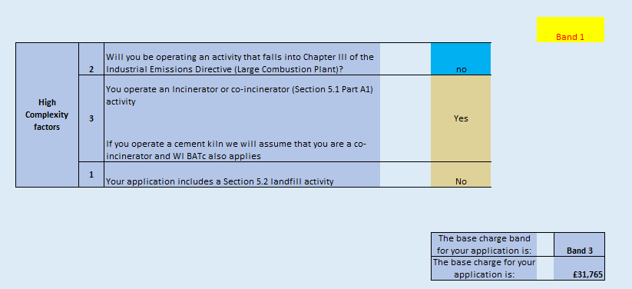

The charges for additional activities are then added. There is a single charge for Medium Combustion Plant or Specified Generator activities and other activities are capped at a maximum of three of any one activity type. These charges cover only the additional time needed to include the activities in the installation permit, so they are lower that the equivalent stand-alone permit

The charge for a directly associated waste activity is 20% of the standard charge for a stand-alone waste activity under our new charging scheme. This is the same amount that we charge for second and subsequent activities in Waste Activity permits.



Lastly, the applicant is asked to list any additional assessments that are included in the application. These are the complex impact assessments that need specialist input to assess and attract a separate fixed charge. The applicant will know which of these are relevant from completing the application form.

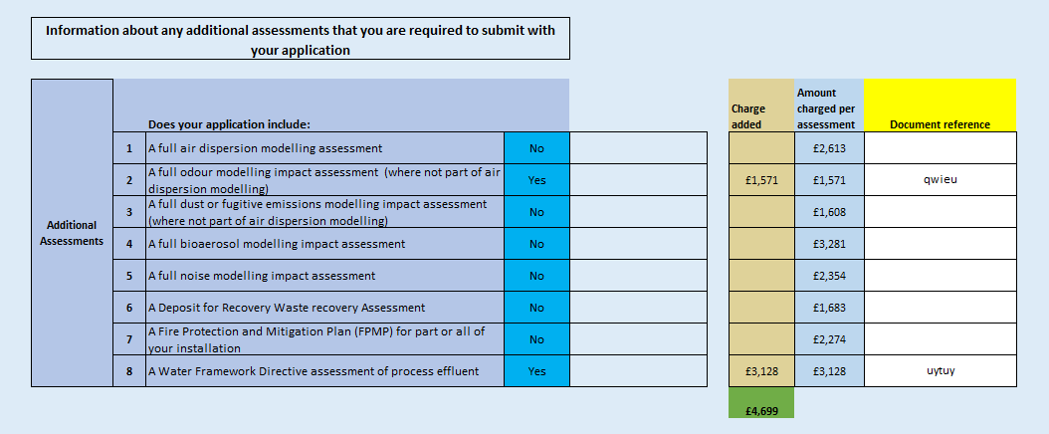

The total charge is given at the foot of the page – along with the number of hours work that this covers at the current rate.

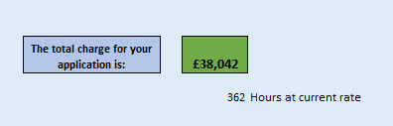

### Variations

The tool works in a similar way for variation applications. The applicant completes the introductory page where they are asked to enter very brief details to say what the variation is for. They are also asked whether they are requesting a consolidation of previous variations.

On the listed activity page the applicant completes the required details for any new activities that are being added, or for any activities which are affected by the changes leading to the variation application. We also ask for the current and proposed capacity of those activities, even if it will be the same.

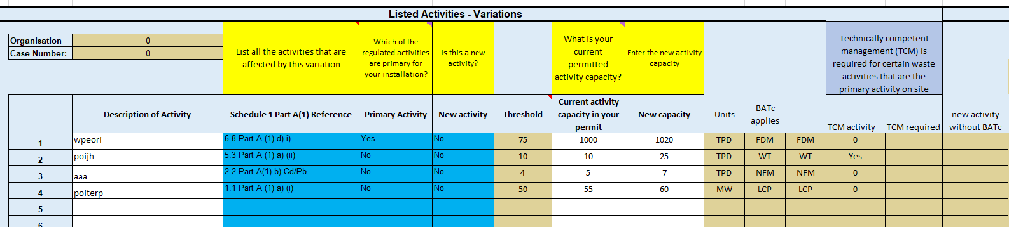

The next page asks the applicant to enter details of any “Other activities” that are being added, or that are affected by the variation.

The third page has a similar list of questions about the complexity of the application, but starts by identifying whether it is a substantial or normal variation.

In this example the applicant is proposing to increase the capacity of an activity such that the application is automatically a substantial variation:

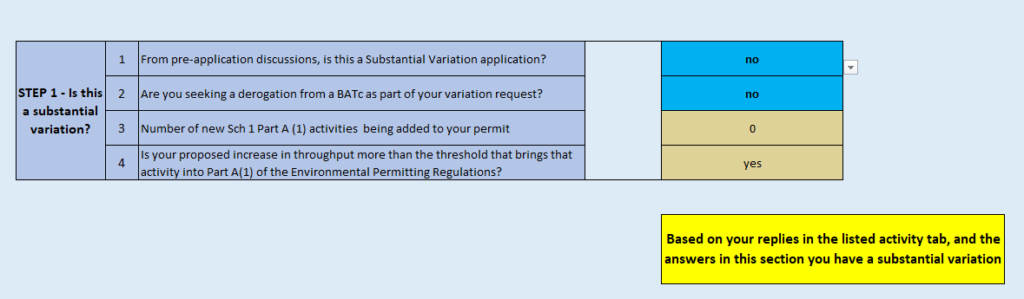

This is an example of a normal variation:

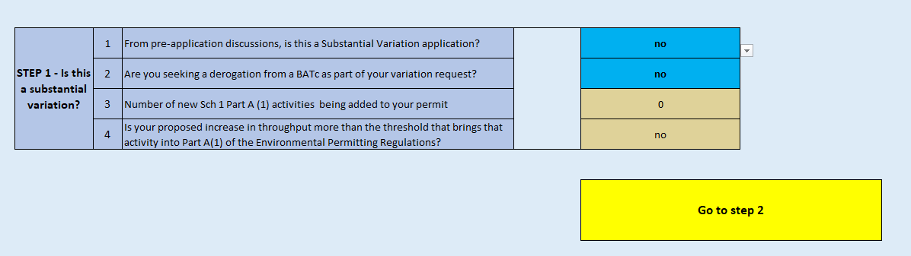

The next step relates to the scale of the changes:



In the same way as for new applications, there is a maximum score of 3 in the right hand green column, so in this example a site where the variation affects two listed activities is placed in Band 2 at this stage. (The green columns will not be visible in the actual tool that applicants will use).

There are then 7 questions relating to the complexity of the changes:

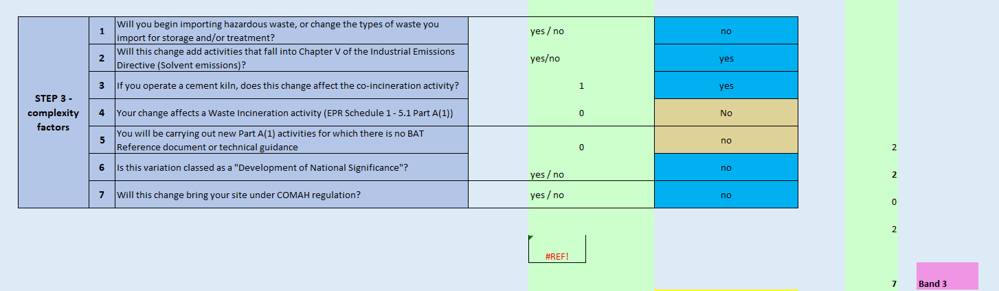

An application will need one “yes” answer to move from Band 1 to Band 2, but two “yes” answers to move from Band 2 to band 3, or from Band 3 to Band 4. It is only possible to move up one band.

If the changes bring the site into COMAH that will reduce the score in this section by 1, and could potentially move the application down a band. This is to account for the significant risk assessment work that is done for COMAH that results in the EPR application determination being more straightforward.

There are then three questions that relate to particularly complex types of variations:

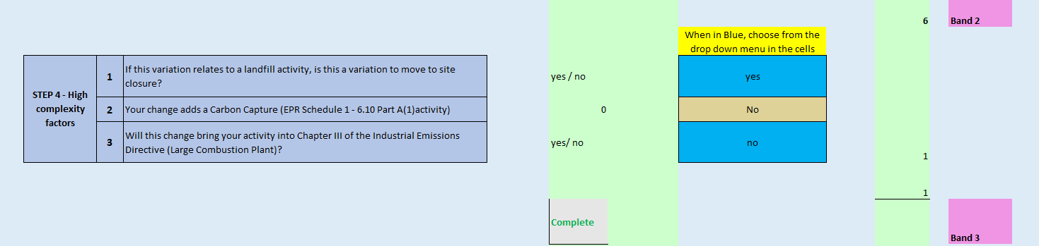

These will automatically place the application in at least Band 3.

Then the appropriate charges are added for any “Other activities” that are also affected by the variation, and “Additional assessments” before the final charge is calculated.

### Transfer applications

It is possible to apply to transfer the entire permit to a new operator, a Full Transfer, or to transfer some of the operations to a new operator, a Partial Transfer. A Partial Transfer is more time consuming as it involves separating the activities and writing a variation for the operator retaining some activities and a new permit for the operator taking on activities. This can become far more complicated if some element of shared operation remains between the two operators. Another aspect which makes a part transfer more complicated is if the operator needs to set up Financial Provision.

The charge tool first asks if it is a full transfer application,

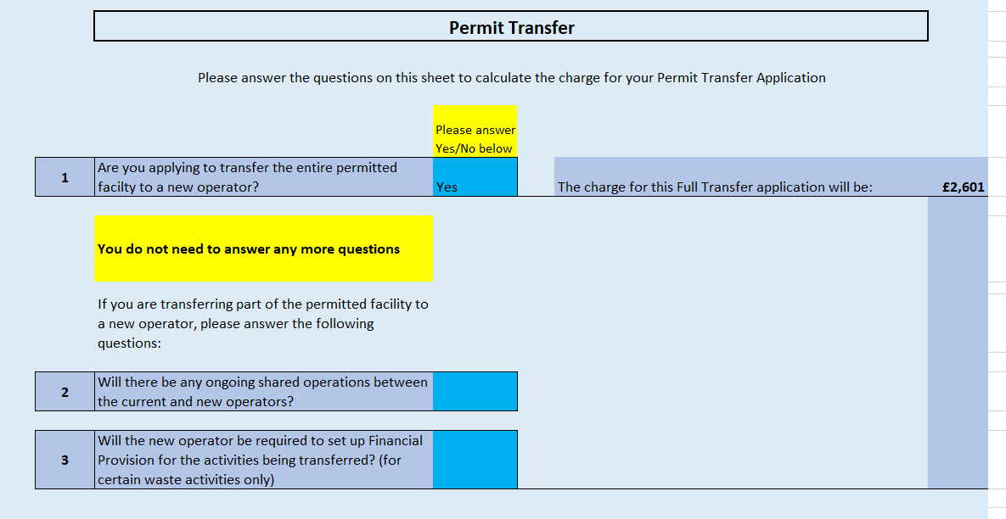

If the answer is “no”, the applicant is asked to answer two further questions which will determine which charge band the application falls into.

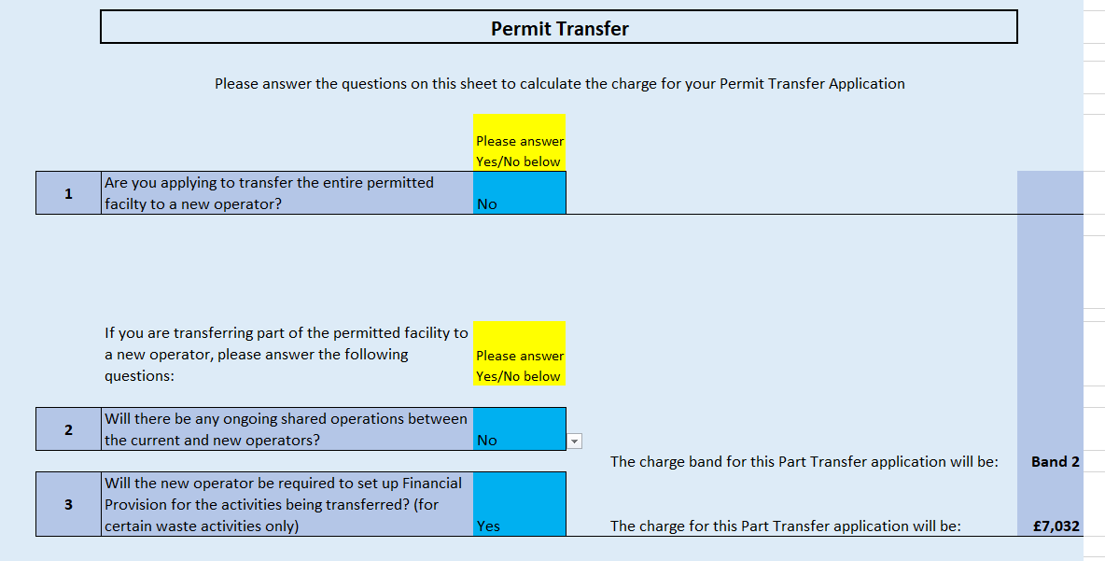

The need for financial provision will put the application into Band 2; shared operations will put it into Band 3 and answering yes to both questions will put it into Band 4.

### Surrender applications

There is an introductory page where the applicant gives details of the activities that are being surrendered.

This is followed by a series of questions about the application and the site, firstly whether it is a low risk surrender application – which must have been agreed beforehand:



Questions 2 and 3 ask about “other activities” that we charge a fixed amount for in addition to the base surrender charge.

Question 4 asks if you are applying to surrender the whole permit, or just part of the installation.



Five further questions are then asked about the condition of the site.



Answering yes to any of these questions indicates that the application will be complex to determine and it will be placed in Band 3. We are not proposing to use Bands 2 and 4 for surrenders.