English copy | Welsh copy | Image
Don't let Facebook dupe you into dumping!  This ‘Stop Facebook Fly-tippers Week’ aims to raise awareness and stop social media scammers posing as legitimate waste removers ⚠️  Beware, Facebook fly-tippers will…  🚨Pose as registered waste carriers (hold no license)  🚨Take householders’ money only to dump their waste (to save on legal disposal costs)  🚨 Put *you* at risk of a £300 fine!  This week we’ll be sharing top tips on spotting and reporting Facebook fly-tippers — so why not like and re-share our posts to help spread the message and clamp down on fly-tippers?🔍  #StopFacebookFlytippersWeek | Peidiwch â gadael i Facebook eich twyllo i mewn i dipio’n anghyfreithlon!  Nod ‘Wythnos Atal Tipwyr Anghyfreithlon Facebook’ yw codi ymwybyddiaeth ac atal twyllwyr ar y cyfryngau cymdeithasol sy’n ymddangos fel cludwyr gwastraff cyfreithlon ⚠️  Byddwch yn ofalus, bydd tipwyr anghyfreithlon ar Facebook yn…  🚨Ymddwyn fel cludwyr gwastraff cofrestredig (ond nid oes ganddynt drwydded)  🚨Cymryd arian deiliaid tai cyn dympio eu gwastraff (i arbed ar gostau gwaredu cyfreithlon)  🚨 Eich rhoi *chi* mewn perygl o gael dirwy o £300!  Yr wythnos hon, byddwn yn rhannu awgrymiadau ar adnabod a riportio tipwyr anghyfreithlon ar Facebook - felly beth am hoffi ac ailrannu ein postiadau i helpu i ledaenu'r neges ac atal tipwyr anghyfreithlon?🔍  #AtalTwyllwyrGwastraffarFacebook | 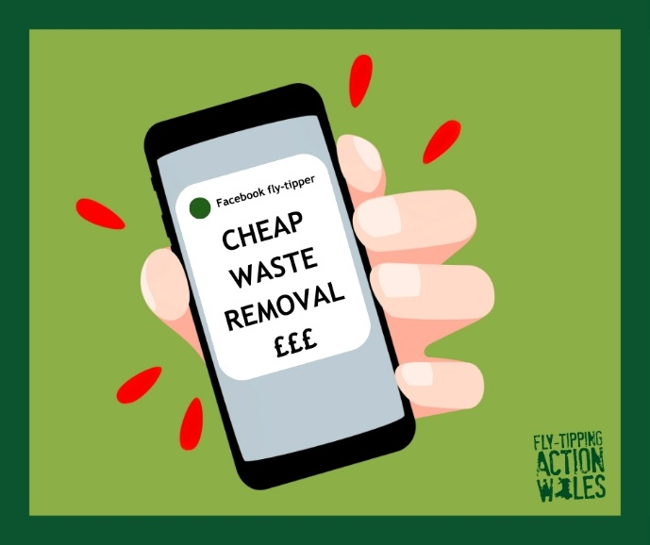
Do you know how to spot a Facebook fly-tipper? 👀  Red flags to watch out for:  Suspiciously low prices  🚩 Not sharing their waste carrier reference  🚩 Asking for cash in hand  🚩Having a suspicious or poorly built website.  Remember, if it seems too good to be true… it probably is!  #StopFacebookFlytippersWeek | Ydych chi'n gwybod sut i adnabod tipiwr anghyfreithlon ar Facebook? 👀  Pethau i gadw llygad amdanynt:  Prisiau amheus o isel  🚩 Ddim yn rhannu eu cyfeirnod fel cludwr gwastraff  🚩 Gofyn am arian parod  🚩Gwefan amheus neu wedi'i llunio’n wael.  Cofiwch, os yw'n swnio’n rhy dda i fod yn wir... mae'n debyg ei fod!  #AtalTwyllwyrGwastraffarFacebook | 
Fly-tippers are targeting people in Facebook groups! ⚠  Before paying someone to take your waste away, always check they are registered to remove waste with Natural Resources Wales.  If your items are found fly-tipped — and you didn’t check for a licence — *you* could be the one fined!  Share this post to stop your community from getting scammed.  To check if your waste remover is registered, visit ➡️ naturalresources.wales/CheckWasteLicence  #StopFacebookFlytippersWeek | Mae tipwyr anghyfreithlon yn targedu pobl mewn grwpiau Facebook! ⚠  Cyn talu rhywun i fynd â’ch gwastraff i ffwrdd, gwiriwch bob amser eu bod wedi cofrestru i gael gwared ar wastraff gyda Cyfoeth Naturiol Cymru.  Os gwelir eich eitemau wedi'u tipio'n anghyfreithlon — ac na wnaethoch wirio am drwydded — gallech *chi* gael y ddirwy!  Rhannwch y neges hon i atal eich cymuned chi rhag cael ei thwyllo.  I wirio a yw eich cludwr gwaredu gwastraff wedi’i gofrestru, ewch i ➡️ cyfoethnaturiol.cymru/gwiriwchdrwyddedgwastraff  #AtalTwyllwyrGwastraffarFacebook | 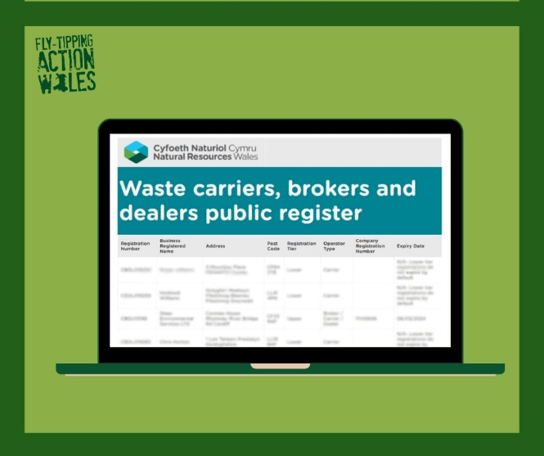
Are you looking to advertise your waste removal services on Facebook? 💻  Fly-tippers are posing as legitimate waste removers in Facebook groups — make sure you can set yourself apart from the scammers.  Let your customers know they can check your licence here ➡ naturalresources.wales/CheckWasteLicence  #StopFacebookFlytippersWeek | Ydych chi am hysbysebu eich gwasanaethau cludo gwastraff ar Facebook? 💻  Mae tipwyr anghyfreithlon yn esgus bod yn gludwyr gwastraff dilys mewn grwpiau ar Facebook - gwnewch yn glir nad ydych chi’n un ohonyn nhw.  Rhowch wybod i'ch cwsmeriaid y gallant wirio'ch trwydded yma ➡ cyfoethnaturiol.cymru/gwiriwchdrwyddedgwastraff  #AtalTwyllwyrGwastraffarFacebook | 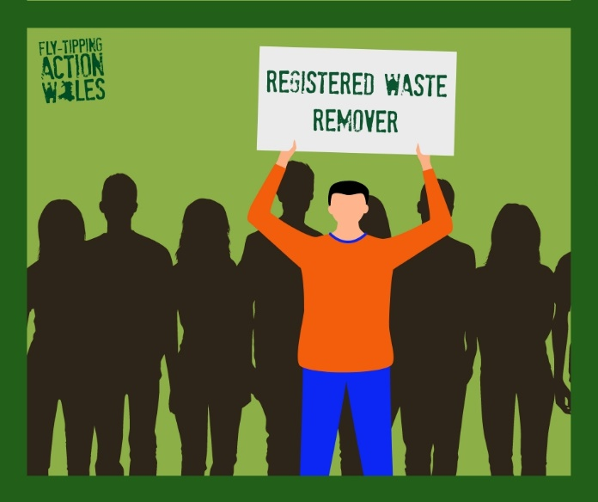
Thank you to everyone who has got involved and supported #StopFacebookFlytippersWeek!  Remember that the number of these scammers are on the rise, so always:  Stay vigilant online and report suspicious behaviour  🚨Share our tips with your family and friends  🚨ALWAYS use a registered waste remover  Together we can protect Wales from fly-tipping |  | 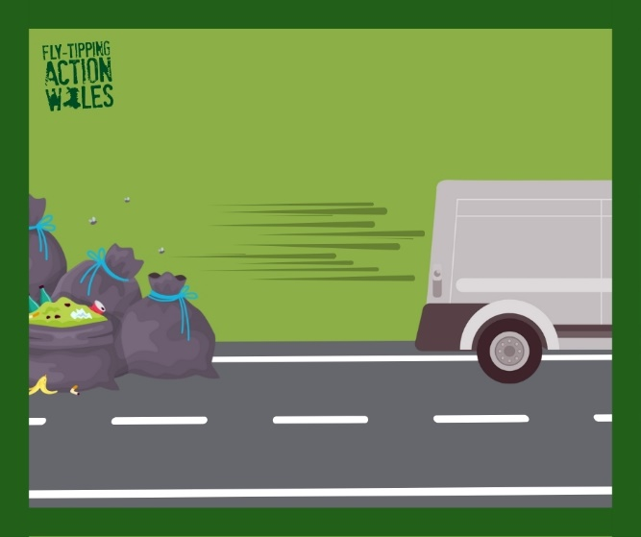

ENDS

