Bethesda and Abergwyngregyn Forest Resource Plan Public Consultation

This document will outline the consultation phase for the Bethesda and Abergwyngregyn Forest Resource plan (FRP), and the responses that have been received from the public, it will then go on to demonstrate the changes that will be implemented as a response to the feedback that was received.

Firstly, the FRP covers the three distinct forest areas of Parc Y Bwlch, Braichmelyn and Abergwyngregyn. Map 1. below shows these woodland areas.

Initial public consultation was started on the 3rd of May 2021 and the online part of the consultation which this document will be focused on ran until the 14th of June 2021.

Due to covid-19 regulations initial public meets weren’t permitted and a consultation hub was created: Bethesda and Abergwyngregyn Forest Resource Plan - Natural Resources Wales Citizen Space - Citizen Space (cyfoethnaturiol.cymru) This aloud the public to view the plans with the draft maps and proposed objectives, and to leave comments which would be view anonymously.

Letters were sent out to adjoining landowners and posters placed at main entrances and public rights of way through the woodlands.

Emails with the links were also sent to local community councillors and external statutory consultees.

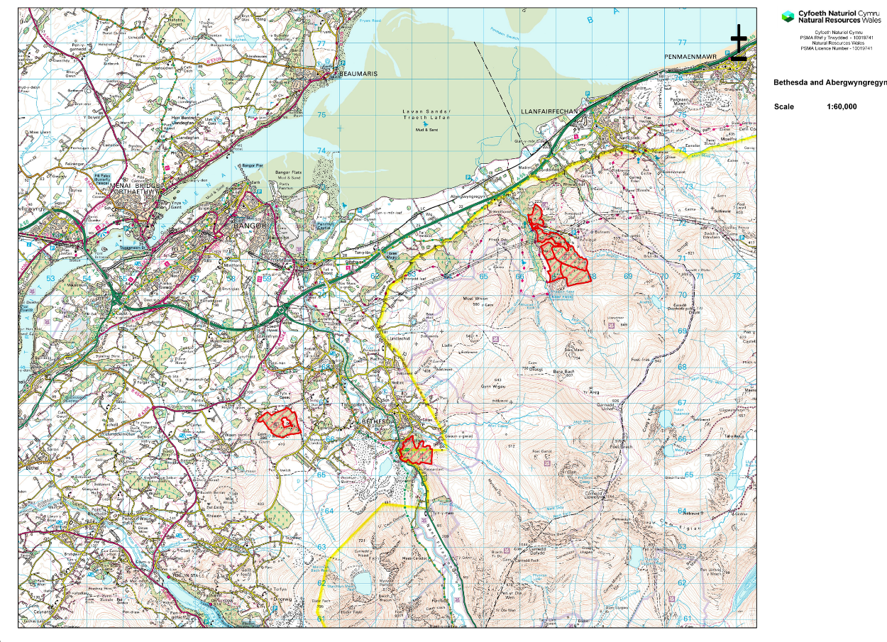

Map 1. Area Map
Results from the consultation

These results below include all the results that were receive through the consultation hub and via emails from the public that where sent directly to NRW staff or the FRP email.

In total we had 75 responses from the public, this is the largest response to a consultation to date for a FRP, and it has shown the great importance these small woodlands have and the value to the local people. 66 of these responses came through consultation hub, of which 64 in English and 2 in Welsh, a further 9 emails were received from the general public, and where possible have been added into the results.

Location

Firstly the location from where the responses have come from, in a couple of situations a generic response was given such as (Wales) or no response was given this has been recorded as other, in some cases multi locations were given and the first of these was taken.

Locations
Braichmelyn | 2
Tregarth | 7
Mynydd Llandygai | 14
Bethesda | 4
Bryn Geraint | 1
Arfon | 1
Llanberis | 5
Deiniolen | 3
Rhiwlas | 4
Gerlan | 2
Abergwyngregyn | 1
Denbigh | 1
Conwy | 2
Caernarfon | 1
Menai Bridge | 1
Y Felinheli | 1
Bangor | 3
Caerhun | 1
Gallt y foel | 1
Llanrug | 1
Buckley | 1
Llanelli | 1
Waunfawr | 2
Llanfairfechan | 1
Mochdre | 1
Pentir | 7
Braich Talog | 1
Rachub | 1
Other (Generalised area or not stated) | 4
Total | 75

From the Table above it is clear to see there is a great deal of local interest but also the distance some people may travel to visit the woodland. From assuming that the public would be more interested in the closest woodland, it would appear that most of the comments have been bought up in relation to Parc y Bwlch and Braichmelyn, and less around Abergwyngregyn, however this may not be true in all cases.

How often people are visiting?

Not all of the comments included this detail, and the responses have been categorised into the table below.

How often to you visit?
Daily | 23
Weekly | 22
Every other week | 8
Once a month | 5
Other | 8

The table shows the usage that people have with the forest, comments under other included were the public visited less than once a month, or in some cases a qualitative comment such as “as often as possible” or “occasionally” was used.

From this most of the responses have come from people who visit the forest on a daily basis, showing the huge amount of use from the public these woodlands get.

What activities are people undertaking?

When viewing the comments under this section, where multiple activities have been mentioned each individual activity has been added. For example, if a comment read “I use the woodland for walking and running” both have been added.

Activities
Dog Walking | 14
Running | 17
Watching Wildlife | 4
Commuting | 2
Horse riding | 4
Mountain Biking | 37
Enjoy Nature | 13
Play area for Children | 2
Health Reasons | 4
Education | 1
Photography | 1
Walking | 33
Biking | 7
Relaxation | 2
Social | 3

The table above Shows that mountain biking, Walking and Running were the most popular activities, where no specification on mountain biking was stated this was added as Biking, and where no activities were stated but a comment such as “meeting friends” was added this has been included as Social. Health reason were included under comments other than for physical health, such as mental health and wellbeing.

The graph below shows the same table in a different format, the recreational value of these woodlands is clear from this information and will be providing a huge amount of health and well being to the local community.

Primary concerns

The following section will highlight the main areas of concerns that have been highlighted from the consultation. Where multiple comments have been stated they have been included in all the areas. In some cases, no specific comments were made.

Many of the comments included great detail, for the purposes of this document the primary concerns have been condensed into the categories that are within the table below.

Concerns | Numbers
Mountain biking (damage to trails from felling) | 38
Size of clearfelling | 15
Red Squirrel conservation | 9
Concerns over future recreational benefits | 7
Damage to Trails | 5
Impact on Biodiversity | 5
Flood risk and water management | 4
General Amenity Value of Parc Y Bwlch | 3
Impact on nature | 3
Landscape impact | 3
Traffic and haulage | 2
Windblow | 2
Not clearing conifers on the lower slopes of Braichmelyn | 1
Horse riding trail damage. | 1
Larch removal | 1
Contractors bringing in Phytophthora | 1
Dislike of commercial forestry plantations | 1
Buzzards in BM | 1
Regeneration of conifers | 1
Overnight camping | 1
Grey Squirrel management | 1
Protection of stone walls | 1
Regulation of Mountain biking | 1
Unmanaged diseased trees | 1
No regular maintenance | 1

As can be seen from the table above, the primary concerns from the public are damage to recreational benefits the predominant issue being the damage to mountain bike trails, but also damage to walking, horse riding and general damage of recreational benefits.

The next concern was around the size of the clearfelling, this in turn is linked to several other comments around the impact this would have on the landscape, wildlife, flood and water management and many other areas.

Further Consultation

Following the feedback presented to us from the public online consultation three days of public information drop in sessions where organised. These were organised to fit the Covid -19 regulations at the time and allowed NRW to meet groups of up to 30 during each time slot. The times that were made available were the following.

Parc Y Bwlch – 30.6.21. 1-2pm, 230-330pm, 4-5pm and 530-630pm.

Braichmelyn – 1.7.21. 1-430pm and 530-8pm

Abergwyngregyn – 2.7.21. 1-430pm and 530-8pm

These sessions were advertised via social media, posters at locations around each of the forests and within some local shops and shared via local councillors.

Again, Parc Y Bwlch had the most interest and in total 20 people attended the meeting at Parc Y Bwlch through the day.

Some of the main topics were around water management, mostly from the residents of Pentir, who live on the lower slopes of the woodland, information around the water management plan of each coupe was discussed and any additional problems or questions would be dealt with via land management. Similar discussions were also had around the water management of the Llandygai side and further information around the flooding incident in August 2020 was passed on.

Again water management will be dealt with at a coupe level.

Further concern was also bought up over haulage, unfortunately the only route for the timber to come out is via the Llon Y Grug but a more detailed assessment will be made at coupe level regarding the extraction of timber.

Further discussion over tree stability and Low impact silvicultural systems management, pathogens specifically phytophthora, mountain biking, recreational access and amenities were all discussed within the groups.

One of the key discussion points was around communication, its important for NRW to acknowledge that these woodlands are often thought of as belonging to the community, and once this consultation process has ended dialogue between NRW and the local public needs to continue in the gaps between the FRP plans, talks between NRWs land management teams and groups such as Llais Y Goedwig and Ogwen Partnership needs to continue to improve future relationships, NRW North West Forest Operations has also acknowledged the importance of these public consultations and has decided to run one day of on site consultation each year to inform the public on upcoming operations but also to listen to the publics concerns, around the site.

The whole consultation process has highlighted the importance of both Parc y Bwlch and Braichmelyn to local health and well being through the local amenities that it provides. As much as possible operations will aim to limit disturbance to public rights of way, however for works close to paths some closures will be needed for public safety.

The onsite information visits at Braichmelyn were less popular originally 5 members of the public booked on however only 1 attended on the day, an in depth conversations of NRW policy and management was discussed. However, they were keen to mention the impact of access to the public for the site, such as cambered pathways and heavy gates limiting local usage, also the impact of the landscape from Gerlan.

Only 1 person showed an interest in Abergwyngregyn, this was dealt with by Land Management as a separate issue as it didn’t fall into the FRP areas.

What will NRW change?

The following section will highlight the areas of change NRW and the planning team have made due to the suggestions made via the consultation.

Areas in red within the objectives are areas of change.

Objectives

Woodland (Visions for each woodland block)

Abergwyngregyn
- Abergwyngregyn forest blocks will become less of a priority for productive conifer timber and has already started to move towards a predominately broadleaf forest that will enhance the existing broadleaves in the area, improve landscape stability and also bring wellbeing, biodiversity, carbon sequestration and retain existing recreational benefits.

- Mixtures of conifer and broadleaf will be expected and tolerated through natural regeneration; however, the conifer element will be targeted at each thinning intervention to favour the broadleaves.

- Consideration of native productive broadleaves within the site will be given. Ideally local providence seed will be sourced and grown on at local nurseries for use.

Braichmelyn
- Braichmelyn will become less priority for productive conifer timber and will slowly move towards a broadleaf forest that will create a greater stability to the landscape and also bring wellbeing, biodiversity, carbon sequestration and retain existing recreational benefits.

- The forest will be allowed to regenerate after coupe felling with a mixture of conifer and broadleaf. Early enrichment in subsequent years after felling may be necessary to achieve recommended stocking densities, recommended species will be Scots Pine, Hazel and Norway Spruce on the lower slopes.

- During the next review of the FRP the Yellow clearfell coupe will be split to retain areas of Lodgepole pine to reduce the size of the clearfell and to retain a strong element of pine that will add age and diversity to the upper slopes, and provide local seed source for the area.

- Tree species that are currently susceptible to severe pathogen attack will need to be felled for the health of the forest and safety of its users. Larch will no longer be used as a component of the forest species.

Parc y Bwlch

- Parc y Bwlch will continue to produce a sustainable supply of timber production through design of felling coupes and choice of restock species to allow productivity through continuous cover forestry (CCF) in future rotations.

- Due to similar aged components within Parc y Bwlch, much of the crop is now approaching biological maturity and areas of clearfell are going to be needed to prevent extensive wind blow.

- A development of native woodland buffer along the upper side of Parc y Bwlch adjacent to Moel y Ci to minimise natural regeneration of Conifer seedlings that may affect features of the adjacent Eryri SAC.

- Opportunities will be taken to soften the coupe edges after felling operations by allowing, regeneration or if needed by enrichment, of broadleaf species for consideration of neighbouring properties. This will also further improve the water management of future rotations.

- Tree species that are currently susceptible to severe pathogen attack will need to be felled for the health of the forest and safety of its users. Larch will no longer be used as a component of the forest species.

- The preferred timber sales option would be Direct production, this would allow local interests, the opportunity to purchase parcels of roadside timber.

General

- In all woodland blocks ensure thinning is done on time will improve the silvicultural management of the forest.

- Consideration to providing a more diverse species and age range to improve resilience where possible.

- Diversify the forest species composition to increase resilience to pests and diseases whilst building a robust forest for future generations.

Ancient Woodland and Biodiversity

- Improve habitat connectivity by maintaining and enhancing areas of ancient semi-natural woodland and restoring plantations on ancient woodland sites, in line with strategic prioritisation policy.

- Thinning of Ancient woodland sites is essential for the maintenance and follows sound silvicultural guidelines.

- Where the main crop of conifer has been harvested, facilitation of native woodland expansion. Restocking of these areas is a key priority to ensure that there is no net loss of forest cover.

Water

- Development of Riparian corridors will improve the connectivity of the forests to create linkages with other habitats and help to minimise the impact of sediment run off from forestry operations.

- Maintenance of culverts and roadside drainage systems to meet current FRM and industry best practice.

Recreation

- Maintain and consider additional recreational benefits and minimise where possible disruption to current recreational areas.

Culture and Heritage

- Identify heritage and cultural features to avoid damage, particularly around identified hotspot areas.

- Improvement of communication between NRW and the local public and groups will be improved through groups such as Llais Y Goedwig and Ogwen Partnership.

Maps

From the feedback we receive we felt that the plans for both Abergwyngregyn and Braichmelyn would remain the same however with some changes to the wording especially around re stocking, and communication.

Parc Y Bwlch as stated above bought up many issues, one of the main ones that can be dealt with around changes to the maps was the size of clearfell areas. From the map below we can see where we have made some significant changes to our plan based of the feedback from the public.
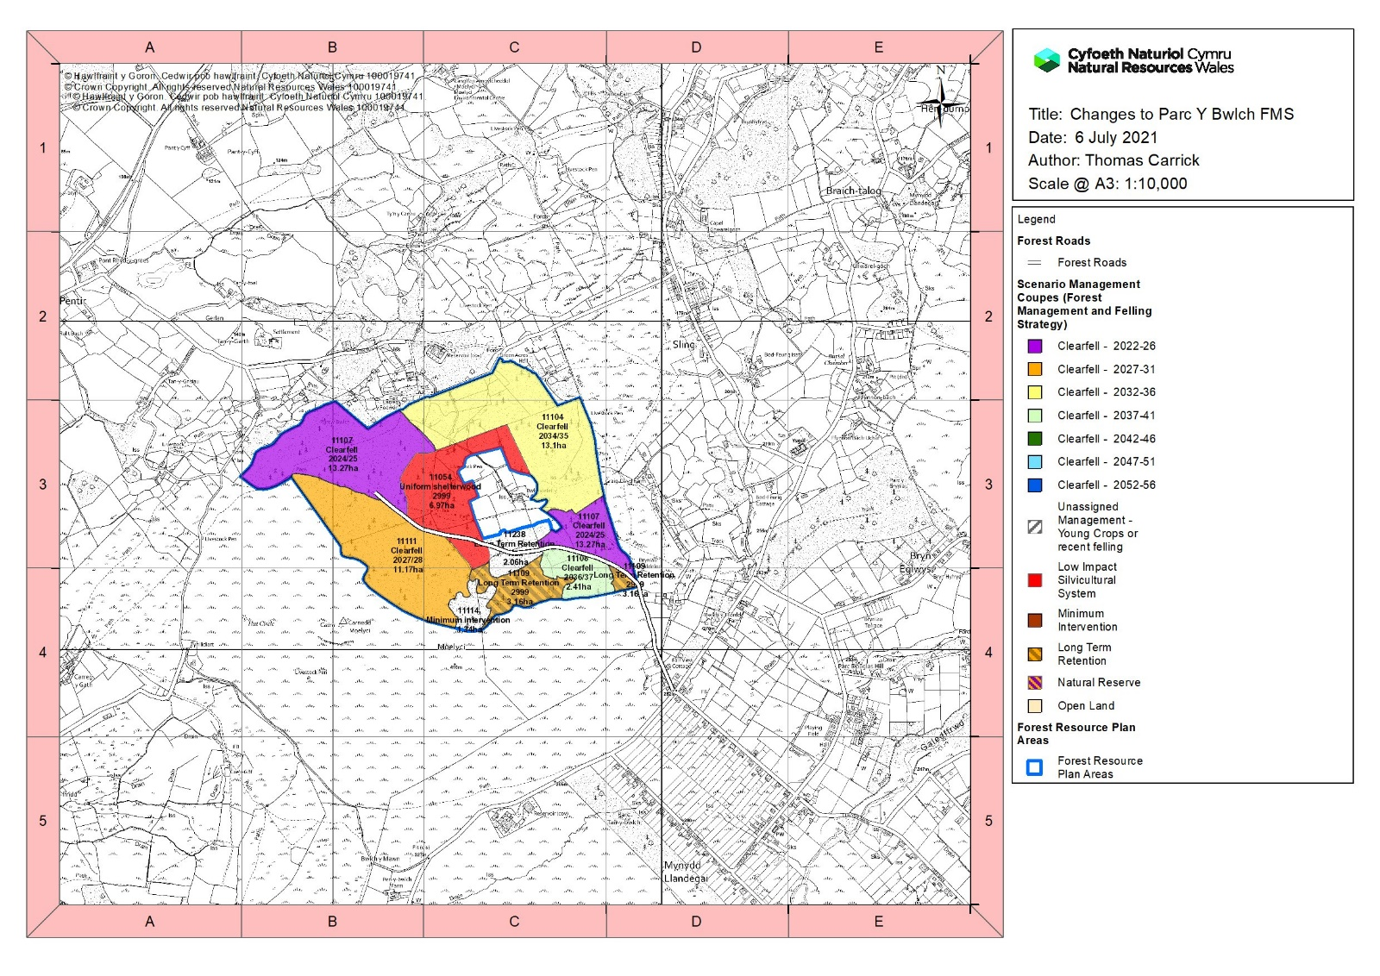
This area of Sitka has been identified as the most stable and will be retained, with a possibility of light thinning.
Mature Lodgepole pine is naturally thinning with a good understorey developing will help keep a mature element to the forest.
Area of windblow will be left with minimal management natural regen is already developing here. This will help to build age and species diversity.
Large purple coupe has been split, 11Ha has been moved back to the orange period to reduce impact on the landscape.
Larch and windblown element will be the priority area to be dealt with first.
Yellow coupe, will be reviewed during the next FRP review in 10 years.

From the map above the planning team has looked at balancing the comments made from the public consultations along with the silvicultural management of the forest, to create this new forest management systems map.

The Indicative forest types map below highlights the changes made in-terms of how the forest might look in 25 years times and with what will be restocked.
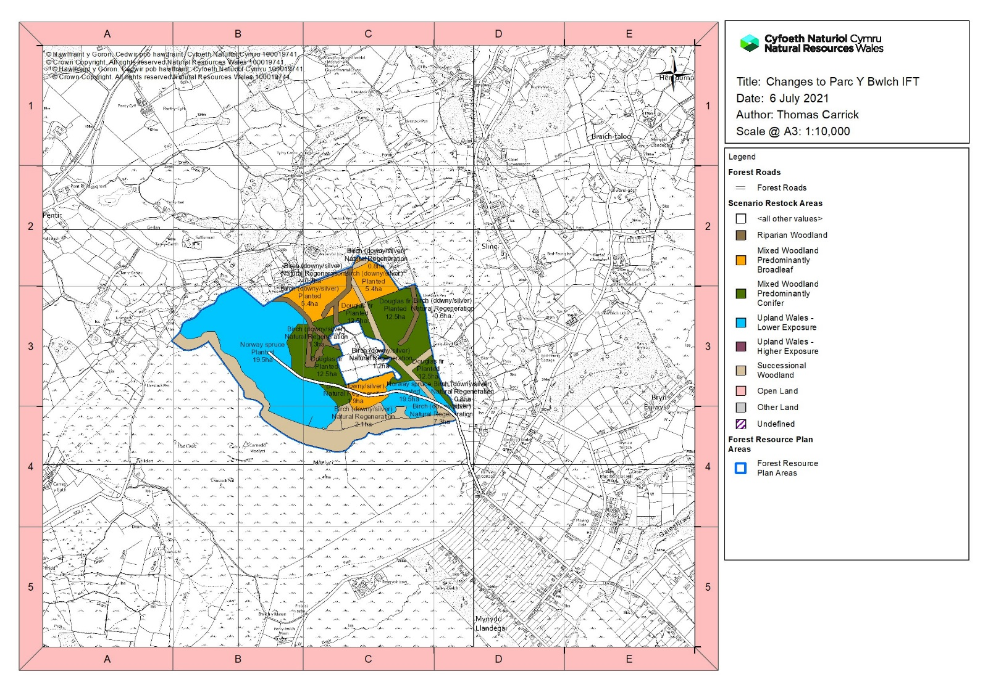
Greater detail of the location of buffers for power lines.
The lower slopes will be managed for broadleaf this will help with future water management and to increase diversity within the woodland, this area also has a complex system of old sheepfolds and historic walls which would be better suited around non-productive management.
Larger areas will rely on natural processes for restocking.

End of Consultation

We would like to thank everyone involved with the consultation, the information provided has helped us produce a plan that is balanced and realistic for forestry operations. As you have seen above we have had a huge amount of interest with this plan and it shows how important these local forests are to the local community.

