SECOND ISSUE
Cardigan Flood Consequence Assessment
Technical Note

Project no. 4081883
Prepared for:
Natural Resources Wales

March 2026

Table of contents

1. Introduction 3
1.1 Background 3
2. Site Location and Existing Conditions 4
2.1 Location 4
2.2 Catchment 5
2.3 Existing Flood Risk 5
2.4 Historic Flooding 7
3. Cardigan Tidal Flood Risk Management Scheme 12
3.1 Proposed development 12
3.2 Vulnerability 13
3.3 Justification 14
4. Flood Consequence Assessment 15
4.1 Introduction 15
4.2 Flood Extents 15
4.3 Flood Levels 17
4.4 Flood Velocity 24
5. Summary 27

Details of document preparation and issue:
Version no. | Prepared | Checked | Reviewed | Approved | Issue date | Issue status
P01 | Holly Garbett | Jawaz Illathukandi | Tim Paddison |  |  | First Issue
P02 | Holly Garbett | Jawaz Illathukandi | Tim Paddison | A. Humphreys | 24/03/2026 | Second Issue

Project no. 4081883 |  | Client’s reference no.
File name: | 4021883-BUK-ZZ-00-RP-HY-00002.docx

Notice:
This report was prepared by Binnies UK Limited (BUKL) solely for use by Natural Resources Wales. This report is not addressed to and may not be relied upon by any person or entity other than Natural Resources Wales for any purpose without the prior written permission of BUKL. BUKL, its directors, employees and affiliated companies accept no responsibility or liability for reliance upon or use of this report (whether or not permitted) other than by Natural Resources Wales for the purposes for which it was originally commissioned and prepared.
In producing this report, BUKL has relied upon information provided by others. The completeness or accuracy of this information is not guaranteed by BUKL.

Introduction

Background
This Flood Consequence Assessment (FCA) has been prepared for Natural Resources Wales (NRW) to support proposed Cardigan Tidal Flood Risk Management Scheme (FRMS). The FCA evaluates flood risk to and from the development from all relevant sources of flooding and assesses the acceptability of flood consequences in line with Welsh Government Technical Advice Note 15: Development and Flood Risk (TAN15)
The FCA has been prepared to demonstrate, so far as is reasonably practicable, that the proposed scheme is acceptable under the criteria laid out in TAN15. The report will do this by identifying and assessing flood risk from all relevant sources (fluvial, tidal, surface water, flood risk from reservoirs and groundwater) and will assess the impacts of the proposed development on flood risk, including both on-site and off-site impacts.
The structure of report is as follows:
- Section 2 focuses on the existing flood risk to Cardigan from all sources of flooding.
- Section 3 provides details on the proposed development and justification for the preferred flood risk management scheme.
- Section 4 examines the flood consequences from the proposed development. As the proposed development is a flood risk management scheme, there is no consequence of flooding to the development itself, so the focus of this report is flood consequences for existing development in Cardigan.
- A summary is provided in Section 5.

Site Location and Existing Conditions

Location
Cardigan, located in Ceredigion, is situated on the estuary of the Afon Teifi. The Afon Teifi flows from east to west past the site, and flows into Cardigan Bay, approximately 5km downstream of the site.
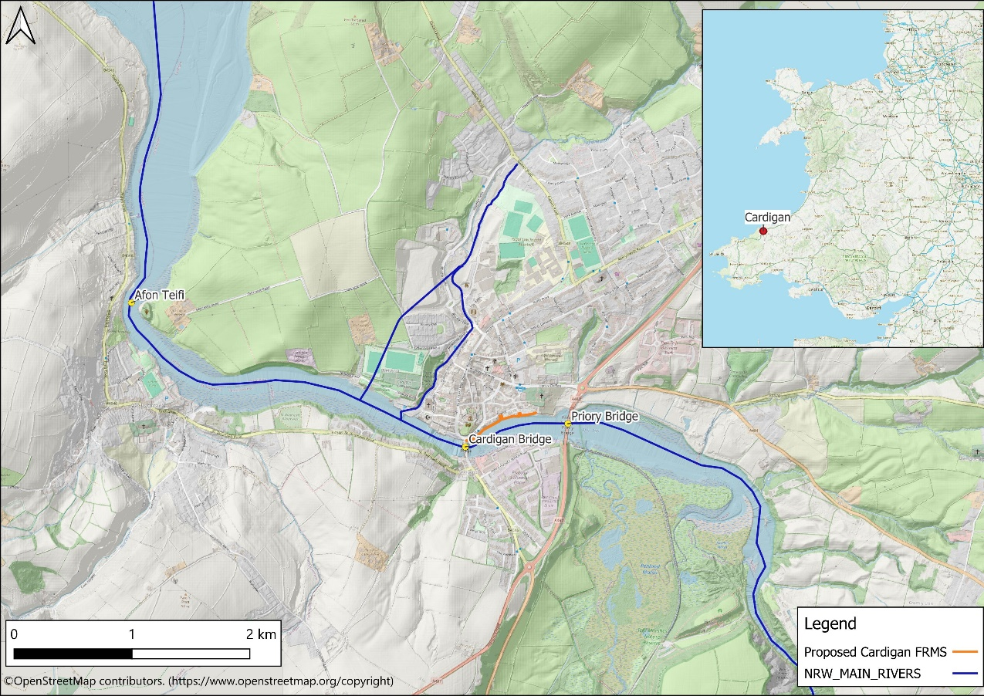
Figure 2-1: Location plan
Using information from the NRW National Flood Asset Database, it is identified that the main river, the Afon Mwldan, flows southward through Cardigan. North of the town, a culvert diverts part of the river’s flow, conveying water to the west of the urban area before it discharges into the Afon Teifi. The remaining flow continues south through Cardigan and outfalls at the Quay Street car park (see Figure 2-2). This section of the watercourse is lined with a flood wall, maintained by Ceredigion County Council, which provides protection to the town against fluvial flooding.
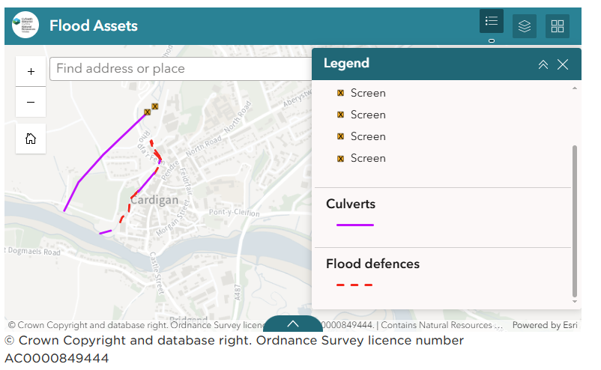
Figure 2-2: NRW Flood Asset database

Catchment
Across the Afon Teifi catchment topography elevation ranges from ~590m OD down to sea level. The site of the proposed development occupies one of the lowest parts of the catchment, located adjacent to the estuary. Geologically, the Afon Teifi catchment is entirely underlain by mudstones, siltstone and sandstone.
The hydrogeology classification follows the underlying geology with Cardigan entirely categorised as “low productive aquifer”, which reflects the moderate permeability of the underlying geology in this area. The land-use of the catchment, where not an urban area, is “improved grassland”. Soil classification of Cardigan is noted as ‘slowly permeable, seasonally wet acid loamy and clayey soils.

Existing Flood Risk
Several significant flood events have occurred in Cardigan between 2000 and 2020. The lowest lying residential and commercial properties in the Strand area have a threshold level below 3.1m AOD and is potentially impacted most years. The 0.5% Annual Exceedance Probability (AEP) still water tidal level on the open coast at the mouth of the estuary, including 100 years of climate change, is estimated at 4.61m AOD, which is well above the existing ground levels at several locations, and the lowest properties are vulnerable to significant depths of flooding.
Flooding from all sources is examined in further detail in the following sections.

Tidal
Tidal flooding represents one of the most significant sources of flood risk in Cardigan. The online NRW long term flood risk flood map includes flood extents for tidal flood risk. Tidal flood risk is shown in Figure 2-3. This shows that the lower quayside is an area of ‘high’ risk, which has a 3.3% AEP or greater risk of flooding. This area is inundated by the tide, which affects the lower Strand and the Cattle Market areas. Low-lying residential and commercial properties are affected by a tidal event that can be expected to occur every year.

Fluvial

Figure 2-4 shows the fluvial flood risk in Cardigan. The figure shows that there is a ‘high’ risk of flooding on the north bank of the Afon Teifi at the Strand, although this does not extend nearly as far north as the ‘high’ risk area from tidal flooding. There is also ‘high’ risk of flooding upstream of Priory bridge, to the south of the A484.

Surface water
The online NRW flood map includes flood extents for surface water flooding. A screenshot of the flood map is shown in Figure 2-5. This shows:
- Most of the site town is at ‘very low’ risk, which has less than 0.1% AEP risk of flooding.
- Surface water risk is dispersed across the urban area, with clusters around topographic low points, road junctions, and areas with impermeable surfaces.
- Noticeable flow paths are visible running from higher ground north‑east of the town centre down towards the river. There is one large area of ‘high’ risk, which is located around the A487/A484 roundabout.

Groundwater
There are no reports of groundwater flooding, and the underlying geology suggests that the risk of groundwater flooding in Cardigan is low.

Reservoirs and canal flooding
Reservoir flood maps show where water may go in the unlikely event of a dam or reservoir failure. Flooding from reservoirs is unlikely in this area .
There are no canals in the area to present a flood risk from canal failure.

Flood Zones
Figure 2-6 identifies the spatial extent of flood zones associated with both fluvial and coastal flooding. This indicates that the entire study area (the area being protected by the proposed flood defence wall) is currently classified as Flood Zone 3 (FZ3). There is also a large area on the south bank that is within FZ3. FZ3 is defined as:
- Rivers: areas with more than 1% (1 in 100) chance of flooding from rivers in a given year, including the effects of climate change.
- Sea: areas with more than 0.5% (1 in 200) chance of flooding from the sea in a given year, including the effects of climate change.

Historic Flooding
Several significant flood events have been reported in Cardigan between 2000 and 2020, with many accounts documented in local newspaper articles. However, no corresponding official flood incident records for these events are available on the NRW flood history database and therefore no anecdotal flood outlines are available to compare.

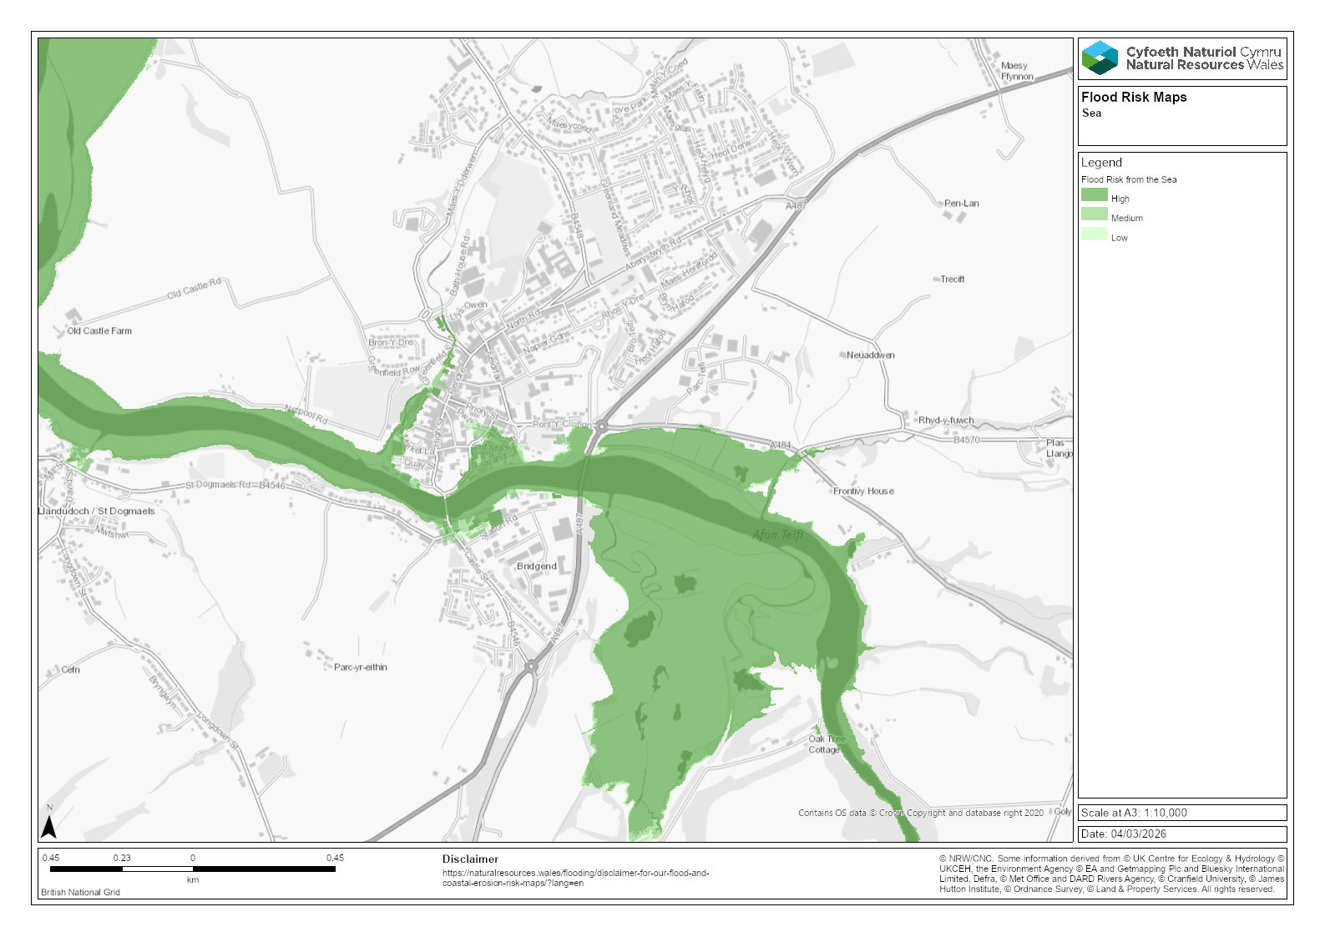
Figure 2-3: Flood risk from the Sea (from NRW flood risk map)
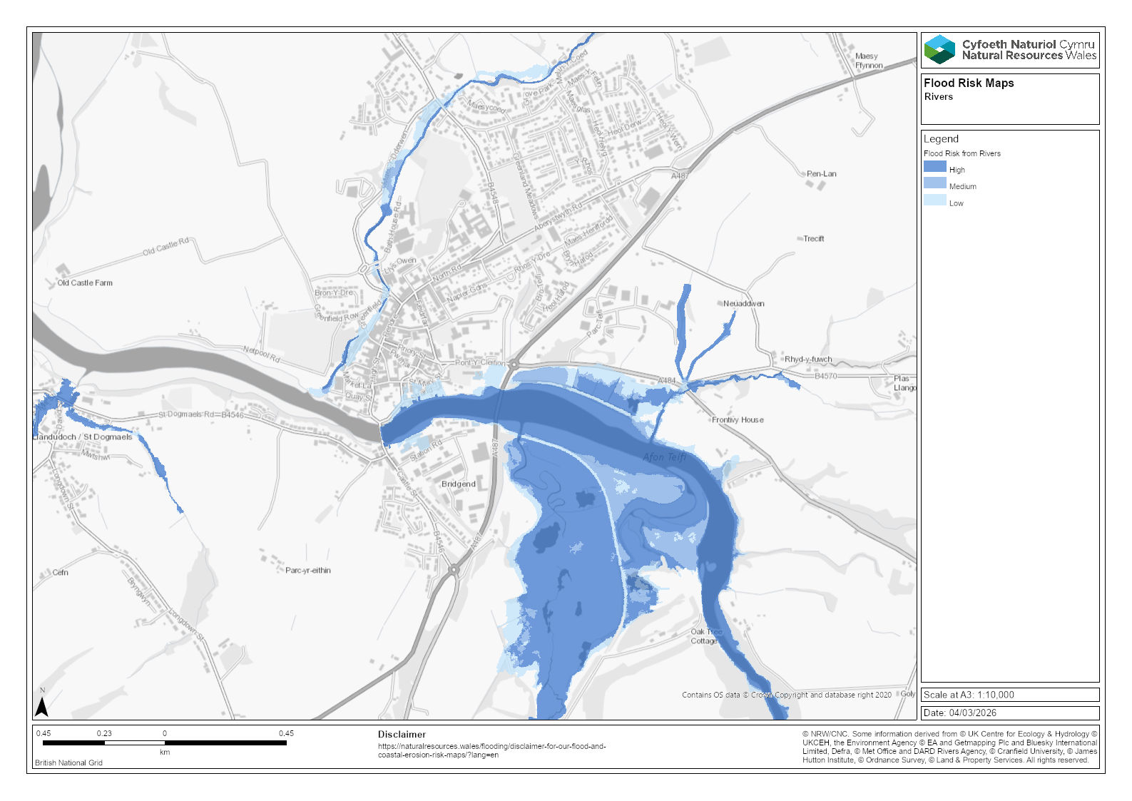
Figure 2-4: Flood risk from Rivers (from NRW flood risk map)
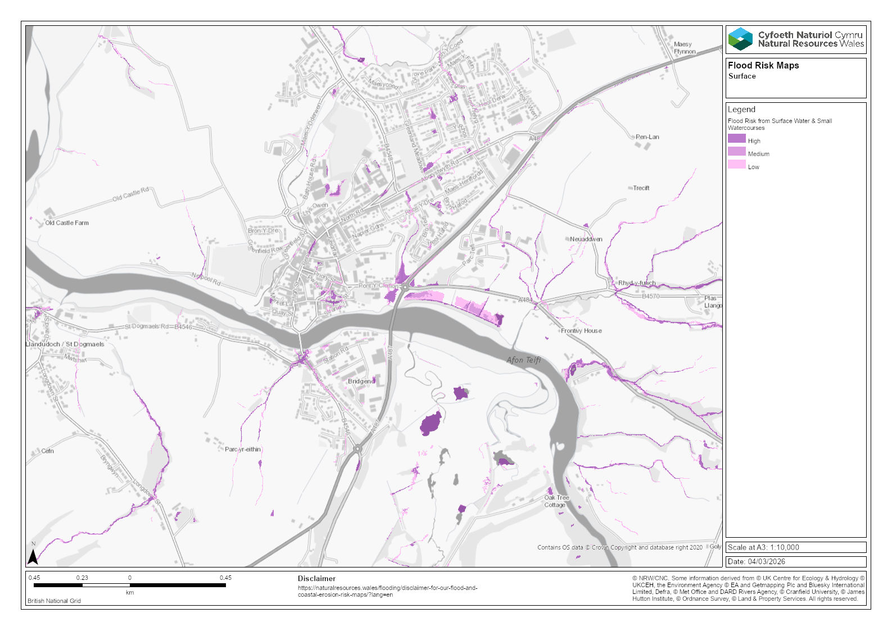
Figure 2-5: Flood risk from Surface Water (from NRW flood risk map)
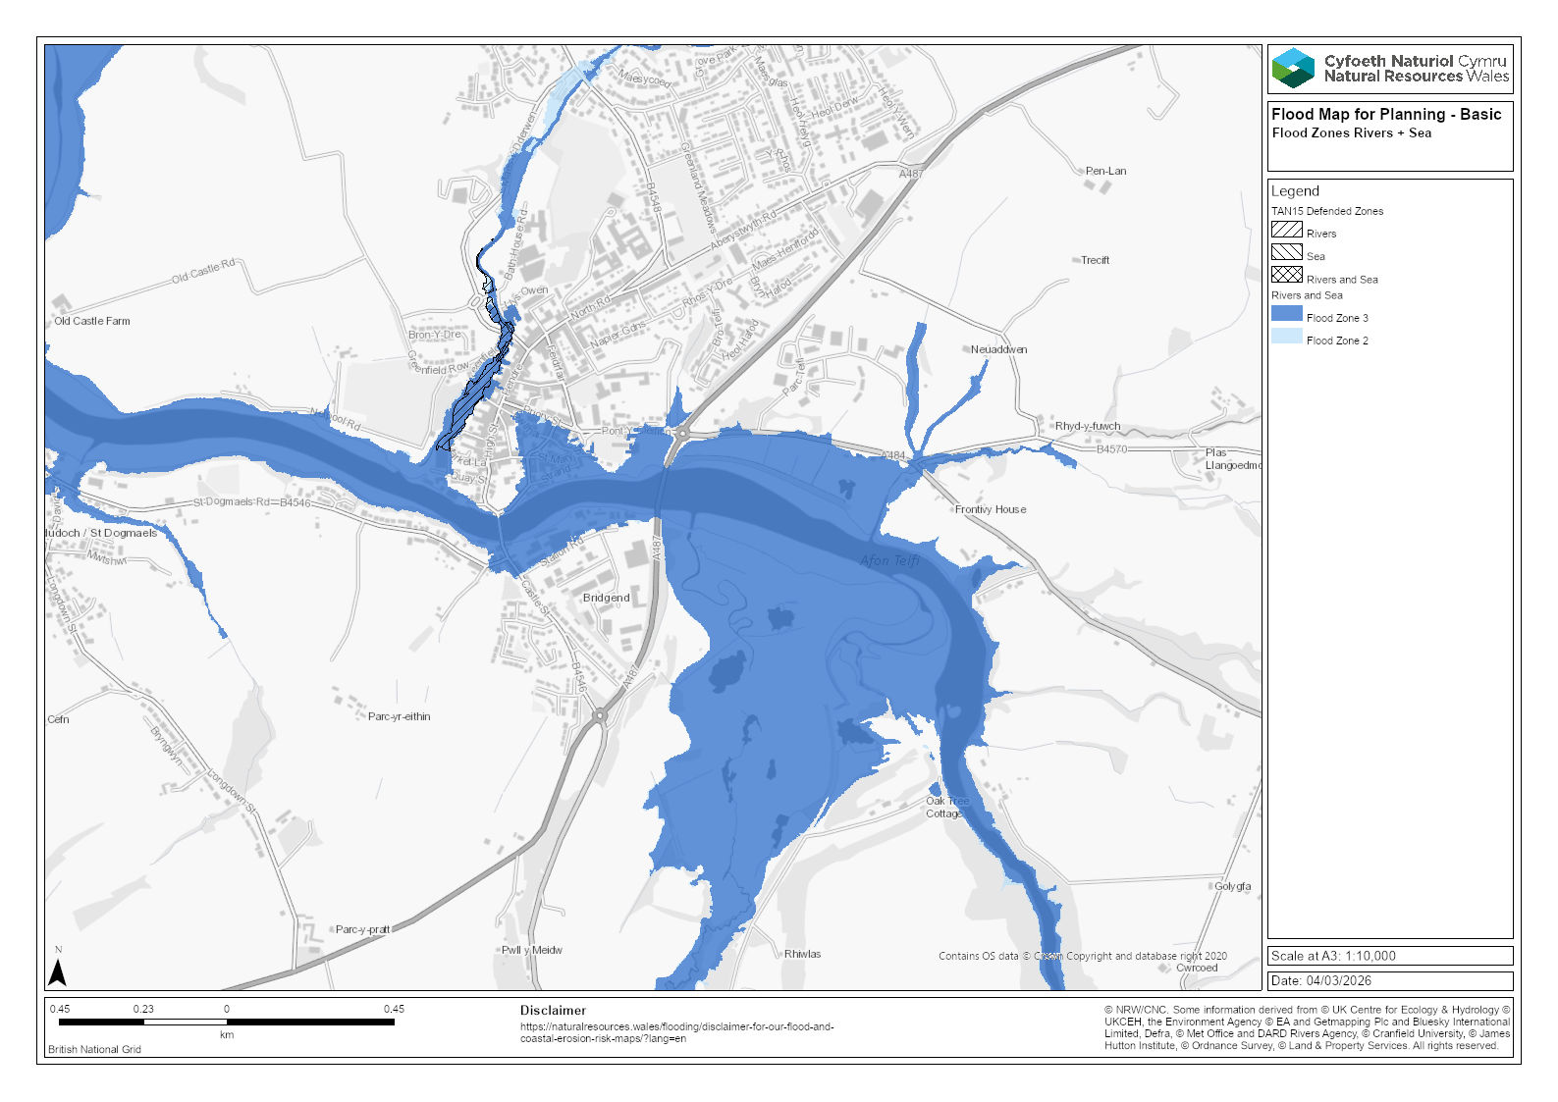
Figure 2-6: Flood Zones from Rivers and Sea (from NRW Flood Map for Planning map)

Cardigan Tidal Flood Risk Management Scheme

Proposed development
The FRMS is in the town centre of Cardigan, on the northern shore of the Afon Teifi. The flood defences are designed to suit the varying constraints along the Afon Teifi frontage between Cardigan Bridge to the west and Gloster Row car park in the east and is approximately 320m in length (refer to Figure 3-1 below). The design flood defence level is 4.95mAOD, which results in wall heights varying between 1.1 to approximately 2m. The defence is designed to provide a standard of protection up to the 0.5% AEP tidal event with 100 years of climate change and includes Residual Uncertainty Allowance (RUA).
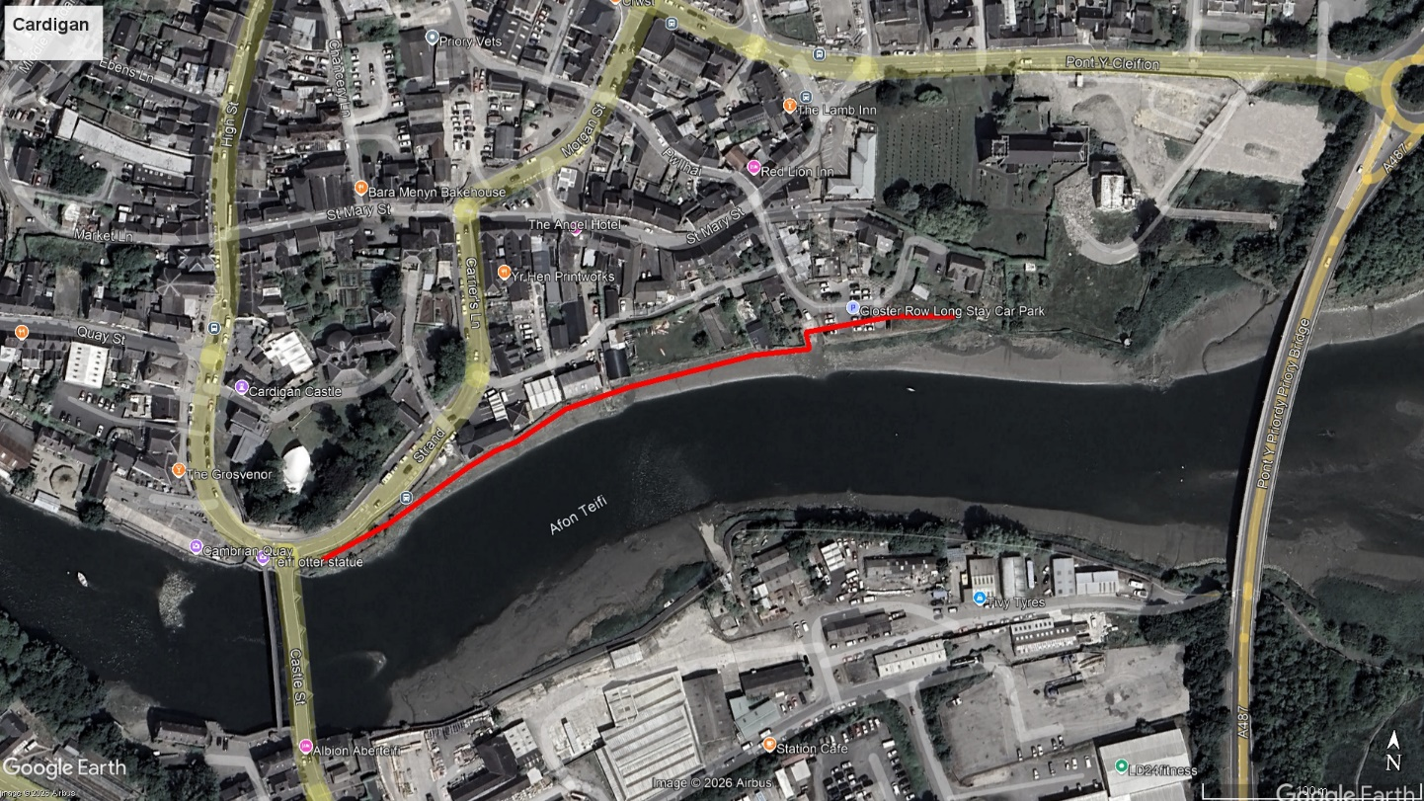
Figure 3-1: Aerial photograph of Cardigan showing indicative alignment of the flood defence
The alignment of the wall changes along the design to:
- avoid loading existing masonry walls,
- maintain access,
- minimise intertidal habitat loss,
- avoid private property impact,
- tie into natural high ground at both ends.

The four scheme areas are shown within Figure 3-2. Further detail can be found in the Detailed Design Report.

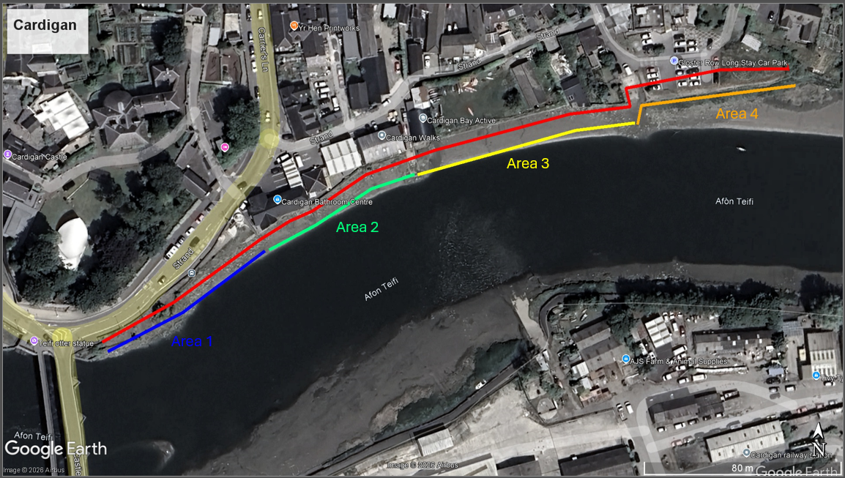
Figure 3-2: The four scheme areas, indicated on aerial photograph of Cardigan.
The proposed flood wall combines reinforced concrete and sheet-pile construction to suit varying ground conditions along the alignment. A reinforced concrete section is used for approximately 30m in Area 1 (shown in blue in Figure 3-2) where piling is constrained by heritage structures and obstructions and will provide a strong tie-into Cardigan Bridge without disturbing the existing river wall.

In Areas 2–4, PU18 sheet piles form the main wall, delivering both structural flood defence and a seepage cut-off by extending to at least –0.5 m AOD into natural deposits beneath permeable made ground. An engineered embankment on the river side enhances stability, reduces bending and embedment demands, and offers scour protection.

Both wall types will be finished with ~100 mm masonry stone cladding, tied back to the structural wall, and topped with a concrete coping to match local heritage character. Sheet piles and RC walls have a 100-year design life.

Vulnerability
The proposed construction is a linear flood defence scheme, consisting of:
- A flood defence wall (reinforced concrete + sheet piles),
- Associated earth embankments,
- Drainage infrastructure and outfall modifications,
- Habitat creation / mitigation works,
- Public realm upgrades (Area 1),
- River access modifications (boat ramp, slipway closures).
This is classed as “Infrastructure – Flood and Coastal Erosion Risk Management (FCERM) Asset”.
The development is not residential, commercial or highly vulnerable development, but a flood risk management structure. Under TAN15, flood alleviation works are generally treated as Less Vulnerable Development, because:
- They do not introduce new people into the flood risk zone.
- They reduce flood risk to existing development.
- They are considered essential infrastructure in flood risk areas.
- Is designed to manage tidal and fluvial flood risk, not create new occupied development.
- Improves safety of the existing community.
Thus, under TAN15, the proposed development is appropriate in Flood Zones 2 and 3, provided it demonstrates acceptable flood consequences.

Justification
In accordance with TAN15, flood consequences for all receptors must be fully assessed within an FCA and shown to be either acceptable or capable of being reduced to acceptable levels through appropriate design and mitigation measures.
For Less Vulnerable development, such as FCERM assets:
- The development must not increase flood risk to third parties.
- Flooding to existing properties must not be worsened in a manner causing material harm.
- Impacts must remain within tolerable thresholds (e.g., +/-0.005 m water level change used in modelling).
The consequences of flooding are considered and justified in the section 4.

Flood Consequence Assessment

Introduction
The proposed development outlined in this FCA is the Cardigan Tidal FRMS. The design for the scheme has been described in the detailed design report.
By their nature, flood risk management schemes can alter flow pathways and, during low‑probability events, may increase flood depths for existing developments. For this reason, it is necessary to assess the flood consequences across the entirety of the Cardigan FRMS, including the wider surrounding area.
Throughout this assessment, references to ‘on-site’ will relate specifically to the proposed flood defence and the area protected behind it, while references to ‘off-site’ describe locations elsewhere within the wider Cardigan area, outside of the defended zone. Flood consequences should be evaluated by comparing the existing conditions (with no scheme in place) to those under the proposed flood risk management scheme. To support this assessment, a 2D TUFLOW model has been developed for Cardigan. Full details of the model build and configuration are provided in a separate modelling report.
Flood consequences from both tidal and fluvial sources have been assessed in detail using the 2D TUFLOW model outputs, covering events up to and including the 0.1% AEP tidal and fluvial flood events including climate change.

Flood Extents

On Site
The proposed flood defence has been designed to protect the town from a 0.5% AEP tidal events with 100 years of sea level rise accounted for. The flood extents with and without the flood defence for this event is given in Figure 4-1. The defence also provides protection against fluvial events on the Afon Teifi. Figure 4-2 shows flood extents with and without the flood defence for the 1% AEP fluvial flood with a 30% uplift in flows to account for climate change. In both cases an area of around 2.35ha of the town is protected by the proposed flood defence.
Although not shown graphically below, the modelling has also demonstrated that the proposed FRMS provides protection against a 0.1% AEP tidal event with climate change and a 0.1% AEP fluvial event (although the RUA is reduced for these events). Of the events that are required for assessment under TAN15, only the 0.1% AEP fluvial event with the climate change allowance applied overtops/bypasses the proposed flood defence.

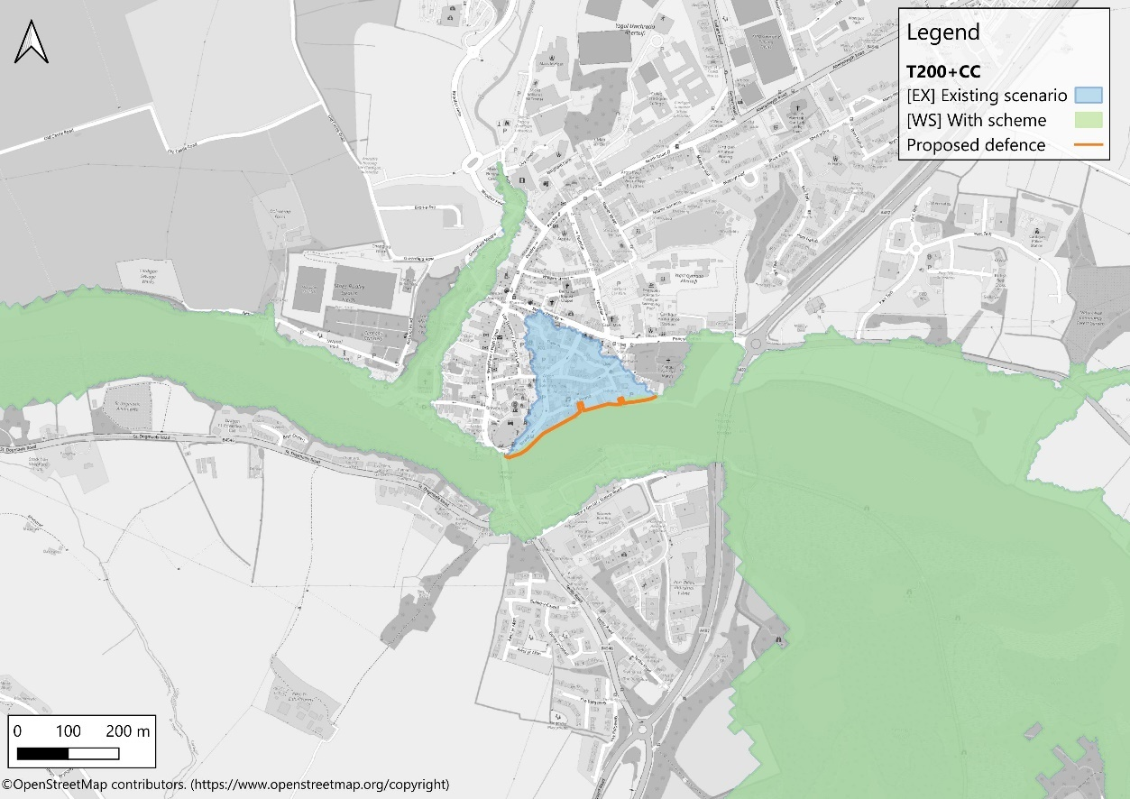
Figure 4-1: Existing and With Scheme flood extents for 0.5% AEP tidal event with climate change
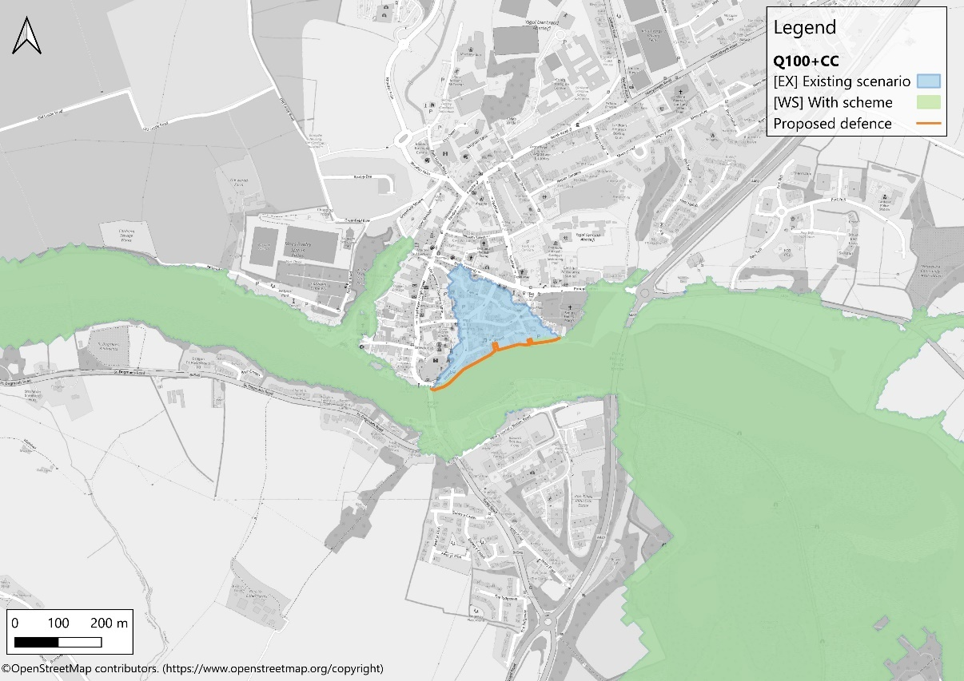
Figure 4-2: Existing and With Scheme flood extents for 1% AEP fluvial event with climate change

Off Site
Outside the immediate area of the proposed FCRM project, the existing and with‑scheme scenarios show no discernible variation in predicted flood extents.

Flood Levels
The construction of a linear flood defence will inevitably remove an area from the floodplain and the volume of water that enters this area must be displaced. It is therefore necessary to review if there is a detrimental impact on third parties. A water level change of +/- 0.005m is agreed with NRW as being within modelling tolerances. Any increase in flood level greater than 0.005m is to be seen as a detriment.
Flood level difference mapping has been prepared for each of the modelled events to compare the existing [EX] and with‑scheme [WS] scenarios. The mapping highlights where the scheme results in no meaningful change in water levels (yellow areas, indicating differences within the model tolerance of ±0.005 m), as well as where reductions or increases occur. Areas shaded green represent reductions in flood levels under the with‑scheme scenario. Areas shaded orange indicate slight increases in water levels (between 0.005 m and 0.01 m), while areas shown in red represent increases greater than 0.01 m. These categories allow the spatial distribution and magnitude of any scheme-related changes to be clearly presented.
Flood depth difference mapping has been prepared for all climate-change modelled events, with the following outcomes:

On Site
There is no flooding of the site except in the 0.1% AEP fluvial event with climate change, where the flood depth is shown to reduce by more than 0.005m (although by no more than 0.01m). This demonstrates the benefit in all flood events on the flood risk management scheme.

Off Site
Figure 4-3 confirms the 0.5% AEP tidal event with climate change. No changes in flood depth are observed outside model tolerances, with the exception of two very small areas off site, adjacent to the A487 south of Priory Bridge. These increases are minor and the A487 remains above predicted flood levels.
Figure 4-4 shows the 0.1% AEP tidal event with climate change. Similarly, no change in peak water level outside of model tolerances are displayed, except for some very small areas at the peripheries of the flood extents. The largest increase in flood level occurs in a ditch located on the west side of the A487 beside the roundabout leading to Priory Bridge (north of the river). Here the very minor increase in flood level (<1mm) is being accentuated as flood water accumulates in a depression and exaggerates the impact. This does not reflect a material increase in flood risk.
Figure 4-5 indicates the peak level water changes for the 1% AEP fluvial event with climate change. Minor increases in water levels are identified near Cardigan Bridge but remain confined within the channel. A slightly larger increase (up to approximately 0.06 m) is shown close to the GRAIN premises, associated with a small local depression where floodwater becomes temporarily trapped. These changes are highly localised and do not indicate any wider off-site impact.
Figure 4-6 highlights the 0.1% AEP fluvial event with climate change, which is the only event where impacts across a wider area are seen. The area of the Strand nearest Cardigan Bridge shows an increase to flood levels in excess of 0.2m; this is because the defence is now trapping flood water behind after it has been overtopped.

There is a much wider impact further upstream where water levels are consistently increased by 0.025m affecting the whole of the marsh on the left-bank of the Teifi, but more critically it affects the A484, Pont-y-Cliefon and Station Yard. However, we should consider the increase in flood depth in context of the frequency of flooding and flood depths that already occur. This is discussed further after the flood depth difference figures below.

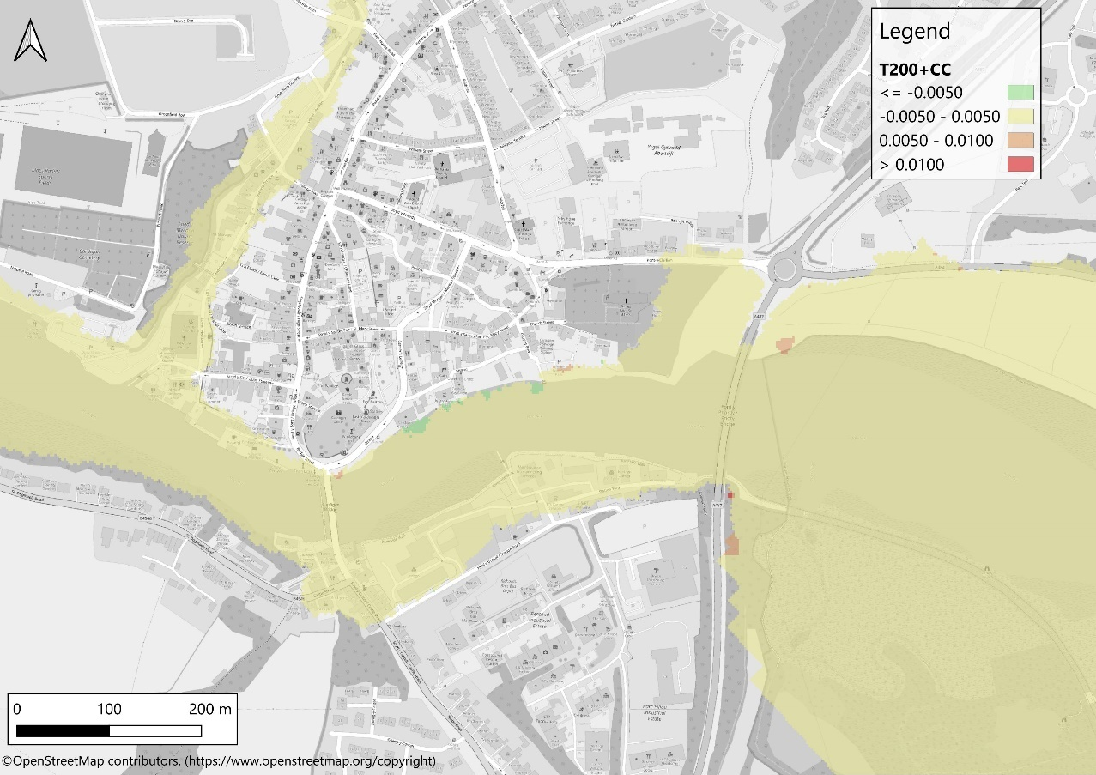
Figure 4-3: Peak water level changes: 0.5% AEP tidal event with climate change
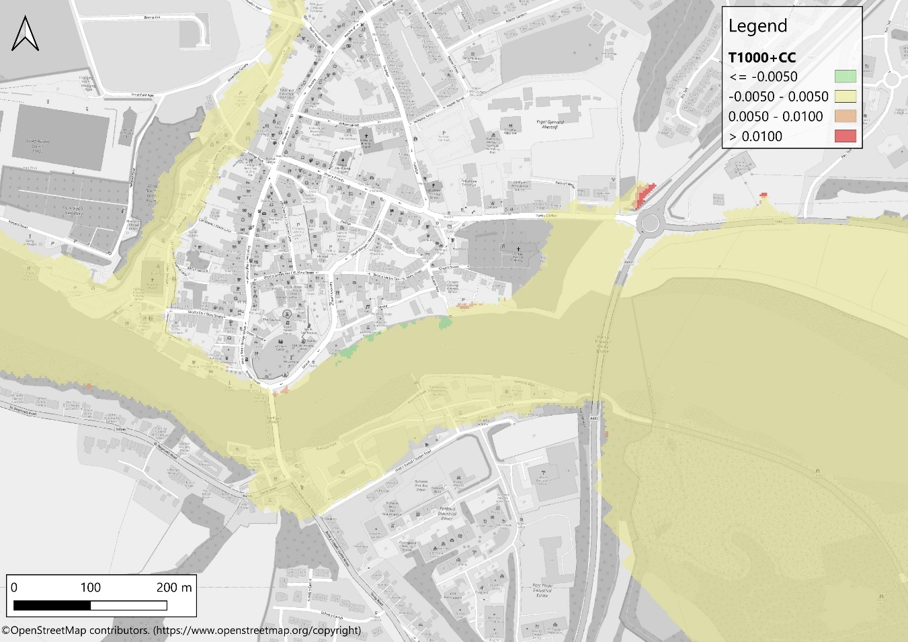
Figure 4-4: Peak water level changes: 0.1% AEP tidal event with climate change
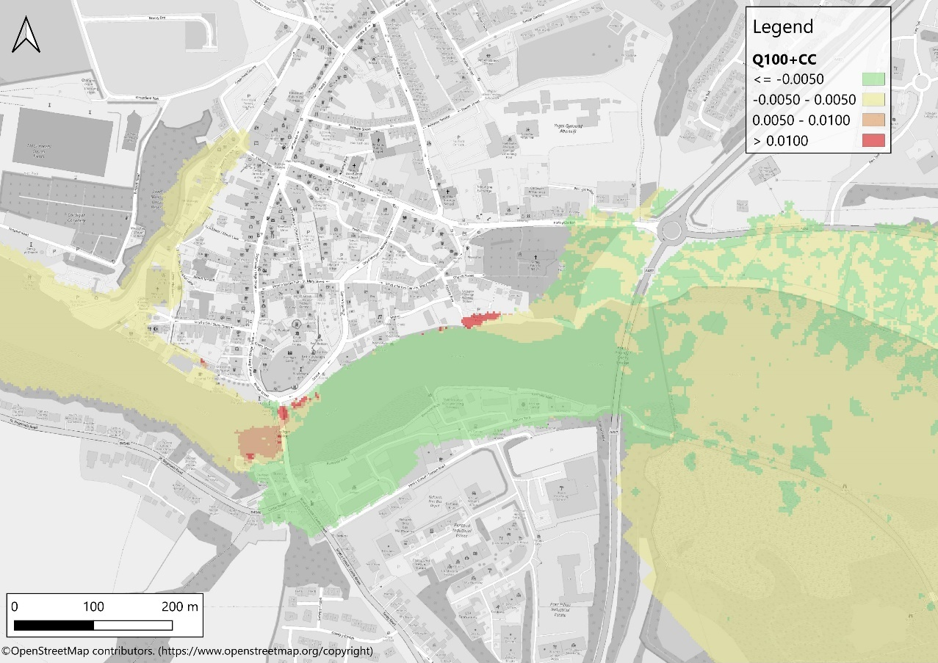
Figure 4-5: Peak water level changes: 1% AEP fluvial event with climate change

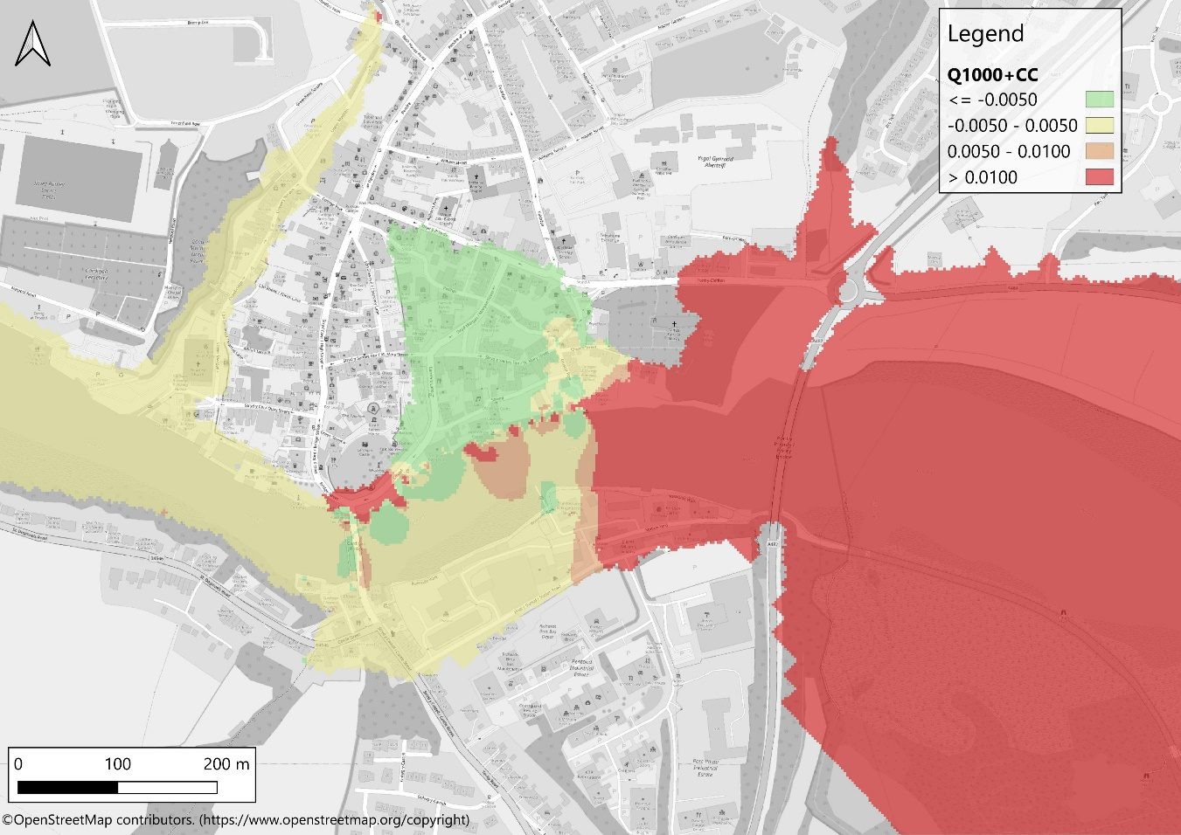
Figure 4-6: Peak water level changes: 0.1% AEP fluvial event with climate change
Figure 4-7 identifies three locations where there is property that is shown by the model to be impacted by the flood defence scheme. Figure 4-8, Figure 4-9 and Figure 4-10 focusses on each of these areas individually showing the flood depths in the 0.1% AEP fluvial event with climate change for affected buildings.

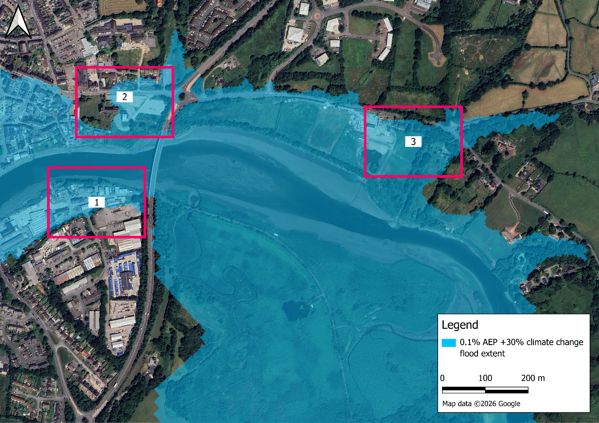
Figure 4-7: Areas of detriment to property

Area 1: Station Yard contains several warehouses for which flood depths would be increased. This area is not currently shown to flood in either the 1% AEP fluvial or the 0.5% AEP tidal events and this would not be changed by the Cardigan Tidal FRMS. The area is flooded in these events when a climate change allowance is applied, but as described above, there is no detriment caused by the FRMS. Detriment is only apparent in the 0.1% AEP fluvial event with climate change. Figure 4-8 shows the flood depths for this event in the existing situation and demonstrates that in this event the existing flood depth exceeds 1m for all affected buildings; in this context, an increase in flood depth of 0.025m is negligible.

Area 2: this includes residential properties along Pont-y-Cleifion, a large residential property to the north-east of Gloster Row Car Park and the disused Cardigan & District Memorial Hospital. Parts of the hospital grounds, including the old hospital building, are flooded either in a 1% AEP fluvial event with climate change or the 0.5% AEP tidal event with climate change. This not changed by the Cardigan Tidal FRMS and no detriment results from these events. The other properties are only impacted in the 0.1% AEP fluvial event with climate change, and this is not change by the Cardigan Tidal FRMS but there is some detriment caused. Figure 4-9 shows the flood depths for this event in the existing situation. Whilst flood depths not as substantial for Area 1 (and Area 3), none of these properties are flooded from a 0.025m rise in flood level and there is no meaningful change in frequency of flood risk.

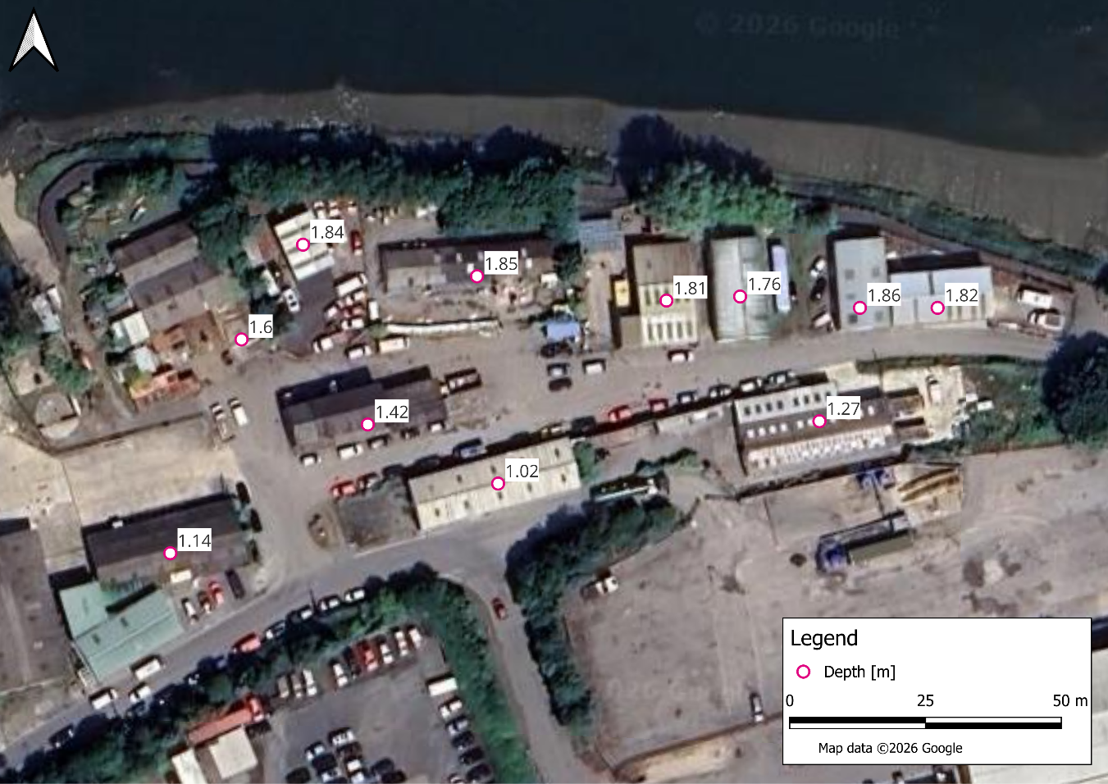
Figure 4-8: Area 1 flood depths (m) for 0.1% AEP fluvial event with climate change

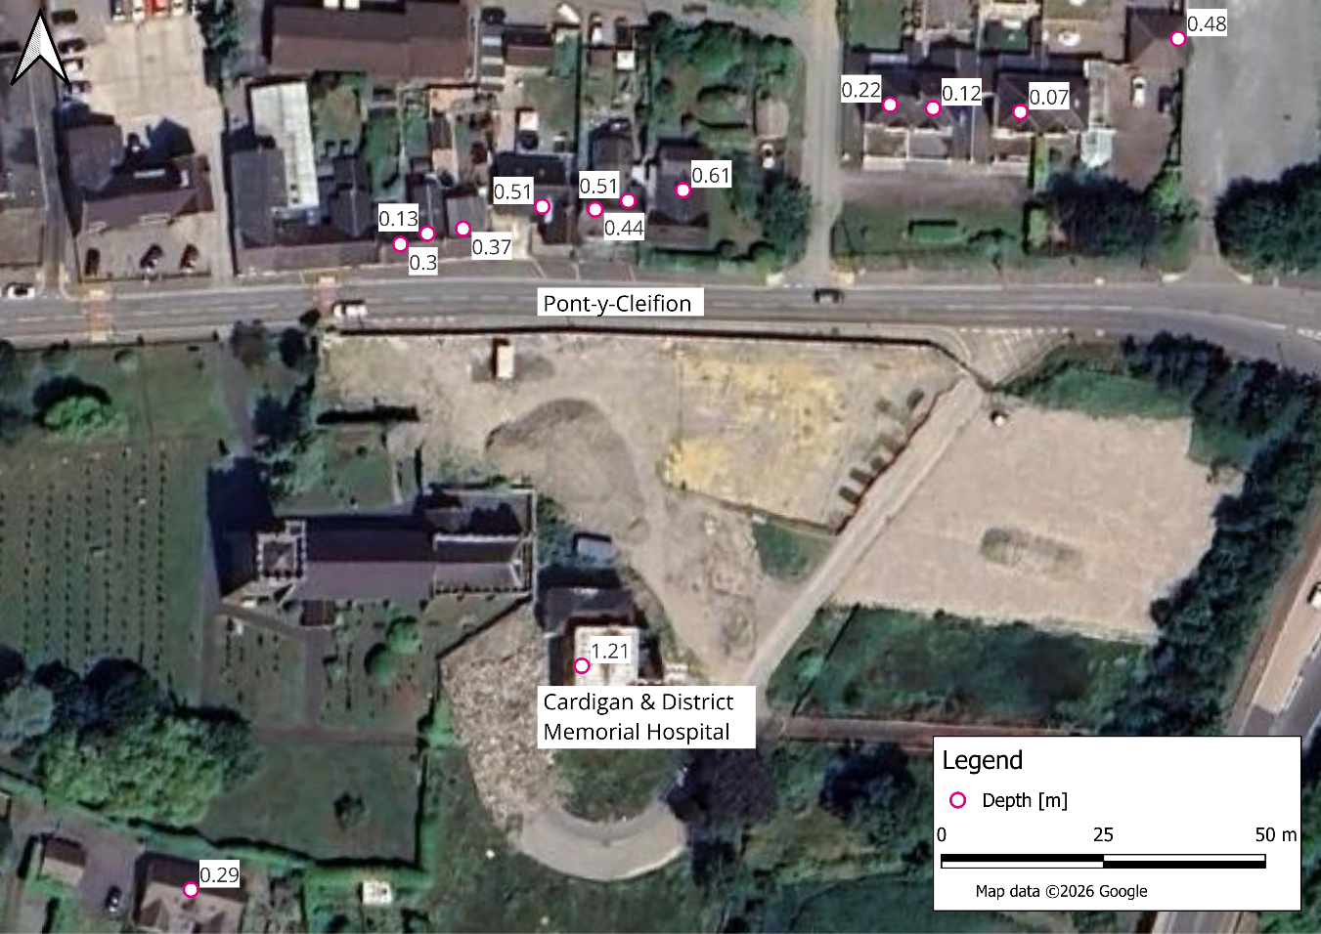
Figure 4-9: Area 2 flood depths (m) for 0.1% AEP fluvial event with climate change
Area 3: on the south side of the A484 there are a couple of residential properties and some large outbuildings. One of the residential properties is called Ty’r Morfa. The outbuildings are flooded either in a 1% AEP fluvial flood and a 0.5% AEP tidal event. The residential buildings are inundated either by a 0.1% AEP fluvial event or a 0.1% AEP tidal event including climate change. This not changed by the Cardigan Tidal FRMS and no detriment results from these events. At the A484/B4570 road junction there are a couple of residential properties set back from the main road. These are flooded in a 1% AEP fluvial flood and a 0.5% AEP tidal event. This not changed by the Cardigan Tidal FRMS and no detriment results from these events.

Detriment in Area 3 is only apparent in the 0.1% AEP fluvial event with climate change. Figure 4-10 shows the flood depths for this event in the existing situation and demonstrates that in this event the existing flood depth exceeds well over 1m for all affected buildings; in this context, an increase in flood depth of 0.025m is negligible.

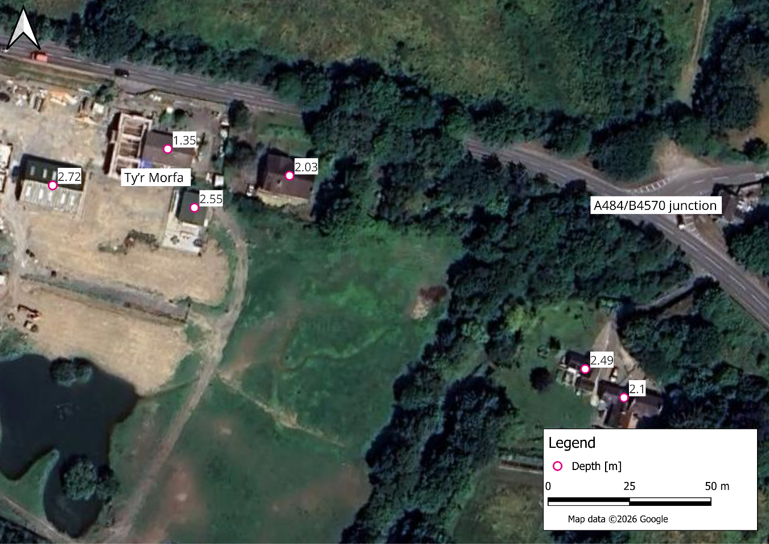
Figure 4-10: Area 3 flood depths (m) for 0.1% AEP fluvial event with climate change

Flood Velocity
Figure 4-11 and Figure 4-12 show the change in flood velocity resulting from the proposed scheme for the 0.5% AEP and 0.1% AEP tidal events, and Figure 4-13 and Figure 4-14 show the 1% and 0.1% AEP fluvial events with climate change allowances applied.
Similar to the flood level difference mapping, flood velocity difference mapping has been prepared for each of the modelled events to compare the existing [EX] and with‑scheme [WS] scenarios. The mapping highlights where the scheme results in no meaningful change in velocity (yellow areas, indicating differences within the model tolerance of ±0.05 m/s), as well as where reductions or increases occur.

On Site
At the Cardigan FRMS site, both the 0.5% AEP tidal, 0.1% AEP tidal and 1% AEP fluvial events with climate‑change allowances indicate a large reduction in floodwater velocities; this is because the FRMS prevents flooding in this area for these events. Figure 4-14 highlights areas that experience an increase in velocity at the site (in excess of 0.2 m/s), when the flood defence is overtopped/bypassed, which only occurs in the 0.1% AEP fluvial event with climate change.

Off Site
Generally off site, the change in velocity for the 0.5% AEP and 0.1% AEP tidal and 1% AEP fluvial events with climate change is neutral (between -0.05 and 0.05 m/s, which is represented within the figures in yellow).
Along the southern edge (riverside) of the flood defence, there are some slightly higher velocities in both tidal and fluvial events, but these remain limited in spatial extent. This is the only significant area of increased velocity, and this is contained within channel. There is therefore no detriment caused by the scheme in terms of flood velocity. In the most extreme event, the 0.1% AEP with climate change fluvial event, this does extend across the channel and has some impact on the opposite bank, but velocities here are already in excess of 1 m/s in the existing situation.

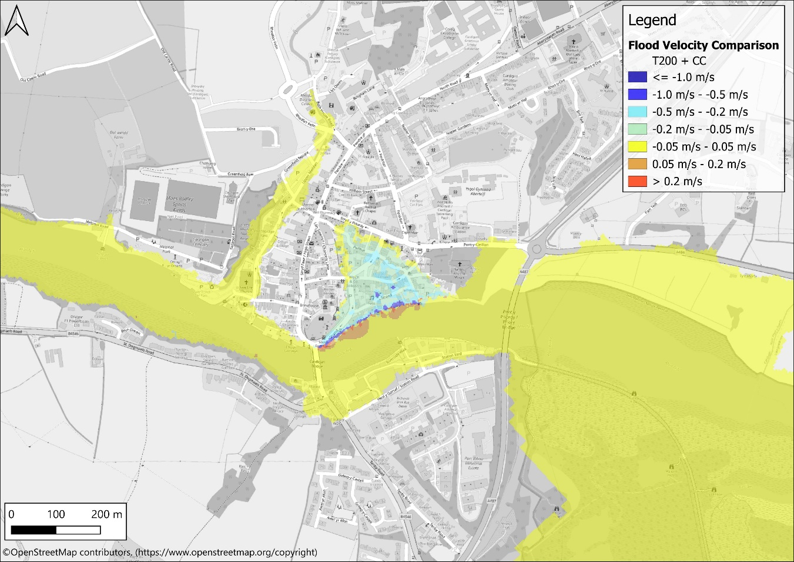
Figure 4-11: Flood velocity comparison: 0.5% AEP tidal event with climate change
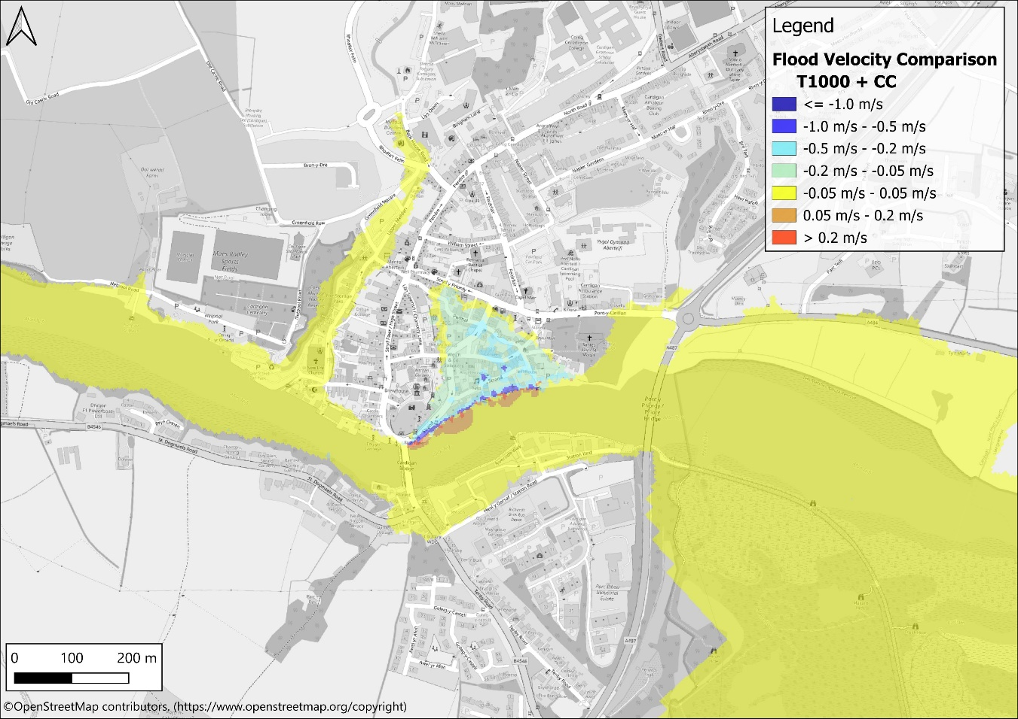
Figure 4-12: Flood velocity comparison: 0.1% AEP tidal event with climate change

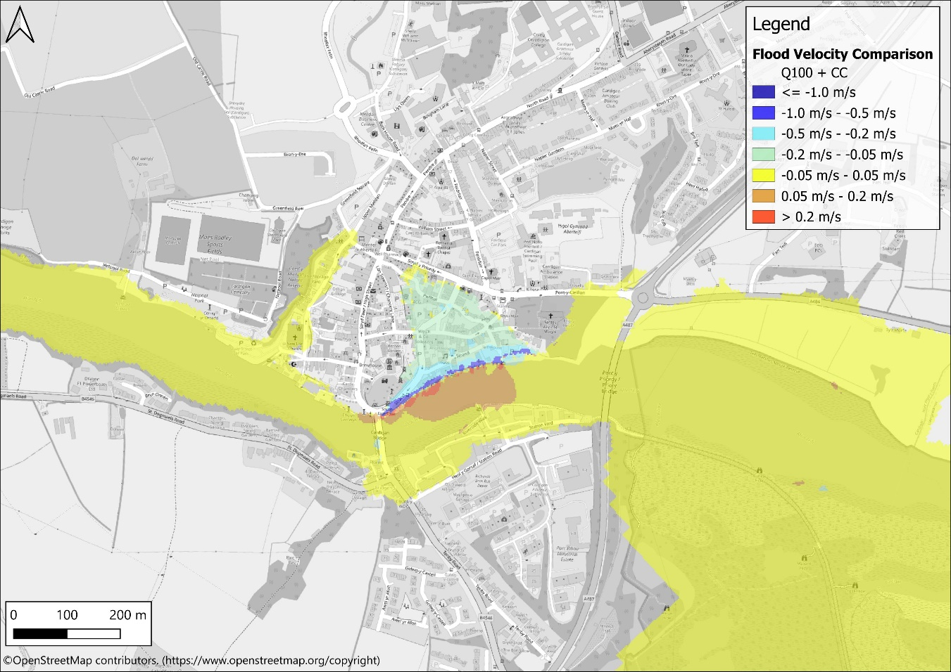
Figure 4-13: Flood velocity comparison: 1 % AEP fluvial event with climate change
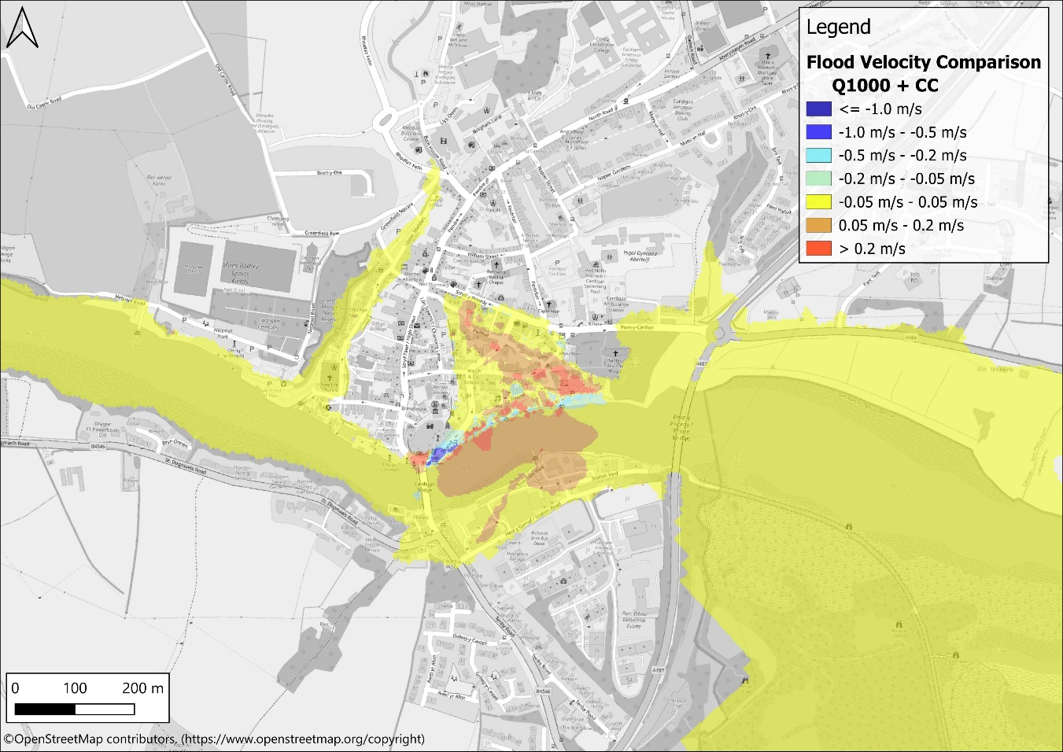
Figure 4-14: Flood velocity comparison: 0.1% AEP fluvial event with climate change

Summary

Cardigan, located in Ceredigion is situated on the estuary of the Afon Teifi. The Afon Teifi flows from east to west past the site, and flows into Cardigan Bay, approximately 5km downstream of the site.

This FCA has been prepared for Natural Resources Wales (NRW) to support a proposed Cardigan Tidal FRMS. This FCA demonstrates that the proposed project delivers a clear reduction in tidal and fluvial flood risk to a large part of the town, while avoiding any unacceptable increases in flood risk elsewhere. The scheme provides protection up to the 0.5% AEP tidal event with taking account of 100 year of climate change and appropriate RUA. The modelling confirms no detrimental effects on peak flood levels, flood extents, or flood velocities beyond the immediate footprint of the defences. All observed increases in water level or velocity are minor, highly localised, and either confined within the river channel or attributable to model tolerances. Therefore, the scheme satisfies the flood-free design standards and extreme-event tolerable conditions set out in TAN 15, confirming that flood consequences for the existing community remain acceptable under the full range of assessed events.

The exception is the fluvial 0.1% AEP flood with climate change, which shows a detriment of up to 0.025m upstream of the FRMS. In the context of existing flood depths, the simulated increase in flood depth is insubstantial for most of the affected properties, which includes the industrial units on the south bank of the Afon Teifi and some isolated properties further upstream on the south side of the A484. Existing flood depths of affected properties along Pont-y-Cleifion are lower, however, none of the properties have a meaningful increase in flooding frequency and all are only at risk only in the most extreme of scenarios. There is a balance to strike between the clear benefit that the Cardiagn Tidal FRMS will provide year after year compared to some possible minor detriment upstream of the scheme, which only occurs in the most extreme of fluvial scenarios.

Planning Policy Wales - Technical Advice Note 15: Development and Flood Risk (2025)
https://naturalresources.wales/flooding/managing-flood-risk/find-flood-defence-structures-near-you-the-national-flood-asset-database/?lang=en
https://www.landis.org.uk/soilscapes/
https://flood-risk-maps.naturalresources.wales
Flood and Coastal Erosion Risk Maps
UK Canal Network Map | Canal & River Trust
Cardigan Tidal Flood Risk Management Project - Detailed Design Report, Binnies UK Ltd, January 2025 (4021883-BUK-ZZ-00-RP-Z-00005)
Cardigan 2D Hydraulic Modelling Report, Binnies UK Ltd, January 2026 (4021883-BUK-ZZ-00-RP-HY-00001)

