Cardigan Tidal Flood Risk Management Scheme
Planning Statement

Project no. 4021883
Prepared for:
Natural Resources Wales
March 2026


Table of contents

1. Introduction 1
1.1 Application site location 1
1.2 Spatial constraints relevant to the Scheme 3
1.3 Consents 5
1.4 Site planning history 6
1.5 Information submitted with this application 6
2. Description of the Proposal 7
2.1 Need for the Scheme 7
2.2 Approach to design 7
2.3 Description of the proposed works 7
2.4 Habitat loss, modification and creation 12
2.5 Operational management 13
2.6 Construction compounds and working areas 14
2.7 Construction traffic and access routes 14
2.8 Programme 16
3. Consultation 16
3.1 Public Consultation 16
3.2 Habitats Regulations Assessment consultation with NRW 17
3.3 Consultation with Ceredigion County Council and NRW 17
3.4 Formal Pre-application Consultation 17
4. Planning Framework 18
4.1 Planning Authority 18
4.2 National Planning Policy 18
4.3 Local Planning Policy 24
5. Assessment of the Scheme against Planning Policy 25
6. Conclusions 30
7. References 31

Details of document preparation and issue:
Version no. | Prepared | Checked | Reviewed | Approved | Issue date | Issue status
P01 | Myles Harding | David Johnson | Andrew Burwood | Alex Humphreys | 11/03/2026 | S3

Project no. 4021883 |  | Client’s reference no. | CE0587
File name: | 4021883-BUK-ZZ-00-RP-EN-00036

Notice:
This report was prepared by Binnies UK Limited (BUKL) solely for use by Natural Resources Wales (NRW). This report is not addressed to and may not be relied upon by any person or entity other than NRW for any purpose without the prior written permission of BUKL. BUKL, its directors, employees and affiliated companies accept no responsibility or liability for reliance upon or use of this report (whether or not permitted) other than by NRW for the purposes for which it was originally commissioned and prepared.
In producing this report, BUKL has relied upon information provided by others. The completeness or accuracy of this information is not guaranteed by BUKL.

Introduction

Application site location
This planning statement relates to the Cardigan Tidal Flood Risk Management Scheme (TFRMS), hereafter referred to as ‘the Scheme’.
The Scheme site (the ‘Scheme Area’) is situated towards the centre of Cardigan town, Ceredigion, in west Wales. The Scheme is positioned along the right bank (northern bank) of the River Teifi (Afon Teifi), which flows east to west, covering an approximate distance of 327m upstream of Cardigan Bridge (Plate 1-1). The permanent works are bound to the west by Castle Street (SN 177 458), to the east by Gloster Row car park (SN 180 459) and the central point of the Scheme is at SN 17932 45940. The nearest postcode is SA43 1EX.
In addition to the permanent works area, the Planning Application boundary includes two remote areas for temporary construction compounds: one east of the roundabout that forms the A487/A484 junction and that has been used previously as a construction compound, and one in the Pentood Industrial Estate on the south side of the Afon Teifi. These are shown on the Planning Application Location Plan (drawing ref: 4021883-BUK-ZZ-00-DR-EN-00005).
Existing infrastructure in the area includes the current flood defences, residential and commercial buildings along the northern riverbank, Gloster Row car park and the slipways/river access points at SN 179 459 and Gloster Row car park. Strand and Castle Street are roads located within the Scheme Area which provide access for local traffic to the town centre. Strand is a one-way road constrained by Cardigan Castle Scheduled Monument and the Afon Teifi. Perpendicular to Strand is Castle Street (Cardigan Bridge) which is a narrow two-way road crossing the Afon Teifi.

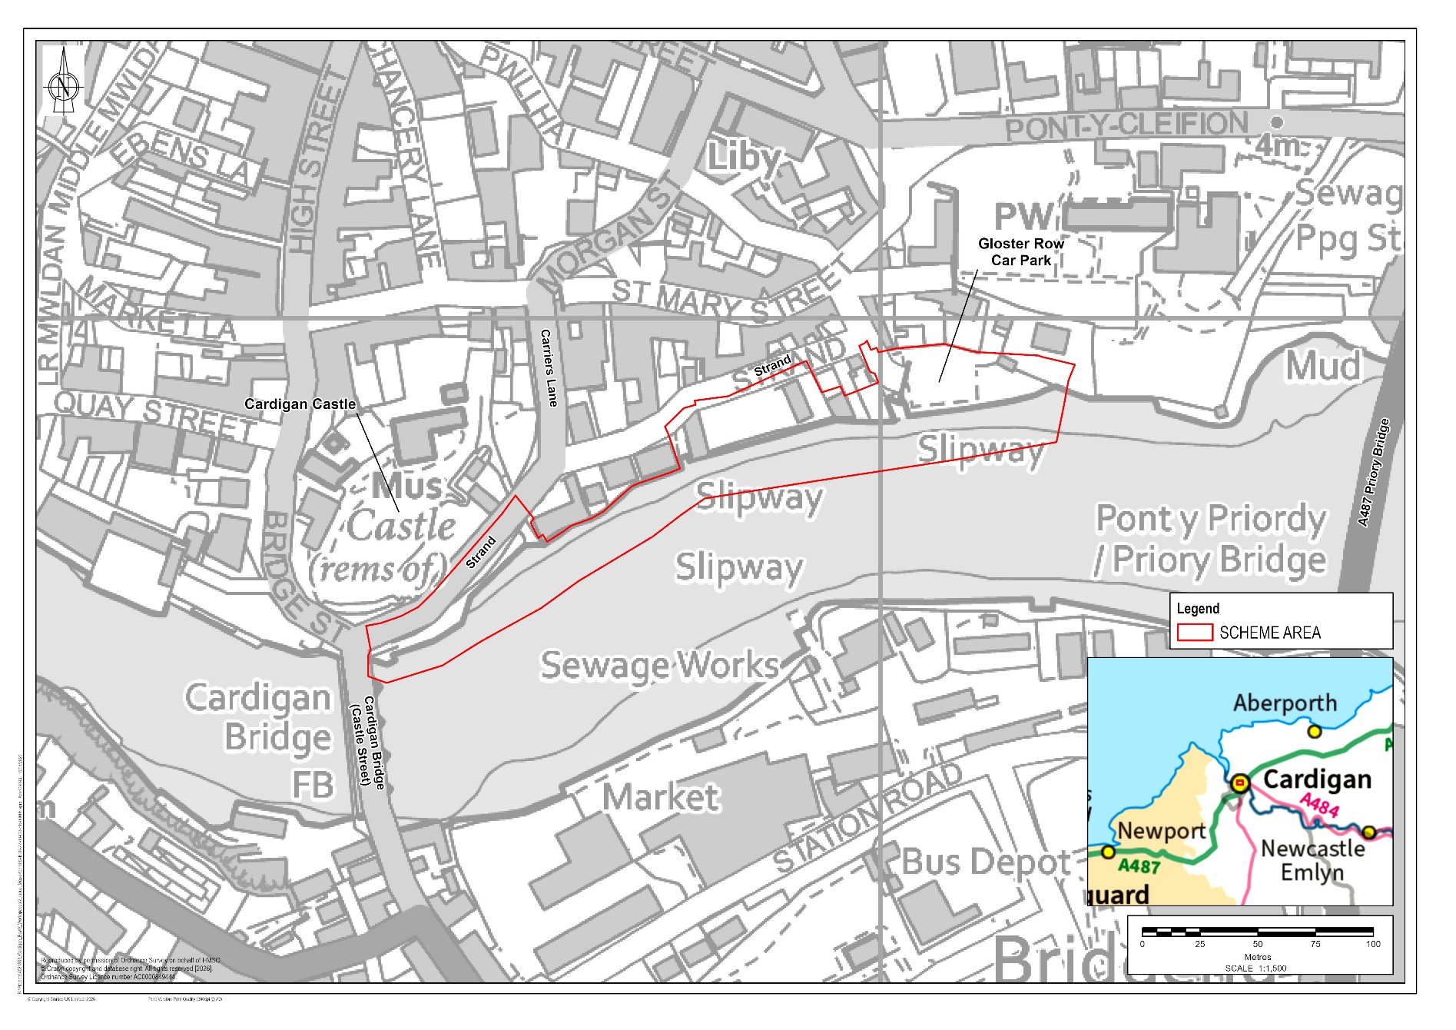

Plate 1-1 – Location of Scheme within Cardigan

Spatial constraints relevant to the Scheme

Population and flood risk
The Scheme Area lies within the Cardigan Teifi Lower Super Output Area (LSOA), which has experienced relatively stable population levels but is among the 10% most deprived areas in Wales according to the Welsh Index of Multiple Deprivation (WIMD), with high levels of income and housing deprivation.
The Strand area on the north bank of the Afon Teifi is highly vulnerable to tidal flooding, with notable events recorded in 2007, 2008, 2012 and 2014, affecting homes and businesses with flood depths exceeding 0.5 m. Many properties have low thresholds and are exposed to annual flooding, with risk expected to increase due to future sea level rise.

Biodiversity
The northern bank of the Afon Teifi which is within the Scheme Area falls within the boundary of the Afon Teifi Site of Special Scientific Interest (SSSI). Habitats and species of special interest which are relevant to the Scheme Area include a transitional reach of the river with both tidal and fluvial influences connecting marine and freshwater systems, associated riverside habitats and protected species including flowering plants, otter, Cetti’s warbler, bottlenose dolphin, fish, dragonflies and a variety of other invertebrates as well as both breeding and wintering bird communities.
The Afon Teifi Special Area of Conservation (SAC) designation also covers the northern bank of the Afon Teifi within the Scheme Area. Designated habitats and species relevant to the Scheme Area include otter, and fish species including Atlantic salmon, bullhead, river lamprey and sea lamprey.
The Cardigan Bay SAC and West Wales Marine SAC are located adjacent to the Scheme Area, downstream (west) of Cardigan Bridge (Castle Street). Designated species relevant to the Scheme Area include bottlenose dolphin, Atlantic grey seal, sea lamprey, river lamprey and harbour porpoise.
A range of habitats are present within the Scheme Area including broadleaved scattered trees, shrub, amenity grassland and poor semi-improved grassland with wildflowers on the landward side of the existing river wall, and running water (Afon Teifi). Habitats of Principal Importance (HPI) present within the Scheme Area include intertidal mudflats and saltmarsh along the northern river bank.
Otters are known to use the Afon Teifi in the Scheme Area, and fish species including Atlantic salmon, sea trout, European eels, river lampreys and sea lampreys use and migrate along the river between Cardigan Bay and the freshwater reaches of the Afon Teifi. Marine mammals may also move up the Afon Teifi as far as Cardigan.
The intertidal mudflats and saltmarsh support waterbirds and invertebrate species. There are bat roosts in Cardigan Castle and bats forage in the Scheme Area including along the Afon Teifi.

Landscape and Heritage
The Scheme Area is located on the periphery of the locally (non-statutory) designated Special Landscape Area (SLA) 7: Teifi Valley, which follows the course of the Afon Teifi through Cardigan, and is defined for its distinctive and coherent sinuous river valley.
In the absence of a published landscape character assessment at a local level, the Environmental Impact Assessment (EIA) study area was divided into appropriately scaled Landscape Character Areas (LCAs) by the Landscape Architect:
- LCA1 (Cardigan urban area) covers the town centre, where traditional buildings, narrow streets and views toward landmarks such as Cardigan Castle give the area a strong local identity, though some modern buildings weaken its historic character.
- Along the river itself, LCA2 (River and intertidal habitat) is defined by open mudflats, saltmarsh and a quiet, natural feel at low tide, creating a strong contrast with the surrounding town and forming an important part of the estuary’s protected habitats
Although no Scheduled Monuments or listed buildings lie directly within the Scheme Area itself, the surrounding area includes three Scheduled Monuments (Cardigan Bridge, Cardigan Castle and Cardigan Town Walls), 36 listed buildings and the Grade II registered historic park and garden at Cardigan Castle.
Almost all of the Scheme lies within the Cardigan Conservation Area, a highly valued historic townscape recognised for its medieval origins, Georgian and Victorian architecture, riverside setting and strong cultural associations. The Scheme Area is also part of the Lower Teifi Valley Landscape of Special Historic Interest.
Although many archaeological sites are recorded in the wider Teifi catchment area, the archaeological potential for the EIA study area was considered to be low for the prehistoric, Roman and early medieval periods. Cardigan was definitively established as a castle and settlement during the medieval period, and therefore there is considered to be heightened potential for medieval and post-medieval archaeological sites. Within the Scheme Area there is an increased potential for medieval activity around the northern bridgehead, below the castle walls, although no specific features are recorded in this area.

Traffic and Transport
The roads around Cardigan comprise mainly of residential/town centre roads with low speed limits and carry light to moderate traffic. Good pedestrian facilities such as footpaths and crossings are present, and public transport is available through local bus stops. Accident records show very few incidents in recent years, with no particular safety concerns.

Water environment
Originating from Llyn Teifi in the Cambrian Mountains, the Afon Teifi flows southwest through predominantly rural uplands before passing through Cardigan and discharging into Cardigan Bay. The catchment is largely rural, with land use comprising agriculture, forestry, and upland moorland.
Within Cardigan itself, the Afon Teifi is transitional, both tidally and fluvially influenced, connecting both the marine and freshwater systems. Existing bank protection comprising of stone walls and gabions restricts natural processes and the ability of the channel to migrate. The riverbed is mostly made up of fine sediments forming mudflats, with patches of saltmarsh along the northern bank.
Two key tributaries, the Afon Piliau and the Afon Mwldan, enter the Afon Teifi upstream and downstream of the Scheme Area respectively. Several other minor drains and watercourses discharge into the Teifi upstream and downstream of the Scheme.
The underlying geology comprises low-permeability mudstones with limited groundwater movement, while more permeable superficial alluvial and tidal deposits potentially support shallow groundwater close to the river.

Land and soils
The Strand area of Cardigan has been built up over time using reclaimed material. This made ground comprises a mix of gravel sized fragments of concrete and brick, clay with mudstone gravel and other materials of human origin (e.g. slate and ceramic fragments). Historically, industrial land uses within the Scheme Area include a smithy, known as “The Old Foundry”, along with a sawmill and timber yard on the southern bank of the river. River sediments are understood to have been affected by this historic industrial activity.

Sources of detailed constraints information
Further details on environmental constraints are provided within the Environmental Statement (ES) and illustrated on the Environmental Constraints and Opportunities Plan (Annex 1 of the Environmental Action Plan).

Consents
The Scheme constitutes a Schedule 2 development under the Town and Country Planning (Environmental Impact Assessment) (Wales) Regulations 2017 (as amended) under Paragraph 10(h) ‘Inland-waterway construction not included in Schedule 1, canalisation and flood-relief works’. The Scheme exceeds the applicable threshold for Inland-waterway construction as the area of the works, including construction working areas, exceeds 1 hectare.
In addition, the Scheme constitutes a Schedule A2 development under the Marine Works (Environmental Impact Assessment) Regulations 2007 (as amended) under Paragraph 64 ‘Inland-waterway construction not included in Schedule A1, canalisation and flood relief works’.
A Screening Opinion was requested from Ceredigion County Council (CCC) and the NRW Marine Licencing Team. Both CCC (Ref. Q230180, 14/11/2023) and the Marine Licencing Team (Ref. SC2303, 14/12/2023) confirmed that the Scheme comprises EIA development and therefore requires a statutory EIA.
The EIA scoping process for the Scheme involved multiple stages of correspondence with Ceredigion County Council and the NRW Marine Licencing team prior to reaching the final scoping opinion. The most recent scoping letter issued in August 2025 requested an update to the previous scoping opinions provided in December 2023, and set the basis for the ES.
The Planning (Wales) Act 2015 places a requirement upon the developer to undertake a minimum 28 day consultation before applying for planning permission for all Major developments, as defined by Article 2 of the Town and Country Planning (Development Management Procedure) (Wales) Order 2012 (as amended by the 2016 Order). See section 3.4 for details of the pre-application consultation.
The following consents, in addition to this Town and Country Planning Application, are required for the Scheme:
- Marine Licence from NRW Marine Licencing Team.

Site planning history
Planning applications submitted since 2000 associated with this Scheme Area are:
- A100058 – Full planning application for the improvement to the waterfront promenade at Strand waterfront. Approved subject to conditions 25/03/2010.
- A070342 – Full planning application for the erection of showroom & store at The Yard. Approved subject to conditions 16/09/2007.
- A160294 – Full planning application for the demolition of existing redundant and derelict church and erection of a new storage shed at the site of the Bathroom Centre. Approved subject to conditions 02/10/2016.
- A201007 – Full planning application for the Installation of a conservation style motor control centre kiosk within associated development including 12no. vehicle bollards and replanting of 3no. native species trees and the extension of the existing parking and construction of a combined sewerage overflow outfall. Approved subject to conditions 27/11/2020.
- A240844 – Full planning application for the change of use from redundant office space to residential accommodation together with extension to ground floor office at the Bathroom Centre. Application refused 26/06/2025.

Information submitted with this application
The following supporting documents have been submitted alongside this Planning statement:
- Design and Access Statement (DAS)
- Green Infrastructure Statement
- Environmental Statement (ES)
- Environmental Action Plan (EAP) including Environmental Constraints and Opportunities Plan (ECOP)
- Environmental Masterplan
- Location Plan
- General Arrangement Plan
- Design detail drawings.

Description of the Proposal

Need for the Scheme
The Strand area of Cardigan on the north bank of the Afon Teifi, which includes residential and commercial properties, is vulnerable to flooding. Flood events occurred in 2007, 2008, 2012 and 2014. In 2007 the lower quayside, including Strand and Cattle Market flooded with flood depths exceeding 0.5m. A tidal flood on 3 January 2014 inundated 29 properties on St Mary’s Street. This area will become increasingly vulnerable with predicted future sea levels rise.
Low-lying residential and commercial properties, particularly on Strand, are highly vulnerable, with thresholds below 3.1m Above Ordnance Datum (AOD) and exposure to annual tidal flooding. The projected 0.5% Annual Exceedance Probability (AEP) (1 in 200) tidal level, including 100 years of climate change, is 4.75m AOD, which is well above current ground levels and therefore poses a risk of significant flooding.

Approach to design
The purpose of the Scheme is to reduce the risk of tidal flooding to the town and community of Cardigan, taking account of predicted sea level rise. This would be achieved by creating new flood defences, which would afford a greater standard of flood protection to properties currently at risk of flooding.

The Scheme has been designed to 4.95m AOD to meet the 1 in 200 design standard with climate change and would allow for 0.2m of freeboard, accounting for uncertainty in long range forecasting of the effects of climate change.

The Scheme has been designed to meet the following Critical Success Factors (CSF) which are defined as attributes which are essential to the successful delivery of the Scheme, and which formed the project brief:
- Reduce present day and future flood risk to people and property in Cardigan, to improve the quality of life to the local community.
- Provide an economically viable option to manage flood risk, with a benefit cost ratio of greater than one.
- Develop a technically feasible option to manage flood risk, with consideration of site-specific constraints and the needs of the community.
- Minimise impacts on habitat and biodiversity and seek to provide enhancements.

Description of the proposed works
The proposed works are illustrated on the General Arrangement Plan (drawing 4021883-BUK-ZZ-00-DR-EN-00008) and Environmental Masterplan (drawing 4021883-BUK-ZZ-00-DR-L-00004), with further details in Chapter 3: Project Description of the accompanying ES. The Scheme is divided into four areas (1-4). The works comprise:

Area 1
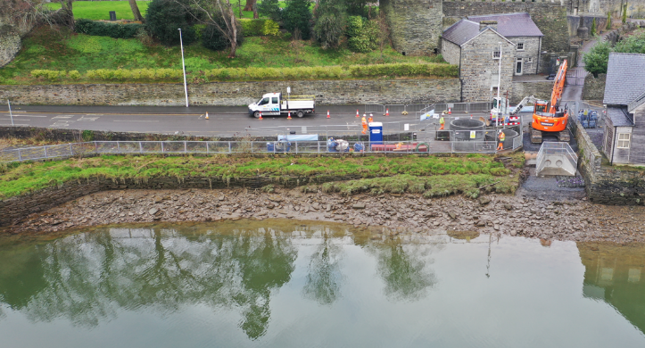
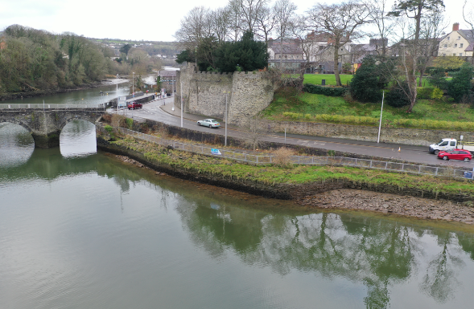
Area 1 lies on the north side of the Afon Teifi, just upstream of Cardigan Bridge and next to Strand. It is a small, enclosed roadside area between the bridge and the nearby Cardigan Bathroom Centre showroom (see Plate 2-1). Existing features here include a Welsh Water discharge chamber, masonry walls and access steps, roadside and plateau area.
Plate 2-1 – Area 1 images
In this location, the Scheme would introduce a new section of flood defence wall. This wall would be approximately 76m long and its height above the existing ground level on the landward would be approximately 1.1m near the bridge, rising to approximately 2m near the Bathroom Centre. The alignment of this wall would start from approximately 10m east of the bridge parapet and would be built from reinforced concrete and finished with stone cladding to match local materials. The remaining 42m section would use steel sheet piles driven into the riverbed, also capped and clad in stone. The landward side of the wall would be backfilled to improve the existing public amenity space, which would include planters or other small enhancements.
To support the 42m long sheet pile wall an engineered riverbank would be constructed on the riverside of the proposed flood defence wall within Area 1.
The engineered riverbank has been designed to achieve a consistent profile, helping to reduce sheet pile requirements along the Scheme. The engineered riverbank also provides the opportunity for a range of intertidal habitats to establish on the banks. Further detail of the design development and reasoning is described in ES Chapter 2: Project Development. As illustrated in Plate 2-2, the riverbank across the majority of the Scheme is a uniform profile with a 1m wide crest at a height of approximately 2.95mAOD and a gradient of 1V in 2H down to the riverbed, extending approximately 10m into the estuary.
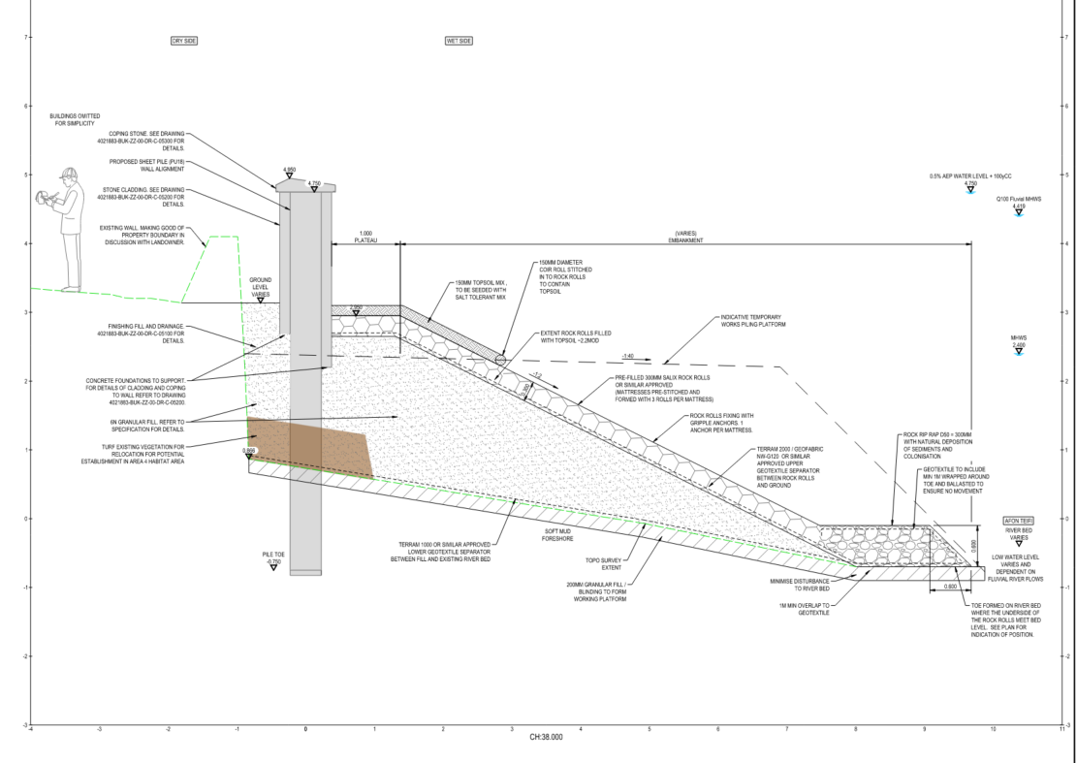
Plate 2-2 – Typical engineered riverbank section
The existing riverbank wall would be removed or buried to allow construction of the new flood defence. The engineered riverbank would comprise granular fill, a permeable geotextile membrane, and rip rap at the toe. Rock rolls would be installed on the lower two-thirds of the slope, where regular tidal inundation would encourage sediment accretion and natural intertidal habitat development.
The upper third of the slope and the crest would be finished with imported soil and a seed mix, as this area is only infrequently inundated. This soil layer would be placed over rock rolls, which continue up the slope to provide scour protection, enhanced further as vegetation establishes. A single unplanted coir roll would be installed to stabilise the soil during vegetation growth.
Due to the encroachment into the estuary, approximately 49m² of existing intertidal habitat would be permanently lost within Area 1 from the footprint of the flood defence wall and the space between it and the existing wall. The engineered riverbank footprint would result in the adaptation of approximately 236m² of existing intertidal habitat.
A part of the public realm enhancements within Area 1, the area behind the flood defence wall would be backfilled to create a new public amenity space. Along Strand, the pavement would be widened to at least 3 m by removing the existing roadside wall and setting the flood defence wall back from the road. The footway would be finished in riven slate to reduce slip risk and visually link Strand with Prince Charles Quay west of Cardigan Bridge, the Cardigan Castle entrance, and the Strand–Cardigan Bridge junction.
A linear planting bed with shrubs, herbaceous species, and street trees would separate pedestrians from traffic. A raised planting bed near the Bathroom Centre would contain taller planting, with its retaining wall aligned with Cardigan Castle’s walls and incorporating integrated seating. Three seats are proposed, offering varied heights, backrests, and armrests to support accessibility.
A small plateau would remain on the riverward side of the flood defence wall. Although not publicly accessible, it would be visible from Strand and seeded with the same salt-tolerant mix used on the upper engineered riverbank. A gate and steps between the western end of the flood defence wall and the existing wall would provide maintenance access.
For further details of the design of the public realm enhancements see Area 1 Landscape Planning drawings (4021883-BUK-ZZ-00-DR-L-01002 and 4021883-BUK-ZZ-00-DR-L-01522).

Area 2
Area 2 runs along the riverside from just east of the Bathroom Centre Showroom to the slipway next to Cardigan Bay Active. Several commercial units lie immediately to the north of this area, alongside Strand. Existing features include masonry river walls that support the raised ground where the Cardigan Bathroom Centre showroom, offices and warehouse are located (see Plate 2-3).
In this area, the Scheme would add a new section of flood defence wall continuing from Area 1. This wall would be around 70m long and about 1.6m high above the existing ground level on the landward side. It would be slightly offset from the current riverside wall. The new wall would be capped and finished with stone cladding, and the space behind it would be backfilled to create a narrow access corridor for the neighboring commercial properties. This backfilling would also bury the existing wall.

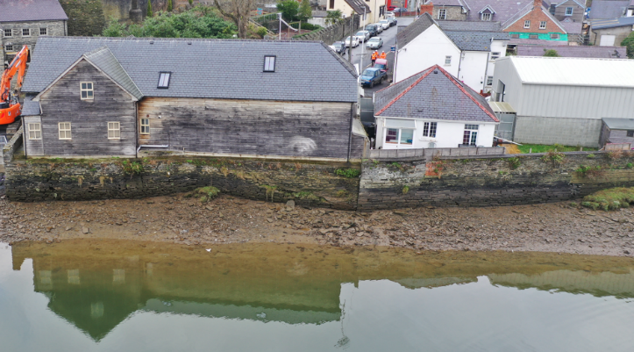
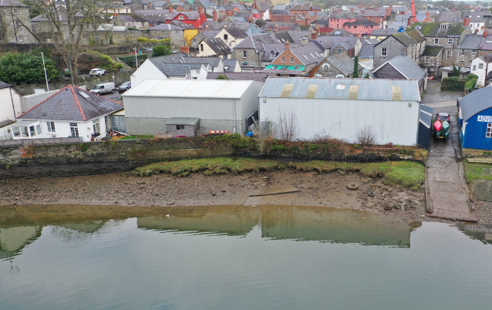
Plate 2-3 – Area 2 imagery
The flood defence wall would be constructed using steel sheet piles driven into the riverbed. The lower part of the piles would be supported by a new engineered riverbank extending approximately 10m into the estuary with a rip rap toe extending a further 2-3m; however these figures will vary depending on localised riverbed levels. This engineered riverbank would replace the existing riverbed profile and would be built using granular fill, a permeable membrane and protective stone riprap at the base. The lower section of the slope would be covered with rock rolls, while the upper third and crest would include a growing medium planted with a seed mix to create a more natural appearance, supported by engineered scour protection to prevent erosion.
Because the alignment of the new flood defence wall new structure extends into the estuary, around 357m² of existing intertidal habitat would be permanently lost and 417m² of existing intertidal habitat would be adapted.

Area 3
Area 3 lies between the slipway next to Cardigan Bay Active and the slipway at the Gloster Row car park. It includes the frontage alongside Old Forge Crafts, Cardigan Bay Active, the Scout field and old foundry site, the Scout hut, Teifi House, a garage/office building, and the Gloster Row slipway, all located along Strand. As in Area 2, a stone river wall currently supports the raised ground where these properties sit (see Plate 2-4).
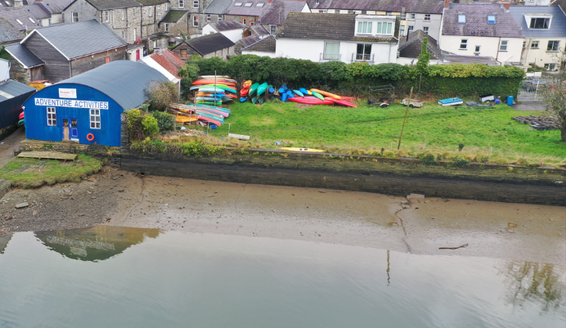
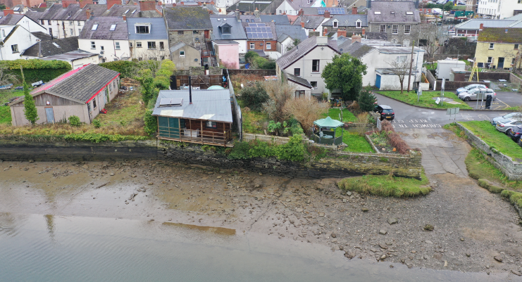
Plate 2-4 – Area 3 imagery
In this area, the Scheme would add a new section of flood defence wall continuing from Area 2. This wall would be about 106m long and between 1.7m and 1.9m high above the existing ground level on the landward side. It would be built using steel sheet piles driven into the riverbed, with the depth of the piles varying depending on ground conditions. As for Area 2, the lower 3m of the wall would be supported by an engineered riverbank extending approximately 10-13m into the estuary.
The engineered riverbank would comprise granular fill, a permeable geotextile membrane, and rip rap at the toe. Rock rolls would be installed on the lower two-thirds of the slope, with the upper third and crest finished with a growing medium and seed mix to provide a naturalised appearance while retaining engineered scour protection. The riverbank would tie into regraded land at the existing Gloster Row car park, where the defence is set back from the water’s edge.
The Scheme would result in the permanent loss of approximately 83 m² of existing intertidal habitat within Area 3 due to the footprint of the new flood defence wall and the space between it and the existing wall. The engineered riverbank footprint would result in the adaptation of approximately 634m² of existing intertidal habitat.
The wall alignment has been positioned towards the riverside of the existing structures to minimise damage, although temporary effects on the Scout hut may occur. An unauthorised structure overhanging the river wall may require demolition, with mitigation measures set out in Chapter 5: Population and Human Health. Towards the Gloster Row slipway, Teifi House sits further back from the works.
The alignment of the flood defence wall requires closure of the existing slipway next to Cardigan Bay Active. To maintain access to the Afon Teifi for the Sea Scouts and other permitted users, the Scheme provides a new canoe/kayak “up-and-over” access ramp south of the Old Foundry site. The public slipway at Gloster Row car park would also be permanently closed; however, it is not regularly used and is not required for emergency access.

Area 4
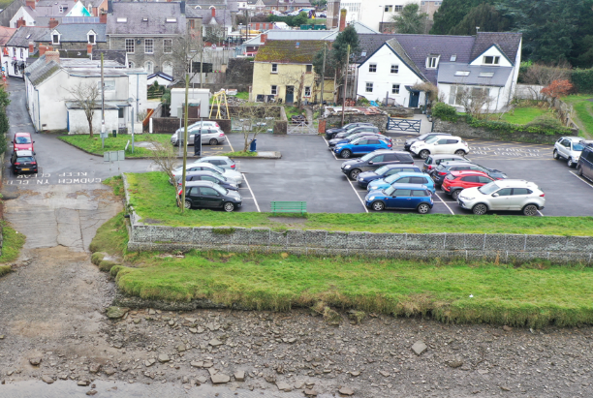
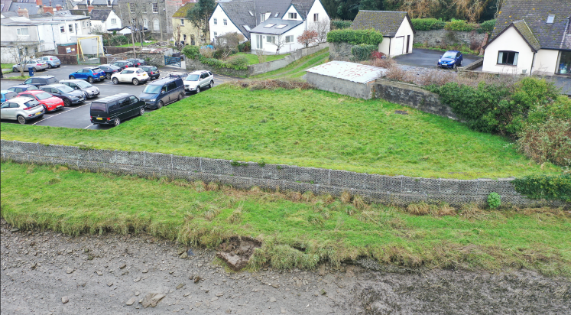
Area 4 extends between the Gloster Row slipway and the eastern boundary of the Gloster Row car park. It includes the car park itself and a small area of grassland to the east. Existing features in this area include a two-tier gabion wall that supports the ground at the car park, the slipway, and infrastructure associated with the Welsh Water pumping station (see Plate 2-5).
Plate 2-5 – Area 4 imagery
In this area, the Scheme would introduce a new section of flood defence wall set further back from the river. This wall would be around 75m long and approximately 1.3m high on the landward side. It would be built using steel sheet piles driven into the riverbed, with the exposed faces finished in stone. The wall will be set back landwards from the existing gabion wall.
It is necessary to set this section back to mitigate the loss of intertidal habitat within Areas 1 to 3. To facilitate the establishment of intertidal habitat the upper tier of the existing gabion wall would be removed and the ground levels lowered to levels suitable for regular tidal inundation. This lowered area would include scour protection to ensure that it continues to provide support to the piles. The lower tier of gabion wall would be retained with existing habitat that has formed on them.
A portion of the Gloster Row car park would be lost through the setting back of defences. The remaining car park area has been redesigned to minimise the reduction in car parking spaces. The car park currently consists of 23 spaces including one disabled space, this would reduce to 17 spaces including one disabled space, a loss of 6 car parking spaces.
It is anticipated that setting back the proposed flood defence wall would allow for the creation of approximately 489m² of new intertidal habitat within Area 4, mitigating for the losses within Areas 1-3 where the wall alignment encroaches out into the estuary.

Habitat loss, modification and creation
As discussed within the Green Infrastructure Statement (ref: 4021883-BUK-ZZ-00-RP-EN-00006), during the design development process, consideration was given to the alignment of the flood defence wall in order to limit intertidal habitat loss along the north bank of the Afon Teifi. Intertidal mudflats and saltmarsh are defined as HPI and are of national importance. However, given the constraints surrounding the area of available space, the flood defence wall alignment could not avoid the river channel completely without requiring the demolition of some properties along the north bank of the river, therefore some loss of intertidal habitat was unavoidable. The flood defence wall at Gloster Row has been set back as far as possible without impacting an adjacent DCWW rising main.
The introduction of an engineered riverbank in front of the sheet-piled flood defence was included to help support the reduction of the overall length of sheet piles required, thereby minimising construction impacts such as reduction in the scale of heavy plant use and disturbance to bedrock and less disturbance of properties on the dry side of the wall. This approach also provided the opportunity to soften the appearance of the defence, providing a more natural frontage compared with the harsher aesthetic of an exposed hard-engineered cladded wall, thereby reducing the Scheme’s overall visual impact, and also allowing for the opportunity for a range of intertidal habitats to establish on the engineered riverbanks.
To mitigate these losses, the alignment of the flood defence wall in Area 4 was modified and set back further than originally envisioned to allow for the creation of an equal area of new estuarine/riverine habitat. In addition, the design has been adapted to include a bioengineered finish, as informed by the environmental assessment process.
Rock rolls were selected as the lower section of the new constructed river bank, which will provide multiple small crevices into which sediment will naturally be deposited by the river, and from which the mud will be less likely to wash away than if a flat surface or larger rocks were used. This will enable intertidal habitats to remain present, although the type of intertidal habitat will change from mudflats to a habitat of seaweeds and lichen on littoral rock. This habitat is already present immediately downstream of Cardigan Bridge on both banks of the river, and as such the change to this habitat type will enhance the extent and connectivity of this littoral rock habitat.
On the upper third and crest of the constructed river bank, the finish will include imported soil planted with a saline tolerant seed mix to create a more natural appearance.

Operational management
The Outline Business Case which informed the need for the Scheme specified a benefits period of 100 years, which provided a basis for the design life of the Scheme elements.
Following completion of the works at Cardigan, the design of the Scheme is intended to be largely passive in terms of operation. However, certain maintenance actions and regular inspections will need to be undertaken by the named organisation responsible for the maintenance and operation of the Scheme element.
The scheme requires routine visual inspections, vegetation management and periodic repairs to ensure long-term performance.
The engineered riverbank, including wet-side habitats, scour protection (rip rap), rock rolls, geotextiles and granular sub-bases, would require occasional vegetation removal, debris clearance and monitoring for erosion or profile changes, with inspection frequencies ranging from monthly to annually, depending on the asset types.
Landscaping features such as riverside planting, grassed areas and hard landscaping elements require routine vegetation control and grass cutting usually every 12 weeks or 6 months.
These activities, together with management of the wall and flood gate components of the design, would form a structured maintenance regime.

Construction compounds and working areas
As shown on the Location Plan (drawing ref: 4021883-BUK-ZZ-00-DR-EN-00005), there are two proposed temporary compound areas which would be used for plant/material storage and housing welfare units during construction works.
The proposed northern compound would be located on the northern side of the Afon Teifi, just to the north of the Pont-y-Cleifion Road (SN 18239 46106). This compound area would be used as the main compound and laydown area for the works and would include the site office and welfare facilities. This area has been proposed as it is close to the A487 turn off, which would allow access for large vehicles. This site has previously been used as a construction compound for other infrastructure projects in Cardigan and therefore comprises an existing hard standing area.
The proposed southern compound would be located on the southern side of the Afon Teifi (SN 17973 45829) off Station Road. This compound would be used as a materials storage and laydown area only. This site is within the industrial estate off Station Road and comprises an existing hard standing area.
Satellite compounds within Areas 1 and 4 will be required for welfare facilities and storage at different times during construction.
The flood defence wall would be predominantly constructed from the river side of the existing walls. Compacted granular fill would be used to create a haul road and working platform along the foreshore, providing access for construction. The haul road would generally be 4-5m wide and would eventually be incorporated into the footprint of the new engineered riverbank.
The anticipated plant to be used on site is detailed below, but the final details will be set out in a detailed Construction Method Statement:
- Excavators with hydraulic breakers will be used where the existing river wall needs to be removed in Areas 1 and 2, where there is a conflict with the new sheet pile line.
- A combination of a Movax side-grip rig and leader rig would utilised for the installation of the sheet piles depending on the ground conditions encountered on site. Pre-auguring of the pile line would be undertaken to reduce refusal risk for hydraulic driving, maintain pile alignment and improve construction safety and programme certainty.
- On-site dumpers, concrete pump, cement mixer, hand based machinery, rollers/vibro plates and power barrows will be used throughout construction.

Construction traffic and access routes
Access to the construction works area will be at Area 1 off Strand. The proposed access route would be from the A487 / Pont-y-Cleifion roundabout and follow Pont-y-Cleifion and down Morgan Street and Carrier’s Lane to reach Strand. This route has been selected as it passes the northern compound area and allows for transit towards a laydown area located in Area 1. Vehicles would exit the working area via Cardigan Bridge (Castle Street) on to the B4546 before either turning onto Station Road for the Southern Compound or rejoining the A487. This would ensure construction vehicles avoid the town centre. Traffic travelling to the Southern Compound may alternatively remain on the A487 and turn onto the B4546, providing flexibility while minimising disruption.
Temporary traffic management measures would be in place throughout the works to ensure safe access. These measures would include temporary lane closures (Strand) during key activities, suspension of on street parking on Strand, use of banksmen and traffic marshals, timed deliveries and a construction delivery management system. Plate 2-6 shows the extent of the proposed temporary road closure, parking restrictions and bus stop closure on Strand. Gloster Row car park would also be closed for the duration of construction but with access maintained to properties.
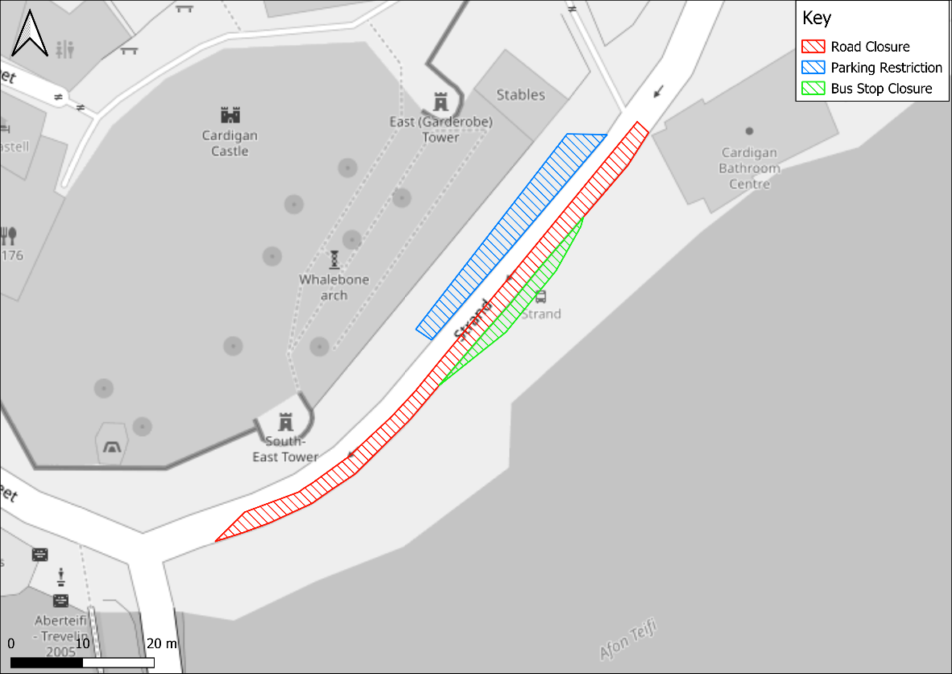
Plate 2-6 – Extent of temporary road closure, parking restrictions and bus stop closure on Strand
The anticipated traffic volumes for different construction activities are set out in Table 2-1, expressed as average daily movements. One movement comprises one vehicle entering or leaving the site.

Table 2-1 – Approximate material volumes and vehicle movements
Works element | Vehicle Movements | Comments/assumptions
Sheet piling | 8 articulated wagons (40t)  (2 months) | Could depend on size loads to site and potential for efficiencies such as double handling etc.
Granular fill / piling platform | 655 tipper wagons (20t)  (6 months) | Based on piling platform for full length. Single access.
Granular fill (removal) | 492 tipper wagons (20t)  (3 months) | Overburden for piling matt and over dig for granular base. Could reduce but no allowance made for other disposal.
Rip rap | 137 tipper waggons (20t)  (1 month) | -
Stone facing | 59 tipper wagons (20t)  (4 months) | Based on 300mm thickness as per drawings (150mm per side).
Copings | 5 artic wagons (40t)  (1 month) | Based on thickness as per drawings.
Concrete | 133 concrete wagons  (2 months) | Assumes concrete fill to piles down to foundation level.
Other disposal | Potential need for 20 tipper waggons (20t)  (3 months) | May be some disposal but it is assumed based on the current design this would be fairly minimal.
Other vehicles | 12-18 light vehicles | Peak numbers likely to increase towards 18 when works overlap.
Construction activities will overlap, for example completion of sheet pile installation in one area will be followed by concrete pours and stonework cladding while sheet pile installation continues in subsequent areas. It is anticipated that the works would begin within Area 4, working back towards Area 1 to allow for access along the haul route throughout the works.

Programme
It is expected that the proposed construction works would start in early 2027, once all approvals have been attained, and take approximately 18 months to complete. Construction durations are estimates and are dependent on the appointed contractor and their detailed construction method statement.
Riverside works would have to take place during suitable tide conditions for the specific task and so may need to be programmed for outside of normal working hours. No piling will take place outside of normal working hours.

Consultation

Public Consultation
Through the course of the Scheme development NRW have sought to engage with the local community. Two public consultation events have taken place which have informed the Scheme design:
- A public consultation event took place on 23rd November 2022 at Cardigan Castle to present the options appraisal process and seek the views of the local community on their preferred option from the short-listed options. Information was also available to view online between 11th November and 22nd December 2022. Respondents generally preferred Option 1 due to the improved public realm features. This informed the design through the development of the public realm enhancement in Area 1.
- An online public consultation period between 3rd and 23rd June 2025 sought views from the public and other stakeholders on options for the public realm enhancements in Area 1. There was a general preference towards the provision of wider pavements for accessibility purposes and undertaking tree planting to provide amenity value and shade during warm weather. Additionally, Cadw voiced their preference to not plant trees in front of the main walls of Cardigan Castle as this would affect views of the castle. As detailed in section 2.24 (landscape design) of the ES, these preferences have been incorporated into the Scheme design.

Habitats Regulations Assessment consultation with NRW
A consultation meeting was held on 19th October 2023 with terrestrial and marine fisheries specialists at NRW where the scope of the Habitats Regulations Assessment (HRA) and proposed mitigation requirements regarding disturbance to various migratory fish species were agreed.
The feedback received during this meeting was included in the production of the HRA (APEM, 2025), which accompanies the Environmental Statement.

Consultation with Ceredigion County Council and NRW
A consultation workshop with environmental, ecological geomorphological specialists at Ceredigion County Council and NRW took place on 18th November 2025. The purpose of this workshop was to present the Scheme design with a focus on how the design has been influenced by environmental conditions and a need to mitigate environmental impacts (see section 2.2.4 of the ES for details of this).
Attendants at the workshop had the opportunity to ask questions following a presentation by the project team. In general, attendees were supportive of the measures taken to mitigate the environmental impacts and deliver a Scheme which reduces flood risk to properties while minimising effects to the environment.
Following the workshop presentation slides and meeting minutes were issued to all attendees, no further follow up questions or responses were received.

Formal Pre-application Consultation
Pre-application consultation for the Scheme, in accordance with The Planning (Wales) Act 2015, was undertaken from 7th April 2026 through to 18th May 2026. As part of this consultation process, notices were placed on site, and notice was served on relevant consultees, including all known affected landowners and occupiers.
The pre-application consultation submission included the Environmental Statement, Habitat Regulations Assessment, Design and Access Statement, Planning Statement, Green Infrastructure Statement, scaled plans and drawings as well as several other technical documents. These were made available to view online and at Cardigan Library.
Following completion of the consultation period a Pre-Application Consultation Report was prepared to document the responses received, issues raised and how these have affected the Scheme design and planning application. The Pre-Application Consultation Report is submitted along with the other application documentation in support of the planning application.

Planning Framework

Planning Authority
The Scheme falls within the boundary of Ceredigion County Council and therefore falls under the Ceredigion Local Development Plan (Ceredigion County Council, 2013).
The following section provides an overview of the key national and local planning policies that are relevant to the site and proposed works.

National Planning Policy

National Strategy for Flood and Costal Erosion Risk Management (2020)
The Welsh Government National Flood and Coastal Erosion Risk Management Strategy (Welsh Government, 2020) sets out how the Welsh Government intends to manage the risks from flooding and coastal erosion across Wales. The national strategy objectives set the framework for flood and coastal erosion risk management work within Wales:
A. Improving our understanding and communication of risk
B. Preparedness and building resilience
C. Prioritising investment to the most at risk communities
D. Preventing more people becoming exposed to risk
E. Providing an effective and sustained response to events.
Every flood risk management action undertaken in Wales must aim to fit with overarching National Flood and Coastal Erosion Risk Management strategy objectives. The Cardigan Tidal Flood Risk Management Scheme (‘the Scheme’) directly achieves three of these objectives by providing an effective and sustained response; prioritising investment to the more at risk communities; and, preparedness and building resilience.

Natural Resources Wales Flood Risk Management Plan 2023 to 2029

National Overview
The first section of the Natural Resources Wales (NRW) Flood Risk Management Plan (FRMP) (Natural Resources Wales, 2023)provides a national overview of where is at risk of flooding in Wales and sets out NRWs Wales-wide Objective, Priorities and Measures for managing the risk of flooding from 2023 to 2029.
The FRMP Objective is to ‘Reduce the risk to people and communities from flooding from main rivers, reservoirs and the sea’. The FRMP identifies 14 priorities:
Priority 1: Respond to the climate and nature emergencies by seeking innovative practices, promoting adaptation and preparing for future change.
Priority 2: Develop and deliver catchment approaches to reduce flooding and contribute to ecosystem resilience, working with partners and stakeholders where possible and appropriate.
Priority 3: Improve community resilience to current and future flood risk. Work with partners to support communities to become more aware and take action to mitigate their own flood risk.
Priority 4: Seek and take opportunities for enhancement to the health and wellbeing of communities, biodiversity and the environment, and the wider benefits they provide, to support NRW’s response to the Nature Emergency.
Priority 5: Increase resilience of flood risk management assets, to reduce the impacts of current and future flood risk
Priority 6: Improve effectiveness of our key products and services, including our digital services, to provide improved services to the public.
Priority 7: Continuously improve our understanding and communication of current and future flood risk (including climate change) so that decisions are based upon the best available evidence and information.
Priority 8: Provide an effective and sustained response to flood events, working in collaboration with Risk Management Authorities and Professional Partners where required.
Priority 9: Continually improve our flood warning service to enable people to take effective action in response to flooding.
Priority 10: Provide effective planning advice on flood risks and consequences to reduce inappropriate development in areas at risk of flooding.
Priority 11: Prioritise our work on a risk basis in alignment with Welsh Government’s National FCERM Strategy and develop our evidence base to secure future investment in flood risk management.
Priority 12: Promote, support and implement nature-based solutions where appropriate to reduce the risk and impacts of flooding and to deliver wider ecosystem benefits.
Priority 13: Undertake our strategic oversight role to understand all sources of flood risk on a national basis to inform investment and optimise how we plan work including with other partners.
Priority 14: Ensure we have an FCERM workforce with the appropriate capabilities and skills required to meet our priorities and respond to future challenges.
The FRMP National Overview section provides further information on the level of risk, including what NRW have planned for the communities with the greatest flood risks. By taking an all-Wales approach to the FRMP, NRW can ensure that they prioritise directing efforts to where is at greatest risk of flooding. This is possible through the use of the Wales wide Communities at Risk Register (CaRR) that considers a number of factors to identify the locations (communities) at greatest risk of flooding. Cardigan is identified by the CaRR as a community at risk of flooding.

Mid Wales Place
The second section of the NRW Flood Risk Management Plan is split according to NRW Operational areas, also known as NRW Places. Cardigan is located within the Mid Wales Place. The Mid Wales Place section of the FRMP (Natural Resources Wales, 2023) provides information about the level of risk at a local scale and describes what is planned for the communities that NRW are most concerned about. The FRMP identifies Cardigan as one of the five communities in Mid Wales Place that are projected to experience the biggest change in danger from the risk of flooding from the sea by 2120.
Measure M8 of the Delivery Plan for the Mid Wales Place is ‘Design and construction of flood alleviation scheme’ for Cardigan, to be delivered in the short term. This links to FRMP Priority 1.
Overall, the Scheme is in accordance with and is part of delivering the NRW Flood Risk Management Plan.

West of Wales Shoreline Management Plan 2
Shoreline Management Plans (SMPs) set out a shared strategic approach for managing the coastline from coastal flooding and erosion risks. Their aim is to reduce the risks to people, the developed, historic and natural environments over the next century. SMPs are not statutory documents, but the Welsh Government want to see them considered both in local decision-making and strategic planning.
Cardigan is on the shoreline covered by the West of Wales Shoreline Management Plan 2 (SMP2) (West of Wales Coastal Group, 2012). SMP2 divides the coastline into Policy Development Zones (PDZs), within are further split into small sections called policy units. SMP2 describes how these sections will be managed over the:
- short-term (2005-2025)
- medium-term (2025-2055)
- long-term (2055-2105).
There are four approaches that can be applied to each policy unit, for each period of time, based on coastal characteristics, flood risk, and socio-environmental priorities:
- Hold the line (HTL) by maintaining or changing the existing standard of protection
- Advance the line (ATL) by building new defences on the seaward side of the original defences (although none applied in Wales)
- Managed realignment (MR) which allows the shoreline to move backwards and forwards, with management to control or limit the movement
- No active intervention (NAI) where there is no investment in coastal defences and natural processes are allowed to continue to create an evolving coastline
Cardigan is within PDZ 5 and the Strand area of Cardigan on the north bank of the River Teifi (Afon Teifi) is within Policy Unit 5.11, Cardigan North. The SMP2 policy for Policy Unit 5.11 is Hold the line in the short, medium and long term. SMP2 includes a preferred policy to implement the plan for PDZ 5, which includes ‘Maintain and improve defence to north and south Cardigan’ in the medium-term.
The Scheme is in accordance with SMP2 policy to Hold the line for Policy Unit 5.11, but the design does require installing a new flood defence on seawards side of the existing sea wall in some areas: the need for this is set out in Chapter 1: Introduction. When considering compliance with a Hold the line policy, section 5.7.8 of the Shoreline Management Plans: Supplementary guidance for their ongoing maintenance and delivery – Wales (NRW, 2021) states:
“The definitions set out in the 2006 Guidance (volume 1, section 2.3) clearly state that use of the Advance the Line policy should be ‘limited to those policy units where significant land reclamation is considered’. This descriptor should not be used for areas where there are already defences but works might encroach seaward to enable the same assets to be protected. This is also covered by the 2006 Guidance, which further states that a Hold the Line policy covers ‘those situations where work or operations are carried out in front of the existing defences …. to improve or maintain the Standard of Protection provided by the existing defence line’.”
One of the examples given in the Supplementary Guidance of Hold the Line (Maintain / Replace) is “Rebuilding with a new line of sheet piling in front of the existing toe to sustain that existing defence line”. The Scheme accords with this example and is therefore considered to be compliant with the Hold the line policy.

Future Wales – The National Plan 2040 (2021)
The Welsh Government formally adopted “Future Wales: The National Plan 2040 (Future Wales)” (Welsh Government, 2021) in August 2019 which was updated in February 2021. Future Wales outlines the Welsh Government’s strategies for addressing key national priorities through the planning system, including sustaining and developing a vibrant economy, delivering growth in the right areas, achieving decarbonisation and climate-resilience, developing strong ecosystems and improving the health and well-being of communities. Future Wales now forms part of the statutory development plan. Future Wales sub-divides Wales into four regions with the application Site located within the Mid Wales region. A total of 36 policies are contained within Future Wales of which 19 are thematic and the remainder relate to the four regions.
The policy in this document relevant to the Scheme includes Policy 9 ‘Resilient Ecological Networks and Green Infrastructure’. Policy 9 aims to promote the enhancement of biodiversity, the resilience of ecosystems and the provision of green infrastructure where possible. The plan states that the Welsh Government will work with key partners to:
- Identify areas which should be safeguarded and created as ecological networks for their importance for adaptation to climate change, for habitat protection, restoration or creation, to protect species, or which provide key ecosystems services, to ensure they are not unduly compromised by future development.
- Identifying opportunities where existing and potential green infrastructure could be maximised as part of placemaking, requiring the use of nature-based solutions as a key mechanism for securing sustainable growth, ecological connectivity, social equality and well-being.

Planning Policy Wales (Edition 12, February 2024)
Planning Policy Wales (PPW) (Welsh Government, 2024a)forms the overarching national planning policy documents within Wales. It contains legislative requirements and reflects Welsh Government expectations. It sets out the material considerations that LPAs must consider in determining an application.
Policies from PPW which are most relevant to the project and that have informed the design process and environmental assessment are outlined below:
Chapter 3 – Strategic and Spatial Choices
3.8 - Good design can help to ensure high environmental quality, landscape and green infrastructure considerations are an integral part of the design process.
3.9 - The layout, form, scale and visual appearance of a proposed development and its relationship to its surroundings are important planning considerations.
Chapter 6 – Distinctive and Natural Places
6.2.4 - Green infrastructure plays a fundamental role in shaping places and our sense of well-being, and are intrinsic to the quality of the spaces we live, work and play in. The planning system should protect and enhance green infrastructure assets and networks because of these multi-functional roles.
6.4.2 - The Environment (Wales) Act 2016 introduced an enhanced biodiversity and resilience of ecosystems duty (Section 6 Duty). This duty applies to public authorities in the exercise of their functions in relation to Wales and will help maximise contributions to achieving the well-being goals.
6.4.3 – Development plan strategies, policies and development proposals must consider the need to:
- support the conservation of biodiversity, in particular the conservation of wildlife and habitats;
- ensure action in Wales contributes to meeting international responsibilities and obligations for biodiversity and habitats;
- ensure statutorily and non-statutorily designated sites are properly protected and managed;
- safeguard protected and priority species and existing biodiversity assets from impacts which directly affect their nature conservation interests and compromise the resilience of ecological networks and the components which underpin them, such as water and soil, including peat; and
- secure enhancement of and improvements to ecosystem resilience by improving diversity, condition, extent and connectivity of ecological networks.
6.4.5 - Planning authorities must seek to maintain and enhance biodiversity in the exercise of their functions. This means development should not cause any significant loss of habitats or populations of species, locally or nationally and must provide a net benefit for biodiversity. In doing so planning authorities must also take account of and promote the resilience of ecosystems, in particular the following aspects:
- diversity between and within ecosystems;
- the connections between and within ecosystems;
- the scale of ecosystems;
- the condition of ecosystems including their structure and functioning; and
- the adaptability of ecosystems.
6.4.21 - Planning authorities must follow a step-wise approach to maintain and enhance biodiversity and build resilient ecological networks by ensuring that any adverse environmental effects are firstly avoided, then minimised, mitigated, and as a last resort compensated for; enhancement must be secured wherever possible... where the adverse effect on the environment clearly outweighs other material considerations, the development should be refused.
6.4.27 - The protection and planting of trees and hedgerows should be delivered, where appropriate, through locally specific strategies and policies, through imposing conditions when granting planning permission, and/or by making Tree Preservation Orders (TPOs). They should also be incorporated into Green Infrastructure Assessments and plans.
A Green Infrastructure Statement should be submitted with all planning applications.
Relevant Technical Advice Notes (TANs):
- TAN 5: Nature Conservation and Planning.
- TAN 12: Design.
- TAN 15: Development and Flood Risk.

Environment (Wales) Act 2016
The Welsh Sustainable Management of Natural Resources (SMNR) principles referenced in Planning Policy Wales are derived from the Environment (Wales) Act 2016 (Welsh Government, 2024b). The legislation established a framework for how natural resources should be managed sustainably in Wales to ensure environmental and socioeconomic benefits for current and future generations. The nine SMNR principles are outlined below:
- Adaptive management
- Collaboration and engagement
- Public Participation
- Long-term Consideration
- Preventative Action
- Evidence Based Decision Making
- Integrated Approaches
- Ecosystem Resilience
- Multiple Benefits from Natural Resources.
The incorporation of these principles is considered key for developments to contribute towards the achievement of the well-being goals of the Well-being of Future Generations (Wales) Act 2015.

Well-being of future generations (Wales) Act 2015
The Well-being of Future Generations Act 2015 (Welsh Government, 2024c) requires public bodies in Wales to improve the well-being of the current and future generations of the Welsh population. The act sets out well-being goals which are primarily achieved through the implementation of the SMNR principles, but the act also encourages public bodies to consider the long-term implications of decision making. Public bodies are encouraged to ensure collaboration and public participation.

Natural Resources Policy
The Welsh Governments Natural Resources Policy (NRP) (Welsh Government, 2017)sets out the strategic priorities for managing Wales’s natural resources sustainably. It aims to align environmental management with socioeconomic goals under the Well-being of Future Generations (Wales) Act 2015. The NRP highlights the following strategic priorities which are relevant to the Scheme:
- Nature-based solutions
- Climate and ecosystem resilience
- Place based approach
- Circular economy and sustainable practice
- Collaboration and engagement

Local Planning Policy

Ceredigion Local Development Plan (LDP1) - 2007-2022
Ceredigion Local Development Plan (LDP1) - 2007-2022 (Ceredigion County Council, 2013) was adopted in 2013 and remains the current Planning Policy. The replacement Ceredigion Local Development Plan (LDP2 - 2018-2033) is currently being drafted.
Relevant policies from the current Ceredigion Local Development Plan (CLDP) are:
- Policy LU22: Community Provision
- Policy LU32: Development and the Waste Hierarchy
- Policy DM06: High Quality Design and Placemaking
- Policy DM07: Conservation Areas
- Policy DM11: Designing for Climate Change
- Policy DM14: Nature Conservation and Ecological Connectivity
- Policy DM15: Local Biodiversity Conservation
- Policy DM17: General Landscape
- Policy DM18: Special Landscape Areas (SLA)
- Policy DM19: Historic and Cultural Landscape
- Policy DM22: General Environmental Protection and Enhancement
- Policy DM23: Coastal Management.

Assessment of the Scheme against Planning Policy
Relevant key planning policy has been considered throughout the design process and environmental assessment to ensure that the Scheme is in keeping with, and will not work against, policy goals. The relevant planning considerations have been grouped into key topic areas within Table 5-1 and relevant corresponding policies from the CLDP and other relevant planning policy have been referenced.
Table 5-1 Assessment of the Scheme against Planning Policy
Topic Area | Assessment against Planning Policy
Principle of Development | - Every flood risk management action undertaken in Wales must aim to fit with the overarching National Flood and Coastal Erosion Risk Management strategy objectives. The Scheme directly achieves three of these objectives by providing an effective and sustained response; prioritising investment to the more at risk communities; and, preparedness and building resilience.  - The Scheme contributes to the Resilient Wales well‑being goal by contributing towards ensuring the local community’s health, wellbeing and safety is protected in the long term by reducing flood risk and accounting for the likely increased frequency of storms, adverse weather and sea level rise associated with climate change.  - The Scheme has been designed to maintain and enhance community provision in line with CLDP Policy LU22 ‘Community Provision’ by avoiding the loss of existing community provisions and providing alternatives where loss is unavoidable. The Scheme requires the closure of the slipway next to Cardigan Bay Activeand Gloster Row slipway but will provide a new up and over slipway for the Sea Scouts and other permitted organisations to avoid the loss of existing community access to the Afon Teifi. The current use of the public slipway at Gloster Row car park is minimal and therefore the impact on the local community is not considered significant.
Sustainability and Climate Change | - CLDP Policy DM11 ‘Designing for Climate Change’ requires developments to consider the implications of climate change and long-term sustainability. The Scheme has been designed to a design standard of 1 in 200 years annual exceedance probability, with allowance for future climate change. The Scheme has a design life of 100 years which reduces the need for future upgrades or rebuilding. The long-term sustainability of the Scheme has been considered throughout the design process. Material selection and energy usage have been considered to minimise embedded carbon and emissions through the use of a carbon calculator. Alternative alignments and reduction of sheet pile lengths have helped to reduce material requirements and associated embedded carbon.  - Future Wales states that changes in the climate and weather patterns will have a significant impact on well-being on both current and future generations. Increased temperatures and extreme weather events caused by climate change will put additional pressure on ecosystems, infrastructure and the built environment. The Welsh Government’s Natural Resources Policy (NPR) outlines the need for climate change adaption and mitigation and social, economic, and ecological resilience. As described, the Scheme would provide climate-resilient infrastructure to reduce flood risk protecting communities now and into the future.
Flood Risk | - CLDP Policy DM23 ‘Coastal Management’ requires developments to be necessary for public safety, protect community socioeconomic interests, consider environmental effects and that recreational facilities and public access are maintained by the development. The Scheme has considered each of these aspects through the design process and environmental assessment undertaken within the environmental statement.  - The Scheme has been designed to fit with the overarching National Flood and Coastal Erosion Risk Management strategy objectives. The proposed Scheme directly achieves three of these objectives by providing an effective and sustained response; prioritising investment to the more at risk communities; and, preparedness and building resilience.
Design and Visual Impact | - CLDP Policy DM06 ‘High Quality Design and Placemaking’ supports development proposals of a high standard of design, which positively contributes to the context of the location and surroundings. The design of the Scheme has considered public consultation feedback regarding preferences for wider pavements and more green areas. To blend into the context of the local surroundings, the flood defence wall will be clad with stone to reflect the existing river side walls and complement the stone used within Cardigan Bridge and Cardigan Castle. Within Area 1, the pavement will be widened and be paved in slate which is in keeping with existing paving material used in the area.  - CLDP Policy DM17 ‘General Landscape’ requires that the Scheme does not have a significant adverse effect on the qualities and special character of the visual, historic, geological, ecological or cultural landscapes and seascapes of Ceredigion by causing significant visual intrusion, being insensitively sited, introducing incompatible features or not being harmonious with the landscape, or by loss of traditional or important features. The design of the Scheme has included the use of sympathetic materials as noted above, but also includes the provision of tree planting and pavement widening to enhance visual amenity in the area.  - CLDP Policy DM18 ‘Special landscape Areas (SLA’S)’ requires that proposals for development within SLAs are assessed in relation to scale and nature of development and their ability to be accommodated without significant damage to, and where possible the enhancement of, the valued visual, historic, geological, ecological and cultural characteristics of the SLA. The Scheme is located on the periphery of (SLA) 7: Teifi Valley, which is defined for its distinctive and coherent sinuous river valley and wooded tributaries. The SLA description does account for the character of the river valley changing as it passes through Cardigan where it is constricted by the urban surroundings, and also for being open with mudflats downstream of Cardigan.  - CLDP Policy DM19 ‘Historic and Cultural Landscape’ requires that development does not significantly adversely affect the distinctive appearance, architectural integrity or setting of landscapes or buildings which are of historical or cultural importance.  - A Landscape and Visual Assessment has been undertaken as part of the Environmental Statement to ensure that likely significant effects upon landscape receptors are minimised. An Environmental Masterplan and Green Infrastructure Statement have been prepared which highlight the approach to landscape within the design. The approach taken is considered to be in line with the LDP Policy.
Landscape and Trees | - CLDP Policy DM06 ‘High Quality Design and Placemaking’ requires that natural features including trees are retained. Minimal vegetation clearance will be required to enable the Scheme. Trees will be planted and planting beds will be installed to provide biodiversity and visual amenity benefit.
Natural Environment | - CLDP Policy DM14 ‘Nature Conservation and Ecological Connectivity’ requires developments to protect, and where possible enhance biodiversity, geodiversity and ecological connectivity across Ceredigion, including local sites and local priority species and habitats.  - CLDP Policy DM15 ‘Local Biodiversity Conservation’ requires the adoption of a step-wise approach which incorporates enhancements, mitigation and compensation measures where appropriate.  - CLDP Policy DM22 ‘General Environmental Protection and Enhancement’ requires that developments protect and enhance air, water, soil and the water environment where possible, whilst avoiding significant adverse effects upon noise and light levels both on and off site. A step wise approach must be adopted to ensure that the Scheme does not have a significant adverse effect on natural processes and ecosystem services, both on and off site, and, where possible, seeks to restore, achieve favourable condition of or enhance associated features.  - CLDP Policy DM23 ‘Coastal Management’ requires developments to be necessary for public safety, protect community socioeconomic interests, consider environmental effects and that recreational facilities and public access are maintained by the development.  - The provision of Net Benefit for Biodiversity is detailed within the supporting Green Infrastructure Statement. This sets out how a net benefit will be achieved though the implementation of green infrastructure and biodiversity enhancements.  - The Biodiversity and Nature Conservation assessment has been undertaken as part of the Environmental Statement and identifies mitigation requirements and enhancements. Mitigation requirements and enhancements are also discussed within the Green Infrastructure Statement, Environmental Constraints and Opportunities Plan, and Environmental Masterplan. Through these measures, the Scheme will ensure the site’s ecological network is protected in line with the requirements of the LDP Policy.  - The engineered riverbank provides habitat benefits by creating a more naturalised frontage in place of an exposed hard‑engineered wall. The use of rock rolls and graded planting areas is intended to produce varied microhabitats which support the establishment of intertidal communities. Sediment accumulation within the rock roll structures will encourage colonisation by seaweeds, lichens, and other estuarine species, while the upper planted sections offer additional vegetated habitat. Together, these features enhance biodiversity, promote more resilient intertidal ecosystems, and deliver a softer, more natural river edge within an otherwise engineered flood defence scheme.  - The set back flood defences within Area 4 provide mitigation for intertidal habitat losses within Areas 1-3. To facilitate the establishment of intertidal habitat within this area, the existing upper gabion wall would be removed and the ground levels lowered to levels suitable for regular tidal inundation. The lower section of gabion wall would be retained with existing habitat that has formed on them as this will aid the re-establishment and colonisation of saltmarsh species in the area. The lower section of gabion wall will also protect the setback area from being washed out by the tide.  - Project development has been carried out in accordance with the SMNR Principles, including collaboration between NRW and CCC and stakeholder engagement, to provide multiple benefits, resilience to the community of Cardigan and ecosystems, and to prevent impacts from the Scheme.
Archaeology and Cultural Heritage | - CLDP Policy DM07 ‘Conservation Areas’ requires that developments demonstrate that regard has been given to conservation areas.  - CLDP Policy DM19 ‘Historic and Cultural Landscape’ requires that developments affecting landscapes or buildings of historical or cultural importance which contribute to the character and interest of the local area avoid adverse effects and enhance these qualities where possible.  - The design of the Scheme has considered the historical setting and buildings present within the town and aims to minimise intrusion. To blend into the context of the local surroundings, the flood defence wall will be clad with stone to reflect the existing river side walls and complement the stone used within Cardigan Bridge and Cardigan Castle. Within Area 1, the pavement will be widened and be paved in slate which is in keeping with existing paving material used in the area.  - The Scheme will not have a long-term impact upon the historic character of Cardigan other than negligible to low magnitude (non-significant) effects upon certain viewpoints. During construction, there will be temporary impacts upon the visual setting.
Access | - CLDP Policy DM23 ‘Coastal Management’ requires developments to be necessary for public safety, protect community socioeconomic interests, consider environmental effects and that recreational facilities and public access are maintained by the development.  - Whilst there will be temporary loss of access along footpaths and part of the road along Strand, access through this area will be maintained throughout the construction phase.  - Gloster Row car park will be closed during the construction phase for safety. Public access to properties surrounding the car park will be retained throughout the construction phase. Due to the alignment of the Scheme defences, the car park has been redesigned to limit the loss of existing parking spaces. The car park currently consists of 23 spaces including one disabled space, this will reduce to 17 spaces including one disabled space, a loss of 6 car parking spaces.  - Due to the alignment of the Scheme defences, the existing footpath in Area 1 would be widened once the existing highway wall is removed. This would create an enhanced accessible public amenity area, which would be further enhanced with ornamental planting. This would primarily provide an aesthetic enhancement to the area.  - The existing slipway next to Cardigan Bay Active and Gloster Row slipway will be permanently closed due to the implementation of the Scheme. A new up and over canoe/kayak access ramp will be constructed to the south of the Old Foundry site which would retain access to the Afon Teifi for the existing users of the closed slipways. It is understood that the Gloster Row slipway is currently only infrequently used by anglers and therefore the loss of this slipway will have minimal impact.  - Through consultation with Afon Teifi Fairways Limited (ATFL), it is understood that emergency services do not rely on either of the slipways which are to be permanently closed, as they only use the slipway on the southern bank of the Afon Teifi for access.
Waste | - CLDP Policy LU32 ‘Development and the Waste Hierarchy’ requires development proposals to demonstrate how waste will be minimised and managed in accordance with the waste hierarchy where applicable, in the design and during construction / demolition phases. Throughout the construction phase of the Scheme, best practice waste management and reduction measures will be utilised.

Conclusions
The Strand area of Cardigan on the north bank of the Afon Teifi, which includes residential and commercial properties, is vulnerable to flooding and multiple flood events have occurred since 2007. A tidal flood on 3 January 2014 inundated 29 properties on St Mary’s Street. This area will become increasingly vulnerable with predicted future sea levels rise. Low-lying residential and commercial properties, particularly on Strand, are highly vulnerable.
The Scheme has been designed to reduce the risk of tidal flooding to the town and community of Cardigan, taking account of predicted sea level rise. This would be achieved by creating new flood defences, which would afford a greater standard of flood protection to properties currently at risk of flooding. The Scheme has been designed to 4.95m AOD to meet the 1 in 200 design standard with climate change and would allow for 0.2m of freeboard, accounting for uncertainty in long range forecasting of the effects of climate change.
The design complies with both national and local planning policy to support the community and reduce the risk posed by tidal flooding in Cardigan. Through the identification of relevant planning policy, consultation and environmental assessment, the Scheme design protects the existing biodiversity value and resilience, is in keeping with the existing landscape character, protects heritage features, maintains recreational access, and provides net benefits for biodiversity and public safety though the use of green infrastructure.

References
APEM. (2025). Cardigan Tidal Flood Risk Management Scheme - Habitats Regulation Assessment. APEM Report P00016173: December 2025.
Ceredigion County Council. (2013). Ceredigion Local Development Plan 2007-2022.
Natural Resources Wales. (2023). Flood Risk Management Plan (FRMP) 2023 to 2029. Retrieved from Available at: https://naturalresources.wales/evidence-and-data/research-and-reports/flooding-reports-evidence-and-data/flood-risk-management-plans/?lang=en
Natural Resources Wales. (2024a, November). Development Advice Map. Retrieved from cyfoethnaturiolcymru.gov.uk: https://gisgeoext.cyfoethnaturiolcymru.gov.uk/Geocortex/Viewers/Html5Viewer_4145/index.html?viewer=FloodRisk
Natural Resources Wales. (2024b, November). Flood Map for Planning. Retrieved from naturalresources.wales: https://flood-map-for-planning.naturalresources.wales/
Welsh Government. (2012). The Town and Country Planning (Development Management Procedure) (Wales) Order 2012. Welsh Government.
Welsh Government. (2017). National Resorces Policy. Welsh Government.
Welsh Government. (2018). Statutory Standards for Sustainable Drainage Systems - Designing, Constructing, Operating and Maintaining Surface Water Drainage Systems. WG36005 .
Welsh Government. (2020). National Strategy for Flood and Coastal Erosion Risk Management in Wales. Retrieved from Available at: https://www.gov.wales/sites/default/files/publications/2021-03/the-national-strategy-for-flood-and-coastal-erosion-risk-management-in-wales.pdf
Welsh Government. (2021). Future Wales - The National Plan 2040. Retrieved from gov.wales: https://www.gov.wales/sites/default/files/publications/2021-02/future-wales-the-national-plan-2040.pdf
Welsh Government. (2024a). Planning Policy Wales - Edition 12. Retrieved from gov.wales: https://www.gov.wales/sites/default/files/publications/2024-07/planning-policy-wales-edition-12.pdf
Welsh Government. (2024b). Environment (Wales) Act 2016. Retrieved from legislation.gov.uk: https://www.legislation.gov.uk/anaw/2016/3/contents
Welsh Government. (2024c). Well-being of Future Generations (Wales) Act 2015. Retrieved from legislation.gov.uk: https://www.legislation.gov.uk/anaw/2015/2/contents
West of Wales Coastal Group. (2012). West of Wales Shoreline Management Plan.

