Cardigan Tidal Flood Risk Management Scheme
Design and Access Statement
Client’s project no. CE0587
BUKL project no. 4021883
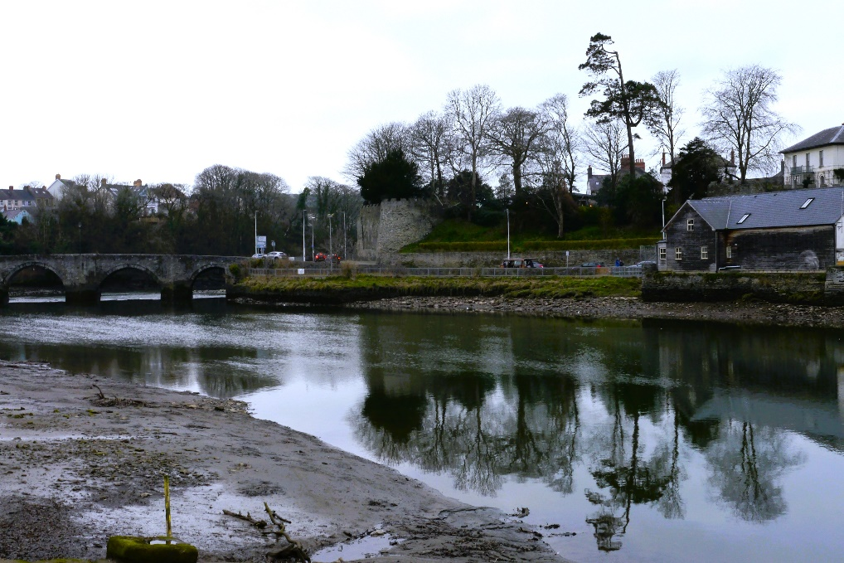
Prepared for:
Natural Resources Wales
Date: March 2026
Revision P01
Revision P01




Table of contents

1. Summary of the proposed development 1
1.1 Location 1
1.2 Type and scale of development 1
2. Development brief 2
2.1 Background 2
2.2 Purpose, brief and vision 2
3. Existing site and context 3
3.1 Site description 3
3.2 Site context 6
4. Interpretation 8
4.1 Meeting the Scheme brief and vision 8
5. Design development 10
5.1 Design approach 10
5.2 Identification of the preferred option 10
5.3 Preferred option development 11
5.4 Consultation 14
6. Proposed development 14
6.1 Overview 14
6.2 Consideration of good design objectives 15
6.3 Consideration of Local Development Plan 17

Details of document preparation and issue:
Version no. | Prepared | Checked | Reviewed | Approved | Issue date | Issue status
P01 | Myles Harding | David Johnson | Andrew Burwood | Alex Humphreys | 11/03/2026 | P03

BUKL project no. 4021883 |  | Client’s reference no. | CE0587
File name: | 4021883-BUK-ZZ-00-RP-EN-00030

Notice:
This report was prepared by Binnies UK Limited (BUKL) solely for use by Natural Resources Wales (NRW). This report is not addressed to and may not be relied upon by any person or entity other than NRW for any purpose without the prior written permission of BUKL. BUKL, its directors, employees and affiliated companies accept no responsibility or liability for reliance upon or use of this report (whether or not permitted) other than by NRW for the purposes for which it was originally commissioned and prepared.
In producing this report, BUKL has relied upon information provided by others. The completeness or accuracy of this information is not guaranteed by BUKL.

Summary of the proposed development

Location
This Design and Access Statement has been written to support the Planning Application for the Cardigan Tidal Flood Risk Management Scheme by Natural Resources Wales (NRW).
The Cardigan Tidal Flood Risk Management Scheme (TFRMS), hereafter referred to as ‘the Scheme’, is located towards the centre of Cardigan town, Ceredigion, in west Wales. The Scheme is positioned along the right bank (northern bank) of the River Teifi (Afon Teifi), upstream of Cardigan Bridge (Castle Street).
The nearest postcode is SA43 1EX. The location of the Scheme is shown on Plate 1-1.
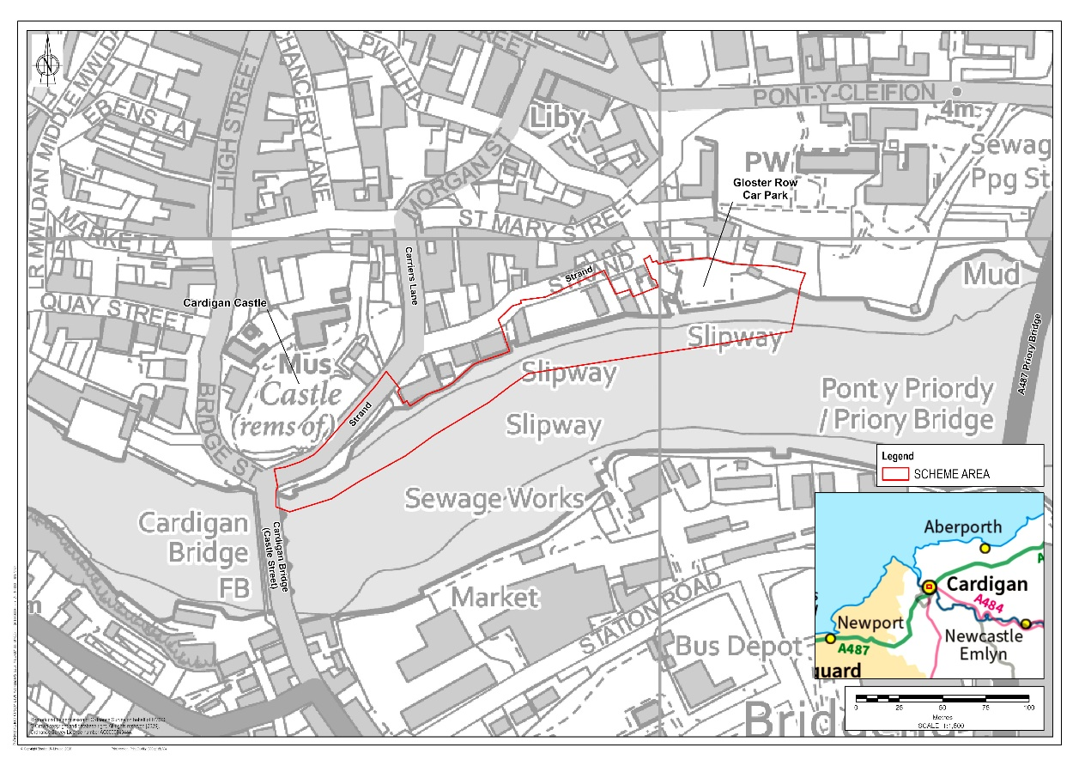
Plate 1-1 – Scheme Area Location Plan
Two remote temporary construction compounds are proposed: one east of the roundabout that forms the A487/A484 junction that has been used previously as a construction compound, and one in the Pentood Industrial Estate on the south side of the Afon Teifi Further details about access during construction is provided in the Planning Statement.

Type and scale of development
The Scheme is a tidal flood risk management scheme required to reduce the risk of tidal flooding to the town and community of Cardigan, which has historically been subject to flood events.
The main Scheme Area covers approximately 1.18 ha, plus the two remote temporary construction compounds with an area of 4,003 m². The flood defences proposed are 327m in length, with a footprint of approximately 1,500 m² within the main Scheme Area.
This Design and Access Statement (DAS) accompanies an application for full planning approval. The Development is considered Major Development as it is over the threshold of Development on a site with an area of 1 hectare or more. The Scheme also constitutes Environmental Impact Assessment (EIA) development as confirmed by EIA Screening Opinions received from Ceredigion County Council and NRW Marine Licencing. An Environmental Statement has been provided with this planning application.

Development brief

Background
Cardigan has a history of tidal flooding from the tidal reach of the Afon Teifi. Low-lying residential and commercial properties, particularly on Strand, are highly vulnerable, with thresholds below 3.1m above ordnance datum (AOD) and exposure to annual tidal flooding. The projected 0.5% Annual Exceedance Probability (AEP) (1 in 200) tidal level, including 100 years of climate change, is 4.75m AOD, which is well above current ground levels and therefore poses a risk of significant flooding.
Further background details are provided in the Planning Statement that accompanies the planning application.

Purpose, brief and vision
The purpose of the Scheme is to reduce the risk of tidal flooding to the town and community of Cardigan, taking account of predicted sea level rise. This would be achieved by creating new flood defences, which would afford a greater standard of flood protection to properties currently at risk of flooding.
The Scheme has been designed to 4.95m AOD to meet the 1 in 200 design standard with climate change and would allow for 0.2m of freeboard, accounting for uncertainty in long range forecasting of the effects of climate change.
The brief and vision for the Scheme are wider than the flood defence functions. The brief is for the Scheme to offer a flood defence which responds to its surroundings and context, in particular to its location within the settings of Cardigan Castle and Cardigan Bridge Scheduled Monuments, and Cardigan Conservation Area. The vision includes providing enhanced public realm to improve the experience of pedestrians and public transport users, and to incorporate. Green Infrastructure benefits into the Scheme to provide a net benefit for biodiversity and enhanced user experience.
The purpose, brief and vision of the Scheme are captured by the specific objectives and Critical Success Factors, set out below.
The specific objectives of the Scheme are to:
- Reduce the risk of tidal flooding to the town and community of Cardigan, taking account of predicted sea level rise.
- Maintain and enhance the natural environment, and the well-being of the community, helping to achieve NRW’s Well-Being Objectives and satisfy Environment (Wales) Act duties.
- Provide a solution that is sensitive to Cardigan’s important historic and landscape interest.
- Apply green-grey estuarine infrastructure to deliver a multi-functional Flood and Coastal Erosion Risk Management (FCERM) asset.
- Engage the community and deliver a publicly acceptable solution.
- Provide a solution that is cost beneficial.
- Work with Dŵr Cymru Welsh Water (DCWW) and Ceredigion Council to discuss their responsibilities, in terms of different types of flooding within the area.
The Scheme has been designed to meet the following Critical Success Factors (CSF) which are defined as attributes which are essential to the successful delivery of the Scheme, and which formed the project brief:
- Reduce present day and future flood risk to people and property in Cardigan, to improve the quality of life to the local community.
- Provide an economically viable option to manage flood risk, with a benefit cost ratio of greater than one.
- Develop a technically feasible option to manage flood risk, with consideration of site-specific constraints and the needs of the community.
- Minimise impacts on habitat and biodiversity and seek to provide enhancements.

Existing site and context

Site description
Detailed site descriptions are provided in the Environmental Statement for Population and Human Health, Biodiversity and Nature Conservation, Historic Environment, Landscape and Visual, Traffic and Transport, Water Environment and Land Use and Soils, and this detail is not repeated in this DAS.
The main Scheme Area is positioned along the right bank (northern bank) of the Afon Teifi, within the town of Cardigan. Existing infrastructure within the Scheme Area includes the current flood defences, a Dwr Cymru / Welsh Water (DCWW) outfall asset, private recreational and commercial buildings and private gardens, slipways at Gloster Row car park and by the Sea Scouts boat house, Gloster Row car park, Strand and the bank of the Afon Teifi.
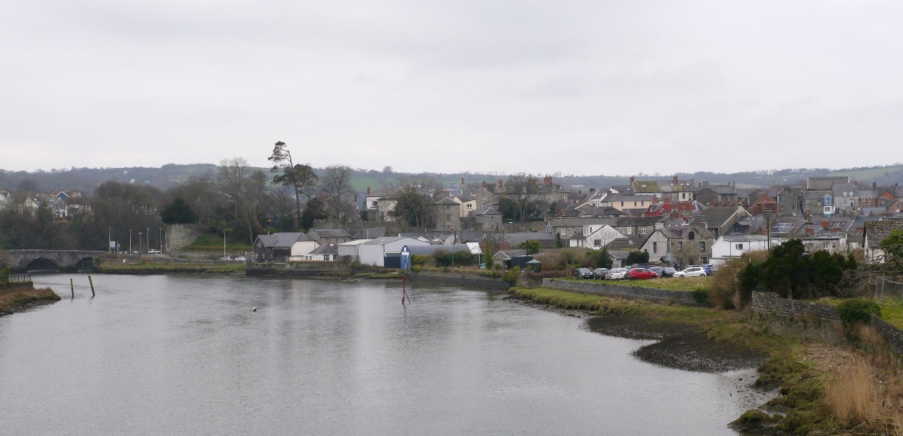
Maes Parcio Gloster Row
Castell Aberteifi
Plate 3-1 – View from Priory Bridge, looking west along the Scheme Area to Cardigan Bridge.
Strand is a one-way road located within the Scheme Area which provides access for local traffic to the town centre and to the south side of the river over Cardigan Bridge (Castle Street). There is a bus stop at the eastern end near a bathroom centre, though no seating or shelter are provided. The footway along the left carriageway of Strand is constrained by an existing low slate wall, and at the western end the topography is steep. Strand is a busy road with associated noise and pollution.
Between the Afon Teifi and the Strand footway is a lower plateau, where public access is restricted by the low wall. Steps to the lower plateau that would provide access are gated off. The plateau surface is paved, with metal railings along the riverside edge, and has become overgrown. At the western end of the plateau by the bathroom centre is the DCWW outfall asset. The inspection chamber associated with the outfall asset has been clad sensitively, similar to Cardigan Castle walls, however it is surrounded by metal railings which are incongruous.
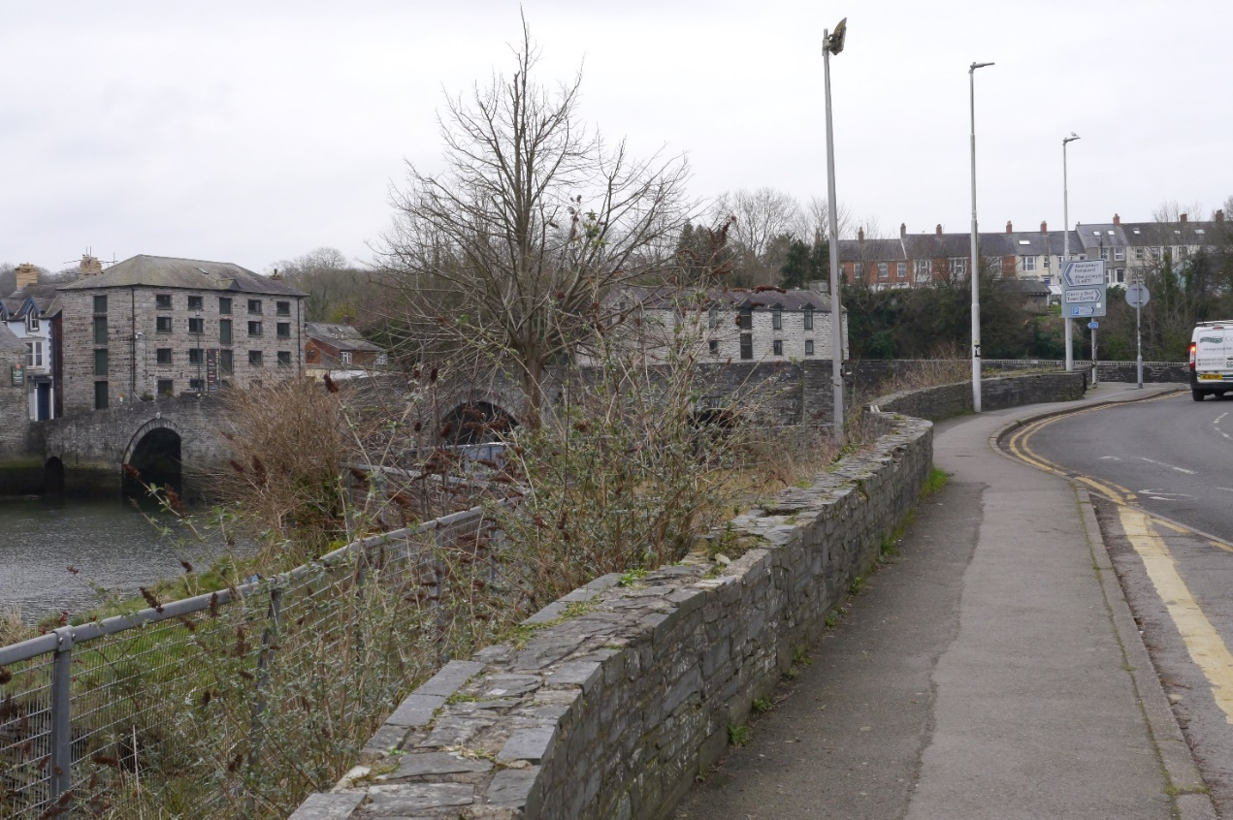
Plate 3-2 – View west along Strand from the bus stop showing the riverside wall, railings and overgrown inaccessible space in between. Cardigan Bridge Scheduled Monument can be seen in the background.
Private recreational facilities are present within the centre of the Scheme Area, at Old Foundry Site, comprising a boat house and scout hut with a shared grassed area between the two buildings. Both buildings and the slipway adjacent to the boat house are accessed from Strand and are used only by the Sea Scouts and other permitted organisations.
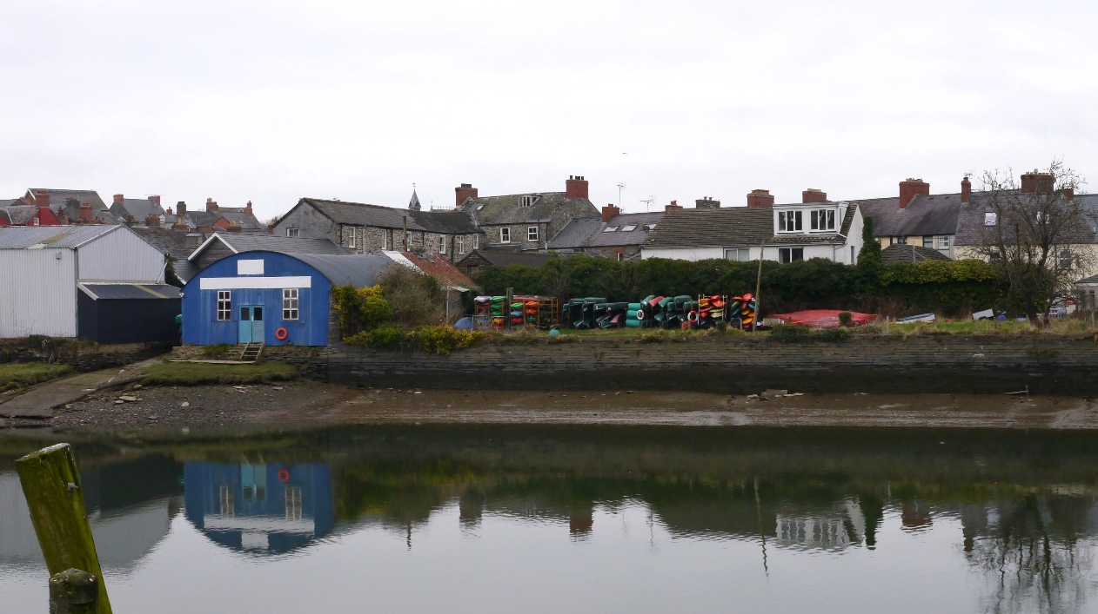
Plate 3-3 – View from the south bank, of Sea Scout’s boat house and slipway with grassed area used for boat storage.
At the eastern end of the Scheme Area, Gloster Row car park provides parking for 23 cars, including one disabled space. Gloster Row car park is accessed via Gloster Row, and in turn provides vehicular access to properties on Church Street. A slipway, although blocked off to vehicles, does provide pedestrian access to the river. A small grassed area is present adjacent to the car park and is publicly accessible.
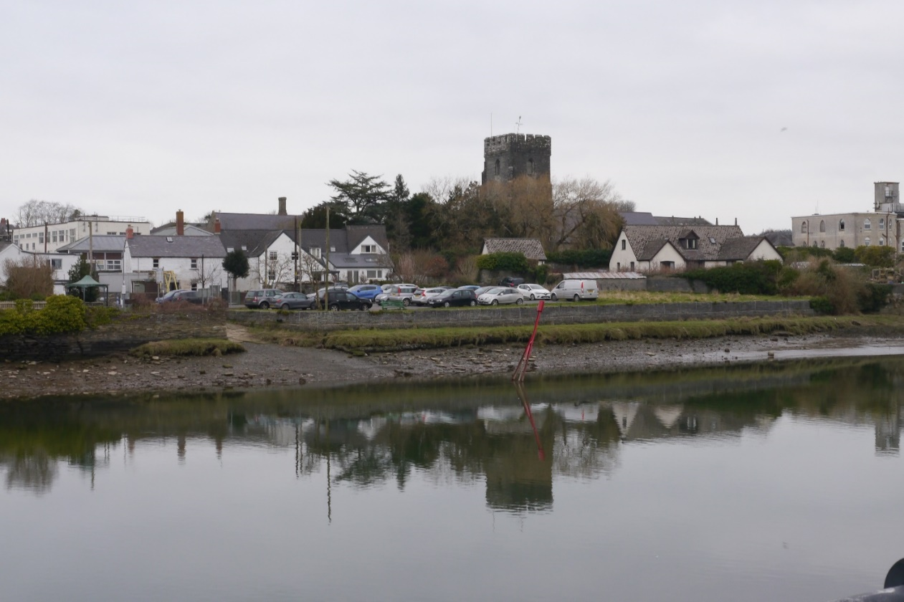
Slipway
Grassed open space
Properties on Church Street
Plate 3-4 – View from the south bank, of Gloster Row car park, slipway, surrounding open space and residential properties. St Mary’s Church Listed Building can be seen in the background.
The Old Foundry Site and Gloster Row car park are sited on level ground, with an existing flood defence wall providing a steep edge to the Afon Teifi.
As shown on the Location Plan (Figure 1.1), there are two proposed temporary compound areas included within the Scheme Area boundary which would be used for plant/material storage and housing welfare units during construction works. The proposed Northern Compound is located on the northern side of the Afon Teifi, just to the north of the Pont-y-Cleifion Road (SN 18239 46106). This compound area would be used as the main compound and laydown area for the works. This area has been proposed as it is close to the A487 turn off, which would allow access for large vehicles. The proposed southern compound is located on the southern side of the Afon Teifi (SN 17973 45829), adjacent to an existing slipway which could be used to access the river.

Site context
The Scheme is situated in an urban area, where the historic core of Cardigan meets the river and the commercial/industrial area on the south bank of the river. Outside of the historic core, built form is not cohesive and comprises a variety of construction materials.
The settlement is on gently sloping land in a valley bottom along the Afon Teifi, with which the town has a strong association. The river has extensive, sweeping mudflats, though these are constrained by flood walls as the river passes through Cardigan town. Mudflats are inundated at high tide. Special Landscape Area (SLA) 7: Teifi Valley follows the river and is defined for its distinctive and coherent sinuous river valley and wooded tributaries.
The Scheduled Monuments of Cardigan Castle (also a Registered Park and Garden) and Cardigan Bridge are immediately adjacent the Scheme Area to the west, and Cardigan Town Walls is 150m to the east of the Scheme Area. Important views from Cardigan Castle look over the Scheme Area. The majority of the Scheme Area falls within the Cardigan Conservation Area, which is linked to the medieval origins of the town. The slate used to clad the Cardigan Castle and bridge are a notable building material and the repeated use of this material ties the built form together.
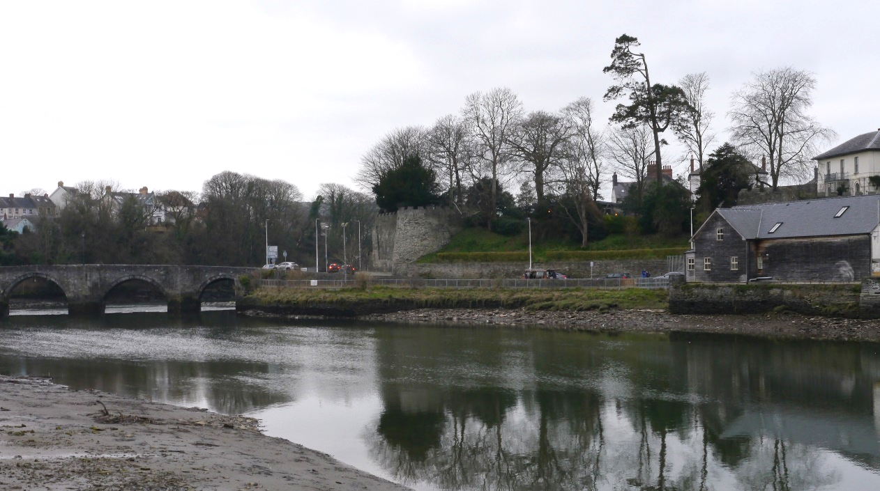
Plate 3-5 – View from the south bank, looking towards Cardigan Castle alongside Strand and Cardigan Bridge. Mudflats are exposed at low tide in the foreground.
Intertidal habitats of saltmarsh and mudflats line the river including within the Scheme Area; these are habitats of principal importance (HPI) under Section 7 of the Environment (Wales) Act (2016). The river as it passes through Cardigan is also designated as the Afon Teifi Special Site of Scientific Interest (SSSI) and Afon Teifi / River Teifi Special Area of Conservation (SAC).
The area surrounding the Scheme comprises mainly of residential/town centre roads with low speed limits. The A487 road is located on the eastern side of the town and crosses the Afon Teifi via the Pont Y Priordy (Priory Bridge). The B4546 road is located to the south of the town and leads towards Castle Street. Strand is the main road within the Scheme Area and is adjacent to the proposed works. Strand is a one-way two lane road that connects Carrier’s Lane to Bridge Street/High Street and Cardigan Bridge (Castle Street) to reach the A487. Other nearby roads include Carrier’s Lane, Morgan Street, Bridge Street/High Street, Gloster Row, Church Street, St Mary Street and Pont-Y-Cleifion.

There are multiple Public Right of Way (PRoW) routes and active travel routes within Cardigan as shown within Plate 3-6. None of these routes cross within the Scheme Area or are located nearby to any key access routes. National cycle route 82 is shown to be present along the left-hand bank of the Afon Teifi.

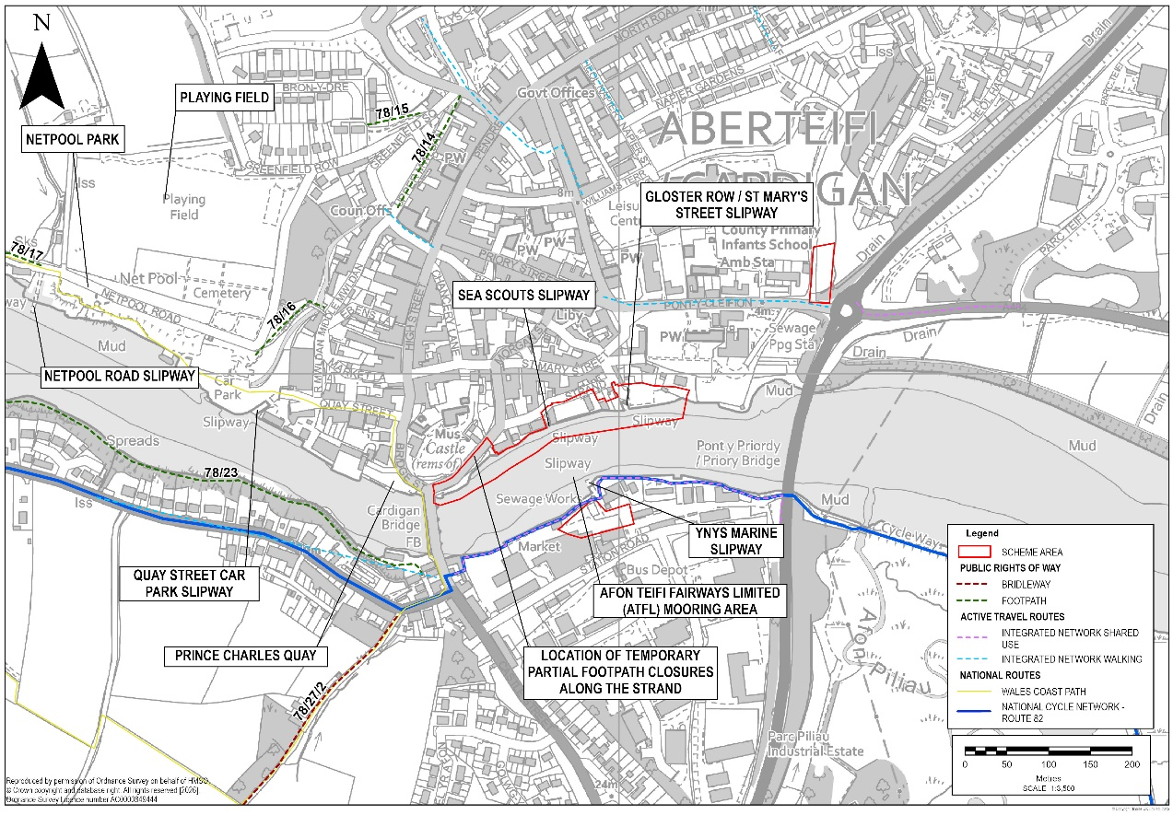
Plate 3-6 – Overview of PRoW, active travel and cycle routes within Cardigan
The Cardigan urban area comprises an intact historic core with traditional building materials of slate and painted render. Modern commercial buildings on the settlement edge are not in keeping with the traditional historic core and detract from the integrity of the landscape. South of the river lies a commercial/industrial area, which does not have a cohesive built form but comprises a variety of construction materials including modern buildings and warehouses. Housing developments are found to the north, and across the river to the south.
The Environmental Constraints and Opportunities Plan (ECOP) shows the Scheme in the context of surrounding designations. Full details of the landscape, ecological, and heritage baselines including photographic records are provided within the Environmental Statement (ES) topic chapters (5-11) and the Green Infrastructure Statement which accompany the planning application.

Interpretation

Meeting the Scheme brief and vision
Table 4-1 describes how the Scheme design would meet the Scheme Objectives listed within section 2.2, which encompass the Scheme brief and vision, in relation to the site and its context.
Table 4-1 – Meeting the Scheme objectives
Scheme Objectives | Design Response
Reduce the risk of tidal flooding to the town and community of Cardigan, taking account of predicted sea level rise. | The Scheme has been designed to 4.95m AOD to meet the 1 in 200 design standard with climate change and would allow for 0.2m of freeboard, accounting for uncertainty in long range forecasting of the effects of climate change.
Maintain and enhance the natural environment, and the well-being of the community, helping to achieve NRW’s Well-Being Objectives and satisfy Environment (Wales) Act duties. | The principles of the stepwise approach, as described in Planning Policy Wales 12, Section 6.4.15 have been embedded into the design process for the Scheme and have been applied to all green infrastructure. Further details of how the stepwise approach has been implemented and how the Scheme provides a Net Benefit for Biodiversity is provided within the Green Infrastructure Statement, including details of how the Scheme complies with the ecosystem resilience aspects of the Environment (Wales) Act 2016.  The Scheme design has sought to maximise public realm enhancements along Strand, taking into account public consultation responses.
Provide a solution that is sensitive to Cardigan’s important historic and landscape interest. | The Scheme has been designed to be minimally intrusive to the existing historic landscape character of Cardigan. Building materials have been selected to be consistent with nearby Scheduled Monuments Cardigan Bridge and Cardigan Castle, allowing the new structures to blend into and contribute to the existing character of Cardigan.
Apply green-grey estuarine infrastructure to deliver a multi-functional Flood and Coastal Erosion Risk Management (FCERM) asset. | The Scheme design incorporates multiple green estuarine infrastructure elements including utilising stone filled nets (rock rolls) and a growing medium seeded with salt tolerant estuarine species mix on the engineered riverbank. This is intended to aid the natural deposition of sediment which would enable the colonisation of intertidal species on the engineered riverbank.
Engage the community and deliver a publicly acceptable solution. | As noted within section 5.4, multiple stages of community consultation were undertaken throughout the design process, which enabled public feedback to influence the final design.
Provide a solution that is cost beneficial. | Cost benefit analysis has been undertaken to provide a solution which meets the necessary standard of protection at a suitable cost.
Work with Dŵr Cymru Welsh Water (DCWW) and Ceredigion County Council (CCC) to discuss their responsibilities, in terms of different types of flooding within the area. | DCWW and CCC have been engaged throughout the design process.

Design development

Design approach
The purpose of the Scheme is to reduce the risk of tidal flooding to the town and community of Cardigan, taking account of predicted sea level rise. This would be achieved by creating new flood defences, which would afford a greater standard of flood protection to properties currently at risk of flooding. The Scheme objectives and Critical Success Factors are outlined within section 2.2.

Identification of the preferred option
The long list optioneering process concluded with the selection of a ‘do something new defences’ preferred option. Do Nothing/Do Minimum and Property Flood Resilience (PFR) options were rejected due to the increasing flood frequency in Cardigan, posing a risk to life. Further consideration was not given to the PFR scenario as whilst it would offer improved resilience to some properties, it would not reduce the risk of life or injury resulting from flooding or reduce the disruption caused by flooding.
At the short list stage, three linear defence short list options were appraised d:
- Flood wall that is offset to the Afon Teifi – This option offers the advantage of preserving existing heritage aspects by creating sufficient space for defence construction without excavation. It would involve backfilling behind the proposed wall and burying the existing revetment and wall. However, this option presents environmental risks due to encroachment on the Afon Teifi Site of Specific Scientific Interest (SSSI) and Special Area of Conservation (SAC).
- New flood wall following the alignment of the existing riverbank/wall (where possible) – This option aims to balance impacts by maintaining the alignment with the river (i.e. minimising encroachment into the designated site), preserving heritage aspects, and avoiding negative impacts on adjacent properties.
- Managed realignment – This option involves a setback wall, providing additional space for water, environmental enhancements and habitat creation opportunities. However, it includes the demolition of some properties to implement the Scheme.
A multi-criteria analysis was undertaken to identify the preferred option alignment. This concluded that Option 2 – provide a flood defence wall along the general alignment of the existing river wall – was the preferred alignment. The reasons for its selection were:
- It minimises incursion upon the Afon Teifi and therefore has reduced effects on the Afon Teifi SSSI and SAC and associated in-river habitats
- It comprises minimum land take, thereby minimising the potential disruption to buried archaeology or historical artefacts
- It achieves the required flood risk mitigation objective
- It presents opportunities to provide environmental enhancements, including developing vertical habitats and habitats on the landward side of the defence.
A public consultation event and feedback period followed the development of the short list options: see section 5.4 for details. Feedback from this, where there was a desire expressed by the public to include public realm enhancements, has been incorporated into the design taken forward as combining elements from Option 1 into Option 2.

Preferred option development
When developing the design, the stepwise approach to avoid damage to existing green infrastructure, as set out in Planning Policy Wales 12, was followed. Full details of how this approach was applied are set out in the Green Infrastructure Statement.
Since the identification of the shortlisted option design development has continued to identify the most effective design that delivers the maximum benefits. The following environmental, construction and other infrastructural constraints have influenced this design.

Alignment of the flood defence
During design development, the alignment of the proposed flood defences was reviewed to minimise intertidal habitat loss along the banks of the Afon Teifi. Habitat loss calculations informed the preferred alignment and the scale of replacement habitat which would need to be incorporated into the Scheme design.
In Area 3, an opportunity to set‑back the alignment at the Old Foundry Site was explored to reduce habitat loss. However, increased construction risk, the impact on Sea Scouts’ existing amenity space, and higher costs outweighed the minimal habitat benefits. The design therefore adopts a nominal riverward offset, following the line of the existing river wall.
Adjustments in Area 3 led to a revised alignment in Area 4, where the defence was intentionally set back to allow for the establishment of new intertidal habitat. This alignment was constrained by a Dwr Cymru Welsh Water (DCWW) rising main, requiring the wall to cross the Gloster Row car park. As a result, some parking capacity would be reduced to achieve the required habitat mitigation. However, the car park has been redesigned to minimise the loss of parking space.
Further detail on flood defence alignment and the intertidal habitat is provided within Chapters 2, 3 and 6 of the Environmental Statement.

Engineered riverbank finish
The introduction of an engineered riverbank in front of the sheet-piled flood defence was included to help support the reduction of the overall length of sheet piles required, thereby minimising construction impacts such as reduction in the scale of heavy plant use and disturbance to bedrock and less disturbance of properties on the dry side of the wall. This approach also softens the appearance of the defence, providing a more natural frontage compared with the harsher aesthetic of an exposed hard-engineered cladded wall, thereby reducing the Scheme’s overall visual impact, and allowing for the opportunity for a range of intertidal habitats to establish on the banks.
As part of the design process, the alignment and finish of the engineered riverbank was considered to deliver a range of intertidal habitats, increase the likelihood of their success and reduce maintenance requirements. Harder engineered finishes such as concrete revetment blocks were discounted due to carbon cost and their limited value to biodiversity. Development of options for the engineered riverbank finish involved undertaking investigations into bioengineering solutions which identified and appraised three main options:
- rip rap or rocks rolls only
- rip rap or rock rolls with a seeded growing medium on upper sections and crest
- rip rap or rock rolls with planted coir matting on upper sections and crest.
When considering the design options, different tidal events were considered to determine the frequency with which the amount of the engineered riverbank would be under water and therefore how quickly the new riverbank would accrete sediment. Plate 5-1 indicates the Mean High Water Spring (MHWS) level whereby the riverbank at this level would be under water approximately every two weeks. Below the MHWS level the riverbank would be inundated by normal tidal conditions more regularly, with the toe being inundated daily. The Highest Astronomical Tide (HAT) level would be reached approximately twice a year.
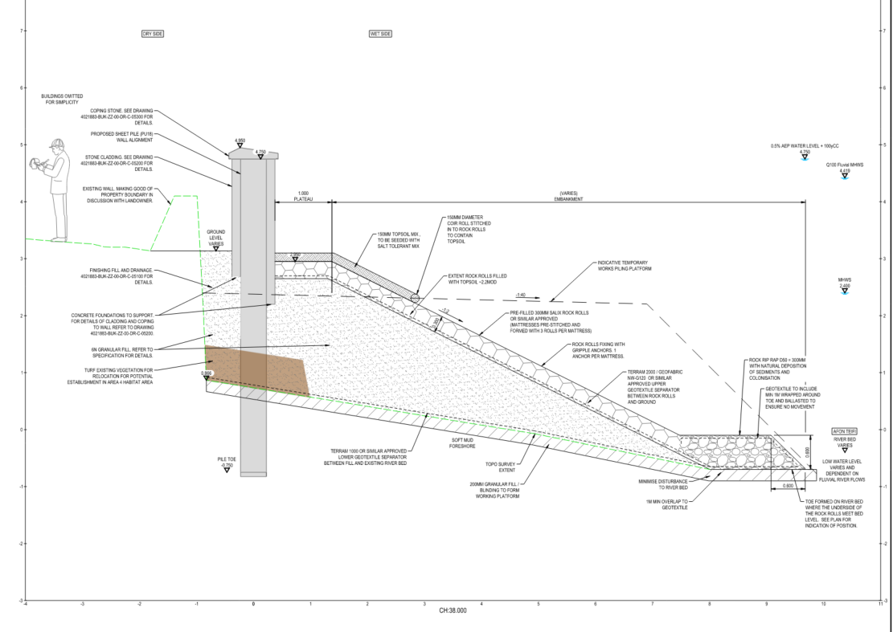
HAT
MHWS
Coir roll
Saline tolerant seed mix
Rip rap toe
Rock rolls
Plate 5-1 – Typical engineered riverbank section showing approximate level MHWS and HAT lines to indicate frequency of tidal inundation
The conclusion to this investigation was to use rock rolls on the lower slope of the new riverbank to approximately two thirds of the height (up to the MHWS level). The remaining upper third of the slope and crest of the new riverbank, which would be inundated by the tide very infrequently, would incorporate a saline tolerant seed mix and imported soil to promote a more natural finish. This would be placed over the rock rolls which would extend up the upper third of the slope and crest providing the required engineered scour protection to protect the new riverbank. To hold soil in a place while the seeded vegetation establishes on the upper slope a single line of coir rolls would be installed, this coir roll would not be planted. A rip rap toe using larger stones than used in the rock rolls is included to ensure the rock rolls remain in position.
As sea level rises in the future more of the engineered riverbank would be inundated by the tide more regularly. The slope of the new riverbank would allow for habitats established on it to migrate upwards as sea level rises, which would increase the length of the time that intertidal habitats are present than without the engineered riverbank.
The use of rock rolls would provide multiple small crevices into which sediment would naturally be deposited by the river, and from which the mud would be less likely to wash away than if a flat surface or larger rocks (i.e. rip rap) were used. This would enable intertidal habitats to remain present, although the type of intertidal habitat would change from mudflats to a habitat of seaweeds and lichen on eulittorial rock and transitioning up the slope to include saltmarsh species. The change from a relatively flat shoreline to a engineered riverbank with gradient of 1V in 2H allows for the progression of intertidal habitats up the new riverbank as sea level rises in the future. This allows for intertidal habitats to be present for longer. For further discussion on the effects of the Scheme on intertidal habitats see Chapter 6: Biodiversity and Nature Conservation.
Planted coir matting was not favoured due to concerns that the matting would be pulled away during flooding events causing damage to the scour protection beneath, leading to increased maintenance requirements.
While it was considered that over time the entirety of the new riverbank would accrete with sediment from the river and naturally colonise, due to the infrequency with which the upper third of the new riverbank and crest would be covered with water it was considered that a seeded growing medium would provide the opportunity for the new riverbank to vegetate more quickly than the use of rip rap or rock rolls only.
Additional enhancements (e.g., living boulders) were considered but would not materially alter the development of seaweed‑ and lichen‑dominated eulittoral rock habitat. For further details of the final riverbank design, see Chapter 3 (Project Description) of the Environmental Statement.

Landscape design
Public realm improvements are proposed in Area 1 (Strand) to provide enhancements pedestrian and bus stop user environment, support biodiversity, and reflect the historic character of the location. Two design options were initially considered: Option 1, which set the flood defence wall closer to the river to create a wider pavement with street trees and a biodiversity planting zone on the wet side; and Option 2, which placed the wall closer to Strand, allowing a larger biodiversity area but reducing pavement width and tree‑planting opportunities.
Public consultation undertaken by NRW in June 2025 showed support for a wider pavement, new trees and planting, and use of natural stone to complement the setting. Residents, including parents and carers, emphasised that the current pavement is too narrow. As a result, Option 1 was selected and developed further. Following discussions with Cadw and Ceredigion County Council, proposed street trees in front of the defensive wall of Cardigan Castle were removed to preserve key views to and from this Scheduled Monument.
The design changes require relocation of existing lighting columns, which would otherwise obstruct the widened pavement. These columns would be repositioned adjacent to the new flood defence wall, with updated lighting fixtures selected to maintain safety while reducing impacts on foraging bats.
Across the Scheme, the flood defence wall would be clad in stone to reflect existing riverside walls and complement Cardigan Bridge and Cardigan Castle. The coping stone forms part of the flood defence level and would be constructed in precast concrete to ensure a watertight finish while minimising the perceived height of the wall.

Consultation
Full details of the consultation that has been carried out, and design responses to that consultation, are provided in the Planning Statement and Environmental Statement which accompany the planning application. The following were consulted during the design process prior to the formal, mandatory, pre-application consultation stage:
- Ceredigion County Council
- NRW terrestrial and marine fisheries specialists
- General Public.
The key design outcomes of those consultations are:
- Preference for wider pavements and tree planting in Area 1
- Avoiding planting of trees directly in front of the main walls of Cardigan Castle
- Preference for a naturalised finish to the upper slope of the engineered riverbank.
Pre-application consultation for the Scheme, in accordance with The Planning (Wales) Act 2015, was undertaken from 7 April 2026 through to 18 May 2026. As part of this consultation process, notices were placed on site, and notice was served on relevant consultees, including all known affected landowners and occupiers.
The pre-application consultation submission included the Environmental Statement, Habitat Regulations Assessment, Design and Access Statement, Planning Statement, Green Infrastructure Statement, scaled plans and drawings as well as several other technical documents. These were made available to view online and at Cardigan Library.
Following completion of the consultation period a Pre-Application Consultation Report was prepared to document the responses received, issues raised and how these have affected the Scheme design and planning application. The Pre-Application Consultation Report would be submitted along with the other application documentation in support of the planning application.

Proposed development

Overview
The proposed works are illustrated on the Environmental Masterplan that accompanies the planning application. The works are outlined in full within the section 2.3 of the Planning Statement.

Consideration of good design objectives

Character
The Scheme sustains and enhances local character primarily through the use of sympathetic design. Building materials have been selected to be consistent with nearby Scheduled Monuments Cardigan Bridge and Cardigan Castle, allowing the new structures to blend into and contribute to the existing character of Cardigan.
Through an understanding of the amenity value and sense of place within Cardigan, particularly alongside the Afon Teifi, the Scheme would contribute to enhancing the sense of place and quality of life. At present, the space between the Afon Teifi and Strand footpath comprises a lower plateau from which public access is restricted by a wall alongside the footpath. The plateau surface is paved, with metal railings along the riverside edge, and has become overgrown.
The Scheme is split into four areas, with Area 1 at the downstream end of the Scheme next to Cardigan Bridge and Area 4 at the upstream end of the Scheme at Gloster Row car park. Within Area 1, the Scheme would backfill the landside space of the proposed flood defence to provide a new public amenity area. The pavement along Strand would be widened by removing the existing roadside wall and from setting the flood defence wall away from the road. This new footway would be at least 3m wide and finished in riven slate to reduce slip risk and visually link Strand with Prince Charles Quay and the Cardigan Castle entrance. The slate surface would continue to the Strand–Cardigan Bridge junction.
Linear planting beds with small shrubs, herbaceous species and street trees would be created alongside the road to separate pedestrians from traffic. A raised planting bed would also be created near the Bathroom Centre planted with taller species. The retaining wall containing the raised planting bed is parallel to Cardigan Castle walls and incorporates integrated seating facing the castle. Three seats are proposed with a combination of backrests, armrests and at different seat heights to facilitate use by users with differing accessibility needs.
Through the implementation of these public realm enhancements, the amenity value and character would be enhanced, creating a space which is suited to the needs of the community.

Access and movement
As described above, the Scheme would widen the existing footway along Strand to at least 3m wide, allowing for improved accessibility. In this area, the existing street lighting columns would be moved to further enhance accessibility.
Due to the alignment of the proposed flood defence wall, the existing slipway used by the Sea Scouts and other permitted organisations need to be closed. To ensure that access to the Afon Teifi would be retained for these groups, the Scheme would provide a new up and over canoe/kayak access ramp to the south of the Old Foundry site. The existing public slipway at Gloster Row car park would also be permanently closed, however it is understood that this is not regularly used and is not required for emergency services to access the river.
As the alignment of the new flood defences would encroach on the existing Gloster Row car park, the car park has been redesigned. The car park currently comprises of 23 car parking spaces including one space for disabled users. The redesigned car park would reduce the number of spaces to 15 and retain the one disabled car parking space. For details of the redesigned Gloster Row car park see drawing ref: 4021883-BUK-ZZ-00-DR-C-04400.
Through these considerations, the Scheme has sought to enhance public access and movement in the area and minimise intrusion as far as reasonably practicable.

Environmental sustainability
During the design development process, consideration was given to the alignment of the flood defence wall to limit intertidal habitat loss along the north bank of the Afon Teifi. Intertidal mudflats and saltmarsh are defined as HPI and are of national importance. The flood defence wall alignment could not avoid the river channel completely without demolition of some properties along the north bank of the river, therefore some loss of intertidal habitat would occur. However, this is mitigated for by setting back the alignment of the flood defence wall at Gloster Row car park.
In order to avoid intertidal habitat loss within the footprint of the engineered riverbank, a permeable geotextile membrane would be placed onto the graded granular fill. Rip rap would be placed at the toe of the new riverbank slope. Rock rolls would be placed on the slope and crest of the new riverbank. Imported soil would be placed on the upper third of the slope and crest of the new riverbank and the seed mix for an estuarine/salt-tolerant environment would be sown to aid vegetation growth on these upper areas which are inundated less frequently by the tides. To hold the soil in a place on the upper slope a single line of coir rolls would be installed, this coir roll would not be planted.
This would enable intertidal habitats to establish on the engineered riverbank, although the type of intertidal habitat would change from mudflats to a habitat of seaweeds and lichen on littoral rock and transitioning up the slope to include saltmarsh species. This habitat is already present immediately downstream of Cardigan Bridge on both banks of the river, and as such the change to this habitat type would enhance the extent and connectivity of this littoral rock habitat.
As previously noted, the enhancements within Area 1 include planters which would primarily provide amenity value and minor biodiversity value to foraging bats.

Community safety
By providing flood defences, the Scheme provides a benefit to mental health and wellbeing by reducing anxiety related to potential flood risk. This is of particular importance in Cardigan where the Welsh Index of Multiple Deprivation (WIMD) indicated that some areas of Cardigan are among the 10% most deprived areas in Wales, and there is a high proportion of vulnerable groups within the town; as these groups have a lower capacity to adapt to change.
The footway along Strand between Cardigan Bridge and the bathroom centre is part of an existing walking route within Ceredigion County Council’s Active Travel Network, with links to Cardigan Bridge, to the High Street via Bridge Street, and along Carrier’s Lane to Priory Street. The enhancement of the footway could encourage use of this route and increase safety for users. A bus stop is located along this footpath, and the Scheme would also improve the experience of people using the bus by providing benches for those waiting for the bus, and by providing an environment of a higher perceptual quality than at present.
There would be no change for emergency services accessing the river as the slipway at Gloster Row car park, which would be permanently closed by the Scheme, is not used by emergency services to access the river.

Consideration of Local Development Plan
Relevant key planning policy has been considered throughout the design process and environmental assessment to ensure that the Scheme is in keeping with and would not work against policy goals. The relevant planning considerations have been grouped into key topic areas within Table 5.1 within the Planning Statement and relevant corresponding policies from the Local Development Plan have been referenced.

