Introduction from the NRW Board on their decisions following consultation with the Trade Unions

The NRW Board and Executive Team extend their sincere thanks to the Trade Union representatives, their members, and NRW colleagues for their professional and constructive engagement with the case for change consultation process. The Board and Executive Team have found the scrutiny and quality of feedback from colleagues to be significant in helping us to improve the Case for Change.

The Board, Executive Team and Leadership Team have carefully considered the written response alongside the detailed comments and this document sets out the formal NRW organisational response to the Trade Unions.

Setting the Strategic Direction

The Board’s role is to set the strategic direction for the organisation. The Corporate Plan “Nature and People Thriving Together” sets the Board’s vision, mission, and well-being objectives for the organisation to 2030. The Corporate Plan is both the cornerstone of our organisation and the guiding light for our direction.

The urgent imperative for action to meet the triple challenge of the nature, climate and pollution emergencies has not dissipated over the last 18 months. In fact, there are daily reminders of the compelling need for action. In the face of this, many colleagues have questioned the timing of this case for change. The harsh reality is that NRW, like the rest of the public sector in Wales is operating in a tough economic environment. Unless we confront these financial pressures now, we will be forced to continue the perpetual cycle of year-on-year cuts to secure a balanced budget each year. The Board and Executive Team believe that such an approach, while in many ways much easier, would only serve to increase the workload pressure on colleagues and deflect everyone from imperative actions for nature and climate in what is left of this critical decade.

The Corporate Plan signalled a change with NRW shifting to become an outcome focussed organisation. The Board’s overriding priority is delivery of the well-being objectives and steps to take in the Corporate Plan. It is critical that we make sure that everyone across the organisation is focused on those things that only we can do and that have the greatest impact for nature, climate, and minimising pollution.

Evolving ways of working

Implementing the case for change will set the organisation on a pathway to financial resilience and stability. However, this does not mean that the organisation stands still. The Board and Executive Team recognise that we need to continually adapt and change in response to changing circumstances driven by a diversity of factors ranging from the global to the Wales specific. We will be guided by the corporate plan and our values, as we focus on delivery to 2030 and setting us on the pathway to the more difficult challenges in the decades to 2050.

The Board and Executive Teams expectation is that we will have to continually adapt our ways of working, being agile and flexible in the face of changing circumstances and testing innovative tools and approaches. The Board and Executive Team will continue to assess their own ways of working, keeping the governance and organisational arrangements under review to ensure they meet the changing needs of the organisation.

Moving to Implementation

As the consultation phase of the case for change closes, the focus now turns to implementation.

Over the course of the consultation new vacancies emerged as colleagues left the organisation. The Leadership Team have taken advantage of these to make changes to their proposals to reflect the feedback from Trade Union members. This has resulted in some posts originally proposed for removal being reinstated, with the newly vacant posts being deleted from the structure. In addition, in a small number of cases some additional funding has been found. In some cases, agreement has been reached with Welsh Government Policy to use a portion of ring-fenced grant to fund a post, in others posts have been funded from charge income, or in exceptional circumstances non-staff costs have been used to fund posts.

Through the consultation period additional information came to light that meant we needed to reconsider the proposals for change in the Customer Service and Evidence Library Service. Applying the approach adopted for the original commission, Leadership Team prepared a range of options assessing the risks and impacts. These were considered by the PRG with recommendations to Executive Team. This has resulted in significant changes to these service proposals.

These changes in response to the Trade Union consultation are documented in the following table, which demonstrates the overall change from where we started at the beginning of the consultation and where we are now. There are 72 less roles directly affected and 42 less roles to be removed.

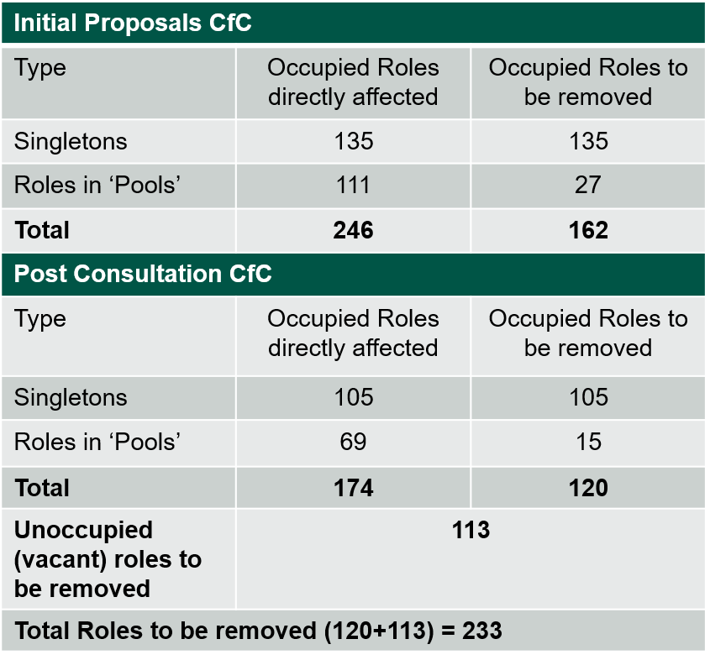

The Board and Executive Team recognise that these adjustments have helped to mitigate the risk of redundancy for colleagues. The detail of the Business Group and Enabling Service Directorate changes are set out in the Statements of Response

The Board and Executive Team recognise the significant dialogue and engagement with the Trade Unions on the process for implementing the change, and extend their sincere thanks. The Trade Unions have endorsed the change implementation approach.

As we now move to implement the change our focus turns to supporting our colleagues and friends through the change process. A range of tailored support will be made available to individuals and their team leaders to support them in the coming weeks.

Looking to the Future

The Board and Executive Team are committed to getting through this change process as quickly as possible, enabling us to refocus our collective energy and passion on delivery for nature, climate and minimising pollution. The next 12 months will be a period of transition. The Board and Executive Team expect colleagues to work with their Leadership Team to revise workplans and departmental/group narratives to follow through on the prioritisation steer. These documents will explain in more detail the new service provision and the opportunities for streamlining and simplifying processes and ways of working. The Board and Executive Team accept that sometimes things will not go as planned, but as long as we evaluate the impact and draw on the learning, they will support teams to be innovative and take greater risk.

NRW Board Decisions

The Board is committed to leading the organisation through this period, navigating a pathway through the changing financial and political operating environment facing the organisation. The decisions have not been taken lightly and the Board has been assured by the Executive Team of the thorough and detailed assessment of the risks and impacts of the changes within each Business Group and Enabling Services Directorate. Although there have been some adjustments to the posts removed from the Business Groups and Enabling Service Directorates, they have not been able to accommodate everyone’s perspective. The reality is that no new money has been identified over the course of the consultation period to allow the Business Groups and Enabling Services Directorates to step away from their financial targets.

At its meeting on the 5 November, the Board agreed to implement the Case for Change. This included the following key decisions:

* To proceed to implement the stop and scale back activities. The Board commends the excellent work undertaken by these teams and the professional way they have conducted themselves throughout the consultation period. The Board underline that this is not a personal reflection on the individuals or the value of their work. These individuals have been truly outstanding.
* The Board recognise the vital role the Senior Leadership Team have played in leading colleagues through the change. Nevertheless, more work lies ahead if we are to meet the Boards ambition to rapidly transition and embed the new ways of working. The Board perceive that this will be disrupted by the Senior Leadership Review and for this reason has decided not to go ahead with the Senior Leadership Review.
* The Board has agreed that the review of enabling services and flood risk management will be managed as projects as part of the case for change Programme. The Enabling Service project will re-focus all enabling service functions to be *customer-focussed, to* *enable* and incentivise innovative delivery for nature, climate and pollution minimisation, reducing the burden on the frontline by integrating, streamlining and simplifying processes and in doing so release capacity, driving efficiency and greater value for money. The Flood Risk Management service will be expected to set out a range of options for meeting a saving of £2.1m by looking at ways of working and organisational arrangements to realise greater efficiencies and opportunities for integrating flood work more closely with other NRW services, with a thorough assessment of the risks and impacts for consideration by the Board and Executive Team.
* To reflect the Board’s commitment to following through on the change, they have agreed to the establishment of the embedding the change project. This will provide oversight of the prioritisation changes instigated in this case for change, monitoring risks, financial and HR information to track progress and ensure that the changes instigated are realised.

The Board has agreed to the financial target moving from £13m to £12m with £10.9m realised by the 1 April 2025. The Board believes that the risks and impacts of meeting the £13m target was outside their risk appetite. The Board recognise that the last 18 months have been tough, with the recruitment controls having an impact on delivery. Such change projects are never easy, but the Board believes that the Executive and Leadership Teams have done the best job they can using their extensive knowledge and experience to realign the organisation to the priorities in the corporate plan. The case for change, while difficult, will allow the organisation to move forward again.

Through this consultation period, the Board recognises the extent to which Senior Leaders have engaged with the Trade Unions and their members, and colleagues, listened to their feedback and where possible taken action. The Board is assured that this has been a meaningful consultation.

**Sir David Henshaw, NRW Chair and the NRW Board endorse the Case for Change and are now tasking the Executive Team to start implementation.**